The Valleys Evangelical Covenant Church
The Rev. Kristine Heckard, Pastor
Worship Leader, Mike Crum
Worship Technicians: Aren Faust & Brooke Croutharmel
September 14, 2014 - Blended Worship, 10:15AM

“Strong in the Word to Serve in the World”

(*Indicates all those who are able are invited to stand.)

Sing a New Song -
“How Great Is Our God” Chris Tomlin
“We Fall Down” Chris Tomlin
“Heart of Worship” Matt Redman

Greetings and Announcements Arletta Thomas

Praise Hymn (follow Screen)
* “Wonderful Words of Life” Page 270

* Confession & Assurance (follow Screen)
* Profession of Faith (follow Screen)

Morning Prayer & The Lord’s Prayer (Debts & Debtors)

Hymn - (follow Screen)
“Breathe on Me, Breath of God” Page 259

Message & Scripture - Jim Lodge a member of The Gideons

Our Morning Offering
Offertory - “Build Your Kingdom Here” Rend Collection
Prayer of Dedication

* Closing Hymn (follow screen)
“Glorious Things of Thee are Spoken‘” Page 278
* Commissioning

* Passing the Peace Greeting:
All who are able may greet those around them with an embrace or a handshake, accompanied by such words as:
Greeting: “The peace of God be with you.”
Response: “And also with you.”
* Post-Service Music - “Grace, Love and Fellowship”

Welcome: Welcome to worship as we come to join our voices to glorify God! May we all find encouragement, inspiration and direction for living during the worship service this morning. If you are a visitor, please take time to sign your name, address, and phone number in our guest book before you leave.

We welcome and thank Jim Lodge of the Gideons for bringing the message this morning.

September Greeters: Gerry Wiest and Dennis Croutharmel.
Announcer: Arletta Thomas. Acolyte: Chris Maichle.
September Offering Team: For Sept. 14: Gloria Duttry, Alvin Duttry, Neva Cichy, Charles Cichy. Please tell the Captain if you are unable to be there for a Sunday in your month. The Captain is responsible to get someone to help with the Offering Team if a member of the team cannot be there.

Lay Readers: Sept. 14 - (Gideons); Sept. 21 - Donna Motter; Sept. 28 - Scott Miller; Oct. 5 - To be announced. If you cannot read on the date assigned, please call Pastor Kris at the church (896-3118) or her home (717-422-5788).

Nursery: Valleys provides nursery care for children ages 5 and under. Sept. 14 - Ann Hale; Sept. 21 - Brandi Crum; Sept. 28 - Patty Hummel; Oct. 5 - Tracey Cooper. If you wish to help in the Nursery or if you cannot be there on your assigned Sunday, please see Donna Novinger.

Church School Teachers (Adults): Sept. 14 - Carol Reisch; Sept. 21 - Bob Endy; Sept. 28 - Marie Herb; Oct. 5 - Jessi Faust. If you cannot be there on your assigned Sunday, please inform Dave Novinger or Jessie Faust who will teach in your place.

Pastor Kris is on vacation September 14th thru September 21st. Worship Leader for September 14th is Mike Crum. The Message and Scripture will be given by Jim Lodge, a member of the Gideons.
Worship Leader for September 21st will be Dave Novinger. Marie Herb will give the Message. Pastor Dale Parker will take Pastoral Calls during Sept. 14th thru Sept 21st while Pastor Kris is on vacation. Please call The Valleys Church Office (896-3118).

Council Meeting: September Council Meeting will be held on Wednesday, September 17th at 7:00PM.

Upcoming Special Activities/Happenings:
********************************************************************************

Pig Roast: The Valleys will host a Pig Roast on Saturday, September 27th from 4:00 - 6:00PM.
Ticket Donation: Adults - $10.00, Ages 4-12: $5.00, Ages 3 and under “FREE”.
Menu: Roast Pig, Filling, Baked Beans, Applesauce, Cole Slaw, Dessert, and Beverage.
Take out orders also available.
Please contact the church office (717-896-3118) for information or tickets.
Entertainment will be provided by The Maus Brothers.
There will be a sign up sheet in the narthex for desserts.
********************************************************************************

Diaper Collection Drive: On Sunday, October 5th we will be taking donations of disposable diapers of all sizes (Newborn to largest size) to partner with Zion Stone UM Church, who is organizing a diaper collection drive this fall, to help fill an ongoing need for struggling families in our local communities.

Halifax CROP Walk will be held on Sunday, October 19th. Participants will meet at the Halifax Memorial Park Pavilion at 1:30PM. More information in upcoming bulletins.

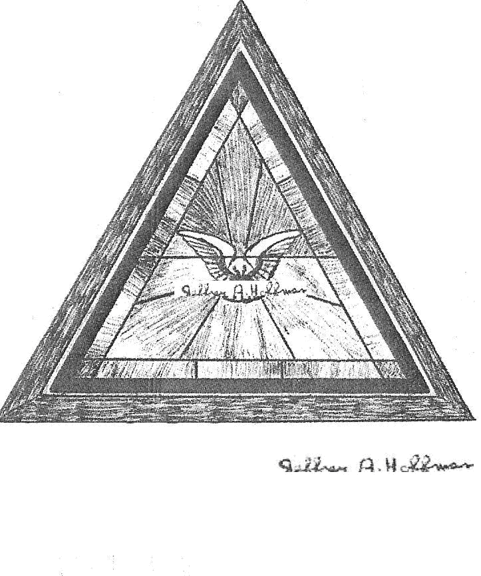

The Valleys
Evangelical Covenant Church
Halifax, PA

Church Office Hours: Mon. thru Fri. - 10AM to 3PM
Church Office(717-896-3118)
Web Site - ValleysEcc.Org Email - valleysecc@verizon.net

Pastor’s Hours: Mon., Tues., Thurs.; 10:00AM - 1:00PM
Office (896-3118), Cell (717-818-3041), home (717-422-5788)
Email - KOHeckard@aol.com

CHURCH CALENDAR

Sept. 14 - 9:00AM - Sunday School -Rally Day
10:00-10:15AM - Learn Praise Hymns
10:15AM Blended Worship (Praise Team & Hymnal) - Jim Lodge of the Gideons, Message & Scripture, Mike Crum - Worship Leader
Sept. 15 - 9:00AM-Noon - Halifax Senior Center open Tues-Thurs
10:00AM - Bible Study (Wilbur & Loretta Prouse, Leaders)
Sept. 16 - 6:00-8PM - Girl Scout Troop 10463
Sept. 17 - Noon-3PM - Senior Center Pinochle Card Party
6:00-8PM - Girl Scout Troop 10573
7:00PM - Sept. Council Meeting
Sept. 18 - 6:10PM - Zumba Gold; 7:00PM - Zumba

Sept. 21 - 9:00AM - Sunday School
10:15AM - Traditional Worship (Enders) - Marie Herb - Lay Speaker, Dave Novinger -Worship Leader
2:00-3PM - Zumba
6:30PM - Youth Group
Sept. 22 - 9:00AM-Noon - Halifax Senior Center open Tues-Thurs
10:00AM - Bible Study (Wilbur & Loretta Prouse, Leaders)
6:00-8PM - Girl Scout Trp. 774
Sept. 23 - 6:00-8PM - Girl Scout Trps. 738 & 740
Sept. 24 - 6:00-8PM - Girl Scout Trp. 10753
Sept. 25 - 6:10PM - Zumba Gold, 7:00PM - Zumba
Sept. 27 - 4:00-6:00PM - Pig Roast at Valleys

Sept. 28 - 10:00-10:15AM - Learn Praise Hymns
10:15AM Blended Worship (Praise Team & Hymnal) - Mission Offering - for Sept. thru Dec. goes to Christmas Benevolence (to be reserved for Emergency needs in the congregation and/or the Christmas Offering

The following groups meet at Valleys: Mondays - Victory Group (Weight Loss) - 5:30PM; Tuesdays - Weight Loss Challenge Group - 5:30-7:00PM

Praise Team Rehearsal - Wednesdays at 6:15PM at Gary & Sharon’s home

*PRAYER REQUESTS*
Please remember all the people on our Prayer List with prayers, thought, and cards: *(indicates new)
Members & Friends of The Valleys: Navigate Pathway; *Savannah Dobbin, (Ed‘s granddaughter); *Dean Etzweiler; Tom Hale; John Shoop; Ken Breeman; Wanda Hendershot and Family; Allen Goss, (UMPC Presby. Hosp,); Elmer Feidt; Melba Croutharmel;
Missions: Covenant Missionaries: Fred & Kelly Prudek; *Cheryl Santello.
Our Shut Ins: Minnie Baker; Anna Portzline; Lydia Peiffer;
Myra Hoffman.
Please inform Pastor Kris if you or a member of your family is in the hospital as the hospitals will not inform us unless you tell them to contact us. You may call the church office (896-3118) or Pastor Kris (818-3041).
~~~~~~~~~~~~~~~~~~~~~~~~~~~~~~~~~~~~~~~~~~~~~~~~~~~~~~~

NO Plastic Bags: Please do not bring in any plastic bags for the Youth Group at this time!

Halifax Senior Center hours have changed! The Center is open 9:00AM-Noon Monday thru Thursday at The Valleys E. C. C. Check the calendar on Bulletin board in narthex for list of activities. Senior Center will not collect coupons over the summer. The Senior Center will hold a Pinochle Card Party on Wednesday, September 17th from Noon to 3:00PM.

Giant Gift Cards available to purchase (before/after church)!
By purchasing Giant gift cards, you can help raise money for Valleys. Valleys receives $5 for every $100 Giant gift card purchased.

Please turn off cell phones, pagers, etc. during our worship service. Thank you for your cooperation.

Church Attendance last Sunday, Sept. 7, 2014 was 74.

