The Valleys Evangelical Covenant Church
The Rev. Kristine Heckard, Pastor
Choir Director, Ed Dobbin
Hymnal Technicians, Brooke Croutharmel,
Bridget Campbell, Mike Crum
Acolyte, Cameron Crum
August 31, 2014
“Strong in the Word to Serve in the World”

(*Indicates all those who are able are invited to stand.)

Chimes
Greetings and Announcements
* Call To Worship - Diane Shaffer
L: Nations have flourished and fallen; ideologies have blossomed and withered; rulers have conquered and been conquered.
P: But the Church of Christ is built on a rock, and neither time, nor enemies, nor hell itself can destroy it.
L: Come, let us worship the Lord of the Church.

Prelude - “Christ We do All Adore Thee”
* Opening Hymn - “I Just Came to Praise the Lord” Pg. 113
* Prayer of Invocation
* Confession: (In Unison)
O God, when the world asks, “Who is this Jesus?” we mumble words about a man from Galilee who lived long ago. We should be proudly proclaiming him as the living Christ, and showing his power by the lives we live. Send your Spirit upon us that we may bear witness to the Son of God, and thus become one of the building blocks of your kingdom. Amen.
* Kyrie: (To Be Sung responsively)
Leader/People: Lord, have mercy upon us.
Leader/People: Christ, have mercy upon us.
Leader/People: Lord, have mercy upon us.
* Assurance of Pardon

* Gloria Patri Pg.623
* Profession of Faith: (In Unison)
We believe in God the Father, Creator of all things, We believe in God the Son, Who came to live among us and die for us, that we might know the fullness of God’s Love. We believe in the Spirit of God, our inspiration and counsel. We believe that God has gathered us together in His Church for praise, learning, and mutual support. From this church, He sends us into the world to give testimony to His Love. Amen.
Hymn of Preparation - “I Must Tell Jesus” Pg. 430
Prayer cards will be collected during Second Hymn.
Morning Prayer & The Lord’s Prayer (Debts & Debtors)
Choral Response - “Hear Our Prayer O Lord” Pg. 614

Scripture - June Wiest, Lay Reader
Matthew 16: 13-23 (Found on Pg. 24 of NT Pew Bible)

Sermon - “Don‘t Leave Jesus Behind”

Our Morning Offering
Offertory - “Psalm 42”
* Offertory Response - “We Give Thee But Thine Own” Pg. 620
* Prayer of Dedication
* Closing Hymn - “Fairest Lord Jesus” Pg. 88

* Benediction/Threefold Amen/Extinguishing of the Candles
* Passing the Peace Greeting:
All who are able may greet those around them with an embrace or a handshake, accompanied by such words as:
Greeting: “The peace of God be with you.”
Response: “And also with you.”
* Postlude - “Lord, Dismiss Us With Thy Blessing”

Welcome: We have come to glorify God and to be guided in the direction our lives need to take. We rejoice in your presence and welcome you sincerely. If you are a visitor, please take time to sign your name, address, and phone number in our guest book before you leave.

Please turn off cell phones, pagers, etc. during our worship service. Thank you for your cooperation.
August Greeters: Donna Motter and Jessi Faust.
Announcer: Diane Shaffer.
August Offering Team: Gloria Duttry, (Captain), Arletta Thomas, Jan Shoop, To be announced.
Please tell the Captain if you are unable to be there for a Sunday in your month. The Captain is responsible to get someone to help with the Offering Team if a member of the team cannot be there.
September Greeters: Gerry Wiest and Dennis Croutharmel.
Announcer: Arletta Thomas. Acolyte: Chris Maichle.
September Offering Team: Donna Novinger, (Captain), Alvin Duttry, Laura Roush, Clarence Roush. Please tell the Captain if you are unable to be there for a Sunday in your month. The Captain is responsible to get someone to help with the Offering Team if a member of the team cannot be there.

Lay Readers: Aug. 31 - June Wiest; Sept. 7th -Mike Crum; Sept. 14 - (Gideons); Sept. 21 - Donna Motter. If you cannot read on the date assigned, please call Pastor Kris at the church (896-3118) or her home (717-422-5788).
Nursery: Valleys provides nursery care for children ages 5 and under. Aug. 31 - Brandi Crum; Sept. 7 - Carol Cooper; Sept. 14 - To be announced; Sept. 21 - Shirley Miller. If you wish to help in the Nursery or if you cannot be there on your assigned Sunday, please see Donna Novinger.
Church School Teachers (Adults): Aug. 31 - Donna Novinger; Sept. 7 - Carol Reisch; Sept. 14 - Rally Day - To be announced; Sept. 21 - Bob Endy. If you cannot be there on your assigned Sunday, please inform Dave Novinger or Jessie Faust who will teach in your place

Upcoming Special Activities/Happenings:
********************************************************************************

“Free” Community Meal will be held on Tuesday, September 9th from 5:30-7:00PM. Menu: Chicken, Mashed Potatoes, Salad, Dinner Roll, Fruit, Dessert, Drink.

Pig Roast: The Valleys will host a Pig Roast on Saturday, September 27th from 4:00 - 6:00PM. Ticket Donation: $10.00, Ages 4-12: $5.00, Ages 3 and under “FREE” . Please contact the church office (896-3118) for information or tickets.

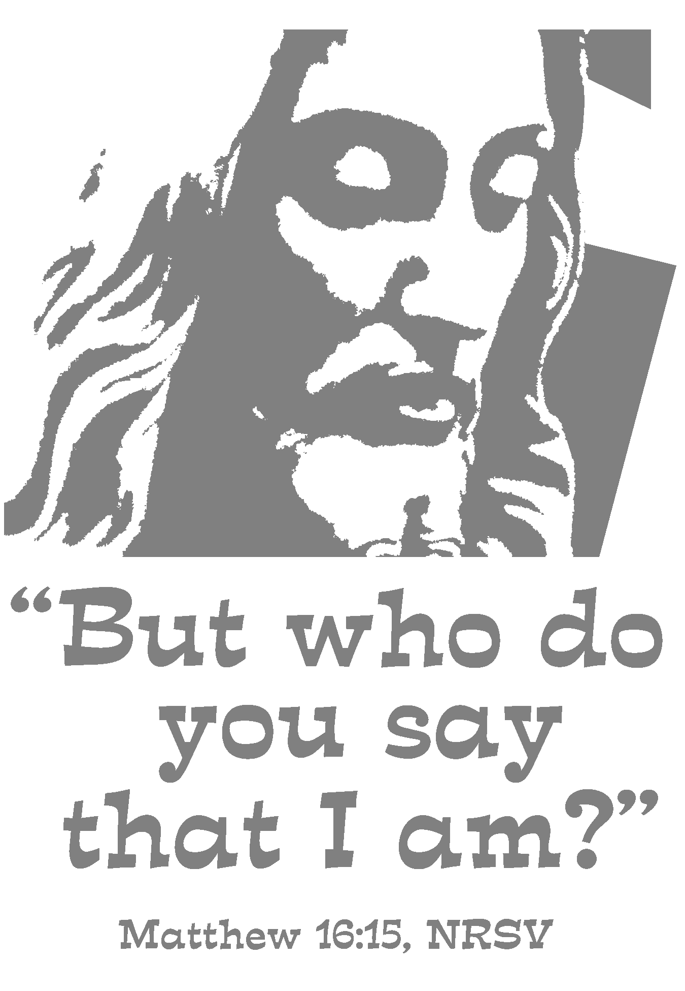

Church Office Hours: Mon. thru Fri. - 10AM to 3PM
Church Office(717-896-3118)
Web Site - ValleysEcc.Org Email - valleysecc@verizon.net

Pastor’s Hours: Mon., Tues., Thurs.; 10:00AM - 1:00PM
Office (896-3118), Cell (717-818-3041), home (717-422-5788)
Email - KOHeckard@aol.com

CHURCH CALENDAR
Aug. 31 - 9:00AM - Sunday School
10:15AM - Traditional Worship (Hymnal)
Sept. 1 - Labor Day (Holiday) - Church Office and Senior Center are closed (No Meals-on-Wheels)
Sept. 2 - 9:00AM-Noon - Halifax Senior Center open Tues-Thurs
7:00PM - Deacons
Sept. 3 - 7:00PM - (Aug.) Council Meeting
Sept. 4 - 11:30PM - Senior Citizens Meeting at Tobias Wildlife Farm
6:10PM - Zumba Gold; 7:00PM - Zumba at Valleys
Sept. 6 - 3:00-7:00PM - Wedding Reception

Sept. 7 - 9:00AM - Sunday School
10:15AM - Traditional Worship (Enders) - Food Offering and Mission Moment (Children’s Church)
Fellowship Meal/Meeting following Worship
2:00PM - Zumba at Valleys
Sept. 8 - 9:00AM-Noon - Halifax Senior Center open Tues-Thurs
10:00AM - Bible Study (Wilbur & Loretta Prouse, Leaders)
5:30PM - Prayer Team
6:00-8PM - G. S. Leaders
7:00PM - Mission Meeting
7:30PM - Summer Dartball at St. John’s (Berrysburg)
Sept. 9 - 5:30-7:00PM - “Free” Community Meal
6:00-8PM - Girl Scout Trps. 738 & 740
Sept. 10 - 6:00-8:30PM - Girl Scout Registration
Sept. 11 - 6:10PM - Zumba Gold; 7:00PM - Zumba

Pastor Kris will be on vacation Sept. 14th thru Sept. 21st.

Sept. 14 - 9:00AM - Sunday School -Rally Day
10:00-10:15AM - Learn Praise Hymns
10:15AM Blended Worship (Praise Team & Hymnal) Gideon Presentation

Monday Evenings - The follow groups meet at Valleys - Victory Group (Weight Loss) - 5:30PM; Weight Loss Challenge Group - 6:00-7:00PM

Praise Team Rehearsal - Wednesdays at 6:15PM at Gary & Sharon’s home

*PRAYER REQUESTS*
Please remember all the people on our Prayer List with prayers, thought, and cards: *(indicates new)
Members & Friends of The Valleys: Navigate Pathway; *Elmer Feidt, (Home); *Tom Hale, (Lebanon VA Hosp.); Allen Goss, (UPMC Hosp,); Melba Croutharmel; Gregg Gelnett; Cindy & Wayne Herb, (Arletta Thomas’ daughter and son-in-law).
Missions: Covenant Missionaries: Fred & Kelly Prudek; *Lisandro & Patricia Rstrepo; *Daniel & Cassidy Roach.
Our Shut Ins: Anna Portzline; Lydia Peiffer; Minnie Baker, Myra Hoffman.
Please inform Pastor Kris if you or a member of your family is in the hospital as the hospitals will not inform us unless you tell them to contact us. You may call the church office (896-3118) or Pastor Kris (818-3041).
~~~~~~~~~~~~~~~~~~~~~~~~~~~~~~~~~~~~~~~~~~~~~~~~~~~~~~~~~~~~~~

Aug. Council Meeting will be held Wed. Sept. 3 at 7:00PM. (It was postponed on Aug. 27th due to unforeseen circumstances.)

Mission meeting will be held on Mon. Sept. 8th at 7:00PM.

Halifax Senior Center hours have changed! The Center is open 9:00AM-Noon Monday thru Thursday for the summer at The Valleys E. C. C. Check the calendar on Bulletin board in narthex for list of activities. Senior Center will not collect coupons over the summer.

Giant Gift Cards available to purchase (before/after church)!
By purchasing Giant gift cards, you can help raise money for Valleys. Valleys receives $5 for every $100 Giant gift card purchased.

NO Plastic Bags: Please do not bring in any plastic bags for the Youth Group over the summer! Youth Group will resume after Labor Day on September 7th.

Church Attendance for last Sunday, Aug. 24 was 55.

