The Valleys Evangelical Covenant Church
The Rev. Kristine Heckard, Pastor
Worship Technicians: Bridget Campbell & Neva Cichy
August 23, 2015 - Blended Worship, 10:15AM

“Strong in the Word to Serve in the World”

(*Indicates all those who are able are invited to stand.)

Sing a New Song -
“The Only Name” Big Daddy Weave
“Forever” Chris Tomlin
“I Give You My Heart” Hillsong

Greetings and Announcements Diane Shaffer

* Praise Hymn (follow screen)
“The Way” Tim Hughes
* Opening Prayer
* Confession/Assurance of Pardon (follow screen)
* Profession of Faith (follow screen)

Prayer Request
Morning Prayer and Lord’s Prayer (Debts/Debtors)
Hymn - (follow screen)
“He Touched Me” Page 504

Scripture - John 6:56-69 (follow screen)
Aren Faust, Lay Reader

Meditation - “Barriers”

Our Morning Offering
Offertory - “Who Am I” Casting Crowns
Prayer of Dedication

* Closing Hymn (follow screen)
“His Name is Life” Page 114
* Commissioning
* Passing the Peace Greeting:
All who are able may greet those around them with an embrace or a handshake, accompanied by such words as:
Greeting: “The peace of God be with you.”
Response: “And also with you.”
* Post-Service Music - “Spirit Song”

Welcome: A joyous greeting to all who have come to worship. It is our hope that each of you may find encouragement, inspiration and direction for living. Above all, we pray that you may sense the loving presence of God. If you are a visitor, please take time to sign your name, address, and phone number in our guest book before you leave.

August 2015
Greeters: Jessi Faust and Matt Faust
Announcer: Diane Shaffer Acolyte: Lydia Faust.
Offering Team (Team 8): Gloria Duttry, (Captain); Arletta Thomas, Jan Quinn, Donna Novinger.
Please tell the Captain if you are unable to be there for a Sunday in your month. The Captain is responsible to get someone to help with the Offering Team if a member of the team cannot be there.

Lay Readers: Aug. 23 - Aren Faust; Aug. 30 - June Wiest; Sept. 6 - Mike Crum; Sept. 13 - Doris Hand. If you cannot read on the date assigned, please call Pastor Kris at the church (896-3118) or her home (717-422-5788).

Nursery: Valleys provides nursery care for children ages 5 and under. Aug. 23 - Theresa Miller; Aug. 30 - Marie Herb; Sept. 6 - Carol Cooper; Sept. 13 - Ann Hale. If you wish to help in the Nursery or if you cannot be there on your assigned Sunday, please see Donna Novinger.

Church School Teachers (Adults): Aug. 23 - Carol Reisch; Aug. 30 - Ed Dobbin; Sept. 6 - Ken Bechtel; Sept. 13 Rally Day - To be announced. If you cannot be there on your assigned Sunday, please inform Jessie Faust who will teach in your place.
9:00AM Sunday School Class Options:
Adult Class - Social Hall Choices - Multi-purpose Room Friends In Faith - Computer Room

Valleys Church Picnic: The Valleys will have a Church Picnic on Sunday, August 30th (following worship Service) at Matt & Jessi Faust’s home. Bring a covered dish to share (swim suit if you wish to swim) and join us in fellowship and fun! Grilled Hot dogs, hamburgers & buns, plates, cups, plastic silverware, napkins will be provided. Everyone who attends Valleys is invited.

Free Community Meal will be held at Valleys on Tuesday, September 8th from 5:30-7:00PM. Menu: Ravioli with meat sauce, Salad, Garlic Bread, Tropical Fruit, Dessert, Drinks. Please see the sign-up sheet in the narthex for donations and helpers.

Fellowship Meal: The Fellowship meal will be held on September 13th (following Blended Worship) as the first Sunday (Sept. 6) is Labor Day weekend. Please bring a covered dish to share and join us in fellowship.

Teachers Workshop: A Sunday School Teachers Workshop will be held at Valleys on Sunday, September 13th at 1:00PM.

Prayer Team will meet on Monday, September 14th at 5:30PM. No Elders Meeting in September.

Summer Dartball: Summer Dartball will be held at St. John’s Lutheran Church (Berrysburg) at 7:30PM on Monday, September 14th. We need some additional players for Valleys team! If you would like to find out what Dartball is all about, please join us. Please bring a snack to share.

FRIENDS HELPING FRIENDS . . . We are called by God to be people who care and reach out to others in the World. While we have been doing a great job in our community, there are needs at home that need to be addressed as well. Just sitting with a friend for an hour or two, running an errand, or providing transportation for doctor appointments are just a few ways that we can be a friend to a friend. If you would like to be on a team of Friends Helping Friends, please call Pastor Kris for more information.

Check out Valleys Website ValleysEcc.Org (website is still under construction). Email us your opinion of the website to Leon Shaffer at shafferlh@epix.net or valleysecc@verizon.net

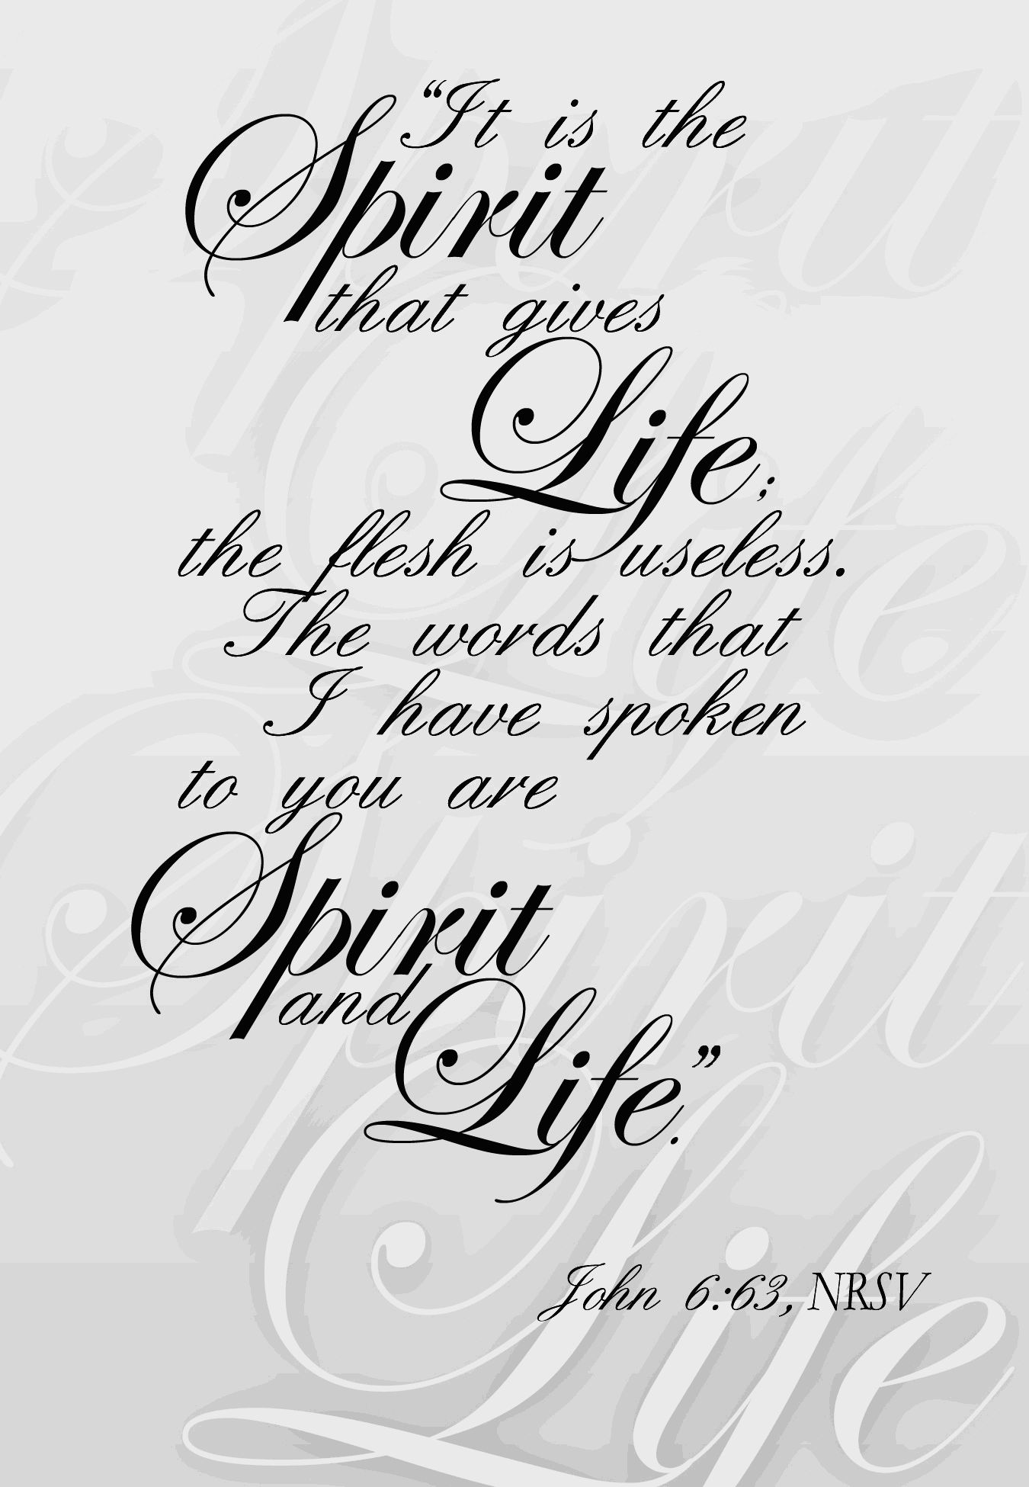

The Valleys
Evangelical Covenant Church
Halifax, PA

Church Office Hours: Mon. thru Fri. - 10AM to 3PM
Church Office(717-896-3118)
Web Site - ValleysEcc.Org Email - valleysecc@verizon.net

Pastor’s Hours: Mon., Tues., Thurs.; 10:00AM - 1:00PM
Office (896-3118), Cell (717-818-3041), home (717-422-5788)
Email - KOHeckard@aol.com

CHURCH CALENDAR
Aug. 23 - 9:00AM - Sunday School
10:00-10:15AM - Learn Praise Hymns
10:15AM - Blended Worship (Praise Team & Hymnal)
Aug. 24 - 9:00AM-Noon - Halifax Senior Center open Mon.-Thurs.
10:00AM - Bible Study (Carol Reisch)
Aug. 30 - 9:00AM - Sunday School
10:15AM - Traditional Worship (Hymnal)
Valleys Church Picnic following Worship at Matt & Jessi Faust’s home (everyone who attends Valleys is invited) - Please bring a covered dish to share.
Pastor Kris will be on vacation Mon. Aug. 31st thru Sun. Sept. 6th.
Aug. 31 - 9:00AM-Noon - Halifax Senior Center open Mon.-Thurs.
10:00AM - Bible Study (Carol Reisch)
Sept. 1 - 7:00PM - Deacons
Sept. 3 - 11:30AM - Senior Citizens will meet at Denny-Lennies
Sept. 6 - 9:00AM - Sunday School
10:15AM - Traditional Worship (Enders) - Marie Herb, Speaker, Mike Crum Worship Leader -Food Blessing
Sept. 7 - Labor Day Holiday - Senior Center and Church Office
are closed (No Elders Meeting in Sept.)
Sept. 8 - 5:30-7:00PM - Free Community Meal
Sept. 13 - 10:00AM - Pre-Music
10:15AM - Blended Worship (Praise Team & Hymnal)
Fellowship Covered Dish Meal following worship
1:00PM - Teachers Workshop
2:00PM - Zumba
Sept. 14 - 9:00AM-Noon - Halifax Senior Center open Mon.-Thurs.
10:00AM - Bible Study (Pastor Denise Haskins, Leader)
7:30PM - Summer Dartball at St. John’s Lutheran, Berrysburg (take a snack to share)
Sept. 16 - Noon-3PM - Senior Center Pinochle Card Party
7:00PM - September Council Meeting
Sept. 20 - 9:00AM - Sunday School
10:15AM - Traditional Worship (Enders
2:00PM - Zumba
6:30PM - Youth Group

Monday evenings - Victory Group (Weight Loss) - 5:30PM at Valleys
Praise Team Rehearsal - (2nd and 4th weeks at church)
*PRAYER REQUESTS*
Please remember all the people on our Prayer List with prayers, thought, and cards: *(indicates new)
*Lisa Stansfield, (friend of Ann Cooper); Hannah Klinger; Sandy & Ron Zimmerman; Jane Baker; Gary Fetterhoff; Tom Lauver; John Shoop; Allen Goss, (Select Specialty Hosp.-Camp Hill-5th Floor Rm. 521, [located inside Holy Spirit Hosp.]); Elmer Feidt; Gail Shertzer; Tom Hale.
Missions: Covenant Missionaries: Fred & Kelly Prudek;
*Stephanie & Francisco Ramos.
Our Shut Ins: Lydia Peiffer; Myra Hoffman
Please inform Pastor Kris if you or a member of your family is in the hospital as the hospitals will not inform us unless you tell them to contact us. You may call the church office (896-3118) or Pastor Kris (818-3041). ~~~~~~~~~~~~~~~~~~~~~~~~~~~~~~~~~~~~~~~~~~~~~~~~~~~~~~~~~~~~~~

Food Donations Needed: U. D. Human Services Food Bank is in desperate need of canned vegetables, peanut butter and jelly. Other items needed: soups, pastas, cake, cookie, brownie, pie (mixes); cake icing; (potatoes - sweet, mashed, boiled) (can/box); gravy (jar/can/mix); canned meats (Spam, ham, chicken, etc.) tuna, Mac & cheese; and canned fruit, or any other non-perishable food items. Please bring your donations to Valleys to be blessed on the 1st Sunday of the month.

Please turn off cell phones, pagers, etc. during our worship service. Thank you for your cooperation.

Halifax Senior Center is open 9:00AM-Noon Mon. thru Thurs. The Senior Center meets in the Multipurpose (meeting) Room. Aug. Bible Study Leader - Carol Reisch. Check the calendar on Bulletin board in narthex for list of activities. Place coupons for U. S. military families in green box in the multipurpose (meeting) room.

Giant Gift Cards available to purchase (before/after church)! By purchasing Giant gift cards, you can help raise money for Valleys. Valleys receives $5 for every $100 Giant gift card purchased.

Church Attendance for Sunday, Aug. 16 was 52.

