The Valleys Evangelical Covenant Church
The Rev. Kristine Heckard, Pastor
Choir Director, Ed Dobbin
Organist, Mark Enders
Acolyte, Brooke Croutharmel
August 17, 2014
“Strong in the Word to Serve in the World”

(*Indicates all those who are able are invited to stand.)

Chimes
Greetings and Announcements
* Call To Worship Diane Shaffer
L: Thankful for God’s presence with us, knowing that God loves us and cares for us,
P: believing in the power of prayer, and anticipating that we will be strengthened for the challenge of the week ahead,
ALL: let us worship the Lord our God.
L: Come, let us worship God!

Prelude - “All the Way My Savoir Leads Me” by Tom Birchwood
* Opening Hymn - “Lavish Love, Abundant Beauty” Pg. 61 * Prayer of Invocation
* Confession: (In Unison)
O Christ, to whom all authority is given both in heaven and earth: transform our wills and our understanding, cleanse our hearts and enlighten our minds, that our thoughts and desires being made obedient to your pure and holy law, we may grow up in all things unto you, and present ourselves a living sacrifice, to the praise and glory of your hold name. Amen.
* Kyrie: (To Be Sung responsively)
Leader/People: Lord, have mercy upon us.
Leader/People: Christ, have mercy upon us.
Leader/People: Lord, have mercy upon us.
* Assurance of Pardon
* Gloria Patri Pg. 623

* Profession of Faith - (In Unison)
We believe that God is our Father and all His children are our sisters and brothers - to be loved, cared for, and forgiven.
We believe in the life of sacrifice, humility and compassion which Jesus both taught and lived.
We believe that if we trust in Him, and accept His atoning death for our sins, our life is eternal and our destiny is in Heaven.
We believe in the Holy Spirit of God, present with us always, inspiring us to walk the pathway of goodness, truth and light. Amen.
Children’s Sermon
Hymn of Preparation - Pg. 528
“No One Ever Cared for Me Like Jesus”
Prayer cards will be collected during the 2nd hymn.
Our Morning Prayer
Choral Response - “Hear Our Prayer O Lord” Pg. 614

Scripture - Matt Faust, Lay Reader
Matthew 15:21-29 (Found on Pg. 22 of NT Pew Bible)

Sermon - “Jesus Loves Me”

Our Morning Offering
Offertory - “Pray for Unity” by Kevin Kell
* Offertory Response - “We Give Thee But Thine Own” Pg. 620
* Prayer of Dedication
* Closing Hymn - “O, How He Loves You and Me” Pg. 284

* Benediction/Threefold Amen/Extinguishing of the Candles
* Passing the Peace Greeting: All may greet those around them with an embrace or a handshake, accompanied by such words as:
Greeting: “The peace of God be with you.”
Response: “And also with you.”
* Postlude - “Postlude in Folk-Hymn Style” by Lani Smith

Welcome: Welcome Brothers and sisters in Christ, we come together as family to worship If you are a visitor, please take time to sign your name, address, and phone number in our guest book before you leave.

Our beautiful Altar Flowers are presented to the glory of God by Tom & Ann Hale in honor of their 12th Wedding Anniversary on August 16th.

August Greeters: Donna Motter and Jessi Faust.
Announcer: Diane Shaffer. Acolyte: Brooke Croutharmel.
August Offering Team: Gloria Duttry, (Captain), Arletta Thomas, Jan Shoop, To be announced.
Please tell the Captain if you are unable to be there for a Sunday in your month. The Captain is responsible to get someone to help with the Offering Team if a member of the team cannot be there.

Lay Readers: Aug. 17 - Matt Faust; Aug. 24 -Aren Faust; Aug. 31 - June Wiest; Sept. 7 - Mike Crum. If you cannot read on the date assigned, please call Pastor Kris at the church (896-3118) or her home (717-422-5788).
Nursery: Valleys provides nursery care for children ages 5 and under. Aug. 17 - Donna Novinger; Aug. 24 - Neva Cichy; Aug. 31 - Brandi Crum; Sept, 7 - Carol Cooper. If you wish to help in the Nursery or if you cannot be there on your assigned Sunday, please see Donna Novinger.
Church School Teachers (Adults): Aug. 17 -Ken Bechtel II; Aug. 24 - Bob Endy; Aug. 31 - Donna Novinger; Sept. 7 - Carol Reisch. If you cannot be there on your assigned Sunday, please inform Dave Novinger or Jessie Faust who will teach in your place.

Council Meeting is on Wed., Aug. 20th at 7:00PM

Halifax Senior Center hours have changed! The Center is open 9:00AM-Noon Monday thru Thursday for the summer at The Valleys E. C. C. Check the calendar on Bulletin board in narthex for list of activities. Senior Center is not collecting coupons over the summer. Pinochle Card Party on Aug. 20th Noon -3:00PM.

Blessing of the Back Packs will be held at Valleys during Blended Worship on Sunday, August 24th.

Fun Day Carnival: Next Sunday, August 25 during the 9:00AM Sunday School hour there will be a “Fun Day Carnival” for kids of all ages! There will be games and some special surprises! Bring your backpacks!

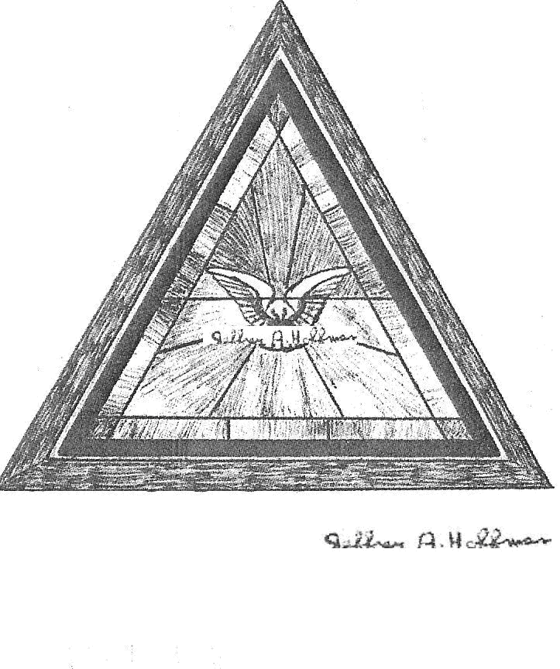
The Valleys
Evangelical Covenant Church
Halifax, PA

Church Office Hours: Mon. thru Fri. - 10AM to 3PM
Church Office(717-896-3118)
Web Site - ValleysEcc.Org Email - valleysecc@verizon.net

Pastor’s Hours: Mon., Tues., Thurs.; 10:00AM - 1:00PM
Office (896-3118), Cell (717-818-3041), home (717-422-5788)
Email - KOHeckard@aol.com

CHURCH CALENDAR
Aug. 17 - 9:00AM - Sunday School
10:15AM - Traditional Worship (Enders)
Aug. 18 - 9:00AM-Noon - Halifax Senior Center open Mon-Thurs
10:00AM - Bible Study (Pastor Denise Haskins, Leader)
Aug. 20 - Noon-3:00PM - Senior Center Pinochle Card Party
7:00PM - Council Meeting

Aug. 24 - 9:00-9:50AM - Sunday School - “Fun Day Carnival” for the children and youth
10:00-10:15AM - Learn Praise Hymns
10:15AM - Blended Worship (Praise Team & Hymnal) - Mission Offering (goes to Back-to-School Program) -
Blessing of the Back Packs
Aug. 25 - 9:00AM-Noon - Halifax Senior Center open Mon-Thurs
10:00AM - Bible Study (Pastor Denise Haskins, Leader)

Aug. 31 - 9:00AM - Sunday School
10:15AM - Traditional Worship (Hymnal)
Sept. 1 - Labor Day (Holiday) - Church Office and Senior Center are closed (No Meals-on-Wheels)
Sept. 2 - 9:00AM-Noon - Halifax Senior Center open Tues-Thurs
7:00PM - Deacons
Sept. 4 - 11:30PM - Senior Citizens Meeting at Tobias Animal Farm
6:10PM - Zumba Gold; 7:00PM - Zumba at Valleys
Sept. 6 - 3:00-7:00PM - Wedding Reception

Sept. 7 - 9:00AM - Sunday School
10:15AM - Traditional Worship (Enders) - Food Offering and Mission Moment (Children’s Church)
Fellowship Meal/Meeting following Worship
2:00PM - Zumba at Valleys

Newsletter articles are due August 15th for Sept./Oct. Newsletter!

The following groups meet at Valleys - Monday - Victory Group (Weight Loss) - 5:30PM; Tuesdays - Weight Loss Challenge Group - 5:30-7:00PM

Praise Team Rehearsal - Wednesdays at 6:15PM at Gary & Sharon’s home

Church Attendance for last Sunday, Aug. 10th was 53.
*PRAYER REQUESTS* *(indicates new)
Please remember all the people on our Prayer List with prayers, thoughts, cards: Members & Friends of The Valleys: Navigate Pathway;
*Tim Miller, (Jan (Shoop) Quinn’s brother); *John Haine; *Charlotte Gingrich; Allen Goss, (UMPC Presby. Hosp,); Elmer Feidt (Stonebridge Health & Rehab Center Rm. 44); Melba Croutharmel; Gregg Gelnett; Cindy & Wayne Herb, (Arletta Thomas’ daughter and son-in-law); Brenda Pellman.
Missions: Covenant Missionaries: *Fred & Kelly Prudek; *Robert & Nancy Reed; *Leonid & Leanna Regheta
Our Shut Ins: Minnie Baker; Anna Portzline; Lydia Peiffer; Myra Hoffman.
Please inform Pastor Kris if you or a member of your family is in the hospital as the hospitals will not inform us unless you tell them to contact us. You may call the church office (896-3118) or Pastor Kris (818-3041).
______________________________________________________________________________
~~~~~~~~~~~~~~~~~~~~~~~~~~~~~~~~~~~~~~~~~
Pig Roast: The Valleys will host a Pig Roast on Saturday, September 27th from 4:00 - 6:00PM. Ticket Donation: $10.00, Ages 4-12: $5.00, Ages 3 and under “FREE” . Please contact the church office (896-3118) for information or tickets.
~~~~~~~~~~~~~~~~~~~~~~~~~~~~~~~~~~~~~~~~~

Thank you to the Community and Members of The Valleys who donated their time, monetary donations, school supplies, clothing donations, and the use of clothing racks for the Back-to-School Yard Sale/First Day, Fresh Impressions!
We asked for help and The Valleys congregation and our Community responded with love ! We couldn’t have done it without everyone’s help!
________________________________________________________________________
Giant Gift Cards available to purchase (before/after church)!
By purchasing Giant gift cards, you can help raise money for Valleys. Valleys receives $5 for every $100 Giant gift card purchased.

NO Plastic Bags: Please do not bring in any plastic bags for the Youth Group over the summer!

Please turn off cell phones, pagers, etc. during our worship service. Thank you for your cooperation.

