The Valleys Evangelical Covenant Church
The Rev. Kristine Heckard, Pastor
Choir Director, Ed Dobbin
Organist, Mark Enders
Acolyte, Lydia Faust
August 16, 2015
“Strong in the Word to Serve in the World”

(*Indicates all those who are able are invited to stand.)

Chimes
Greetings and Announcements
* Call To Worship Diane Shaffer
L: With all my heart I will thank the Lord.
P: How wonderful are the things the Lord does!
L: The Lord is full of honor and majesty; his righteousness is eternal.
P: In all he does he is faithful and just; all his commands are dependable.
L: Come, let us worship together!

Prelude - “Sweeter As the Years Go By” by Thygerson

* Opening Hymn - “Immortal, Invisible” Pg. 25
* Prayer of Invocation
* Confession: (In Unison)
Heavenly, Father, we have wasted a great deal of time when we should have been serving you. We are not lazy, just thoughtless and irresponsible. Lord, grant us the wisdom we need, to know your will and to do it. Amen.
* Kyrie: (To Be Sung responsively)
Leader/People: Lord, have mercy upon us.
Leader/People: Christ, have mercy upon us.
Leader/People: Lord, have mercy upon us.
* Assurance of Pardon
* Gloria Patri Pg. 623

* Profession of Faith - (In Unison)
We believe in God the creator of all, known to us through perfect love, who has called forth a people of faith. We believe in Jesus Christ, the Word become flesh, crucified and resurrected, our savior from sin, our peace, and Lord of the Church. We believe in the Holy Spirit, poured out on all believers, our source of inspiration and power. We respond to Christ in faith as the church, the community sustained by the Spirit, called to proclaim and witness to the kingdom of God. We accept God’s call to live in the Spirit as faithful disciples, practicing purity, stewardship, justice and peace, and loving friend and enemy. We believe in God’s everlasting reign, in victory over evil, in the resurrection of the dead, in Christ’s coming again in judgment and glory. To God be praise forever and ever. Amen!
Children’s Sermon
Hymn of Preparation - “Spirit of the Living God” Pg. 247
Prayer cards will be collected during the 2nd hymn.
Our Morning Prayer
Choral Response - “Hear Our Prayer O Lord” Pg. 614

Special Music - “How Great Thou Art” Jackie Lutz

Scripture - Ephesians 5:15-20 Matt Faust, Lay Reader (Found on Pg. 263 of NT Pew Bible)
Sermon - “Careful Considerations”

Our Morning Offering
Offertory - “People Need the Lord” Jackie Lutz
* Offertory Response - “We Give Thee But Thine Own” Pg. 620
* Prayer of Dedication
* Closing Hymn - “Be Thou My vision” Pg. 382
* Benediction/Threefold Amen/Extinguishing of the Candles

* Passing the Peace Greeting: All may greet those around them with an embrace or a handshake, accompanied by such words as:
Greeting: “The peace of God be with you.”
Response: “And also with you.”
* Postlude - “Peace I Leave With You” by David Haas
Welcome: On this summer day, we welcome you to worship. Let us join our hearts and voices in praise and thanks to God! If you are a visitor, please take time to sign your name, address, and phone number in our guest book before you leave.

Our Beautiful Altar Flowers are presented to the glory of God by Ann and Tom Hale in honor of their 13th Wedding Anniversary, which is today.

Special Music: We welcome and thank Jackie Lutz for sharing her talent and providing us with special music this morning. Sunday, Aug. 30 Special Music: Josh and Lora Kobel.

August 2015
Greeters: Jessi Faust and Matt Faust
Announcer: Diane Shaffer Acolyte: Lydia Faust.
Offering Team (Team 8): Gloria Duttry, (Captain); Arletta Thomas, Jan Quinn, Donna Novinger.
Please tell the Captain if you are unable to be there for a Sunday in your month. The Captain is responsible to get someone to help with the Offering Team if a member of the team cannot be there.

Lay Readers: Aug. 16 - Matt Faust; Aug. 23 - Aren Faust; Aug. 30 - June Wiest; Sept. 6 - Mike Crum. If you cannot read on the date assigned, please call Pastor Kris at the church (896-3118) or her home (717-422-5788).

Nursery: Valleys provides nursery care for children ages 5 and under. Aug. 16 - Donna Novinger; Aug. 23 - Theresa Miller; Aug. 30 - Marie Herb; Sept. 6 - Carol Cooper, If you wish to help in the Nursery or if you cannot be there on your assigned Sunday, please see Donna Novinger.

Sunday School Teachers (Adults): Aug. 16 - Sharon Fetterhoff; Aug. 23 - Carol Reisch; Aug. 30 - Ed Dobbin; Sept. 6 - Ken Bechtel. If you cannot be there on your assigned Sunday, please inform Jessie Faust who will be teaching in your place.
9:00AM Sunday School Class Options:
Adult Class - Social Hall Friends In Faith - Computer Room
Choices - Multi-purpose Room

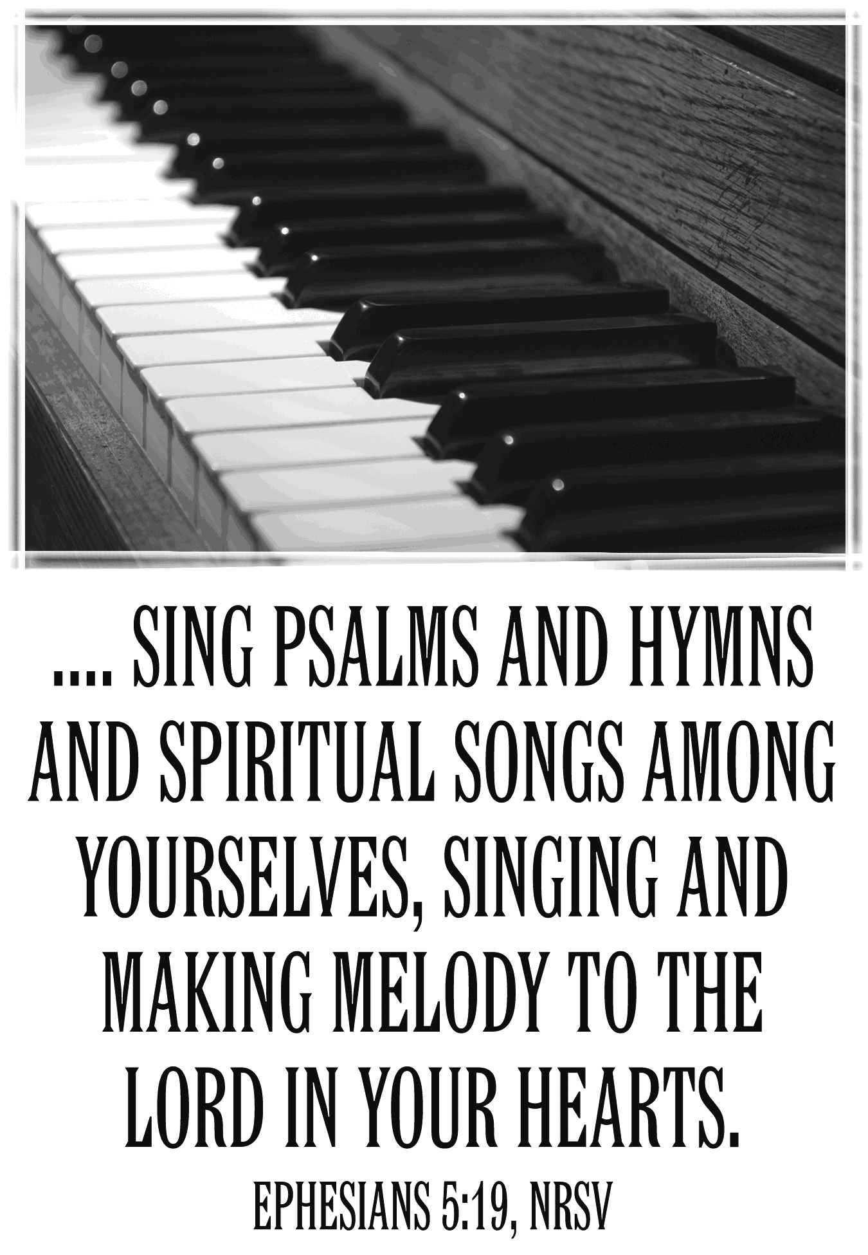

The Valleys
Evangelical Covenant Church
Halifax, PA

Church Office Hours: Mon. thru Fri. - 10AM to 3PM
Church Office(717-896-3118)
Web Site - ValleysEcc.Org Email - valleysecc@verizon.net

Pastor’s Hours: Mon., Tues., Thurs.; 10:00AM - 1:00PM
Office (896-3118), Cell (717-818-3041), home (717-422-5788)
Email - KOHeckard@aol.com

CHURCH CALENDAR
Aug. 16 - 9:00AM - Sunday School
10:15AM - Traditional Worship (Enders)
Aug. 17 - 9:00AM-Noon - Halifax Senior Center open Mon.-Thurs.
10:00AM - Bible Study (Carol Reisch)
Aug. 19 - Noon-3PM - Senior Center Pinochle Card Party
7:00PM - August Council Meeting
Aug. 21 - 10:00AM-7:00PM - Free Back-to-School Yard Sale
Aug. 22 - 10:00AM-2:00PM - Free Back-to-School Yard Sale
Aug. 23 - 9:00AM - Sunday School
10:00-10:15AM - Learn Praise Hymns
10:15AM - Blended Worship (Praise Team & Hymnal)
Aug. 24 - 9:00AM-Noon - Halifax Senior Center open Mon.-Thurs.
10:00AM - Bible Study (Carol Reisch)
Aug. 26 - 7:00PM - Pastoral Search Committee Meeting
Aug. 30 - 9:00AM - Sunday School
10:15AM - Traditional Worship (Hymnal)
Valleys Church Picnic following Worship at Matt & Jessi Faust’s home (everyone who attends Valleys is invited) - Please bring a covered dish to share.

Pastor Kris will be on vacation Mon. Aug. 31st thru Sun. Sept. 6th.

Aug. 31 - 9:00AM-Noon - Halifax Senior Center open Mon.-Thurs.
10:00AM - Bible Study (Carol Reisch)
Sept. 1 - 7:00PM - Deacons
Sept. 6 - 9:00AM - Sunday School
10:15AM - Traditional Worship (Enders) - Marie Herb, Lay Speaker -Blessing of Food
Sept. 7 - Labor Day Holiday - Senior Center and Church Office
are closed (No Elders Meeting in Sept.) (Prayer Team will meet on September 14 at 5:30PM due to Holiday)
Sept. 8 - 5:30-7:00PM - Free Community Meal
Sept. 13 - 10:00AM - Pre-Music
10:15AM - Blended Worship (Praise Team & Hymnal)
1:00PM - Teachers Workshop
10:15AM - Blended Worship (Praise Team & Hymnal)

Monday evenings - Victory Group (Weight Loss) - 5:30PM at Valleys
Praise Team Rehearsal - (2nd and 4th weeks at church)

*PRAYER REQUESTS* *(indicates new)
Please remember all the people on our Prayer List with prayers, thoughts, cards: Members & Friends of The Valleys: Navigate Pathway;
*Matt Etzweiler, (son of Dean & Lisa); Tom Lauver; Gary Fetterhoff; John Shoop; Jane Baker; Allen Goss, (Select Specialty Hosp.-Camp Hill-5th Floor Rm. 521, [located inside Holy Spirit Hosp.]); Elmer Feidt; Ron & Sandy Zimmerman; Gail Shertzer; Tom Hale; Etta & Bob Miller.
Missions: Covenant Missionaries: Fred & Kelly Prudek.
Our Shut Ins: Lydia Peiffer; Myra Hoffman
Please inform Pastor Kris if you or a member of your family is in the hospital as the hospitals will not inform us unless you tell them to contact us. You may call the church office (896-3118) or Pastor Kris (818-3041).
______________________________________________________________________________

Please turn off cell phones, pagers, etc. during our worship service. Thank you for your cooperation.

Church Attendance for last Sunday, July 12th was 50.

Check out Valleys Website ValleysEcc.Org (website is still under construction). Email us your opinion of the website to Leon Shaffer at shafferlh@epix.net or valleysecc@verizon.net

Newsletter articles for Sept./Oct. newsletter must be given to church secretary by Tuesday August 18th!

Free” Back-to-School Yard Sale is Friday August 21st (10:00AM to 7:00PM) and Saturday, August 22nd (10:00AM to 2:00PM) at The Valleys. Donations of clean, gently used clothing (or new) for ages Kindergarten thru 12th grade, Baby and adult clothing is also being accepted. School supplies still needed: (rulers, markers (Sharpie) & highlighters (various colors); pens; colored pencils; vinyl protractor (no compass), pencil bag or box, and tissues. At this time we do have enough book bags, notebooks, regular pencils & crayons. Anyone who wishes to help at the yard sale, please see Ed Dobbin or call the church office (896-3118).
We are also accepting checks (to The Valleys ECC) or monetary donations. Please earmark any checks or monetary donations “Back-to-School Program” or “First Day Fresh Impressions” - you may sponsor a child for a ($50 donation or any donation).
Church Picnic: The Valleys will have a Church Picnic on Sunday, August 30th (following worship Service) at Matt & Jessi Faust’s home. Bring a covered dish to share (swim suit if you wish to swim) and join us in fellowship and fun! Plates, cups, plastic silverware, napkins will be provided by the church. Everyone who attends Valleys is invited.

Food Donations Needed: U. D. Human Services Food Bank is still in desperate need of canned vegetables, peanut butter and jelly. Other items needed: soups, pastas, cake, cookie, brownie, pie (mixes); cake icing; (potatoes - sweet, mashed, boiled) (can/box); gravy (jar/can/mix); canned meats (Spam, ham, chicken, etc.) tuna, Mac & cheese; and canned fruit, or any other non-perishable food items.
Please bring your donations to Valleys to be blessed on the 1st Sunday of the month.

Guess the Bride and Groom!
It is time again for summer weddings and they call to mind our own weddings. Let us walk together back through time and remember those weddings of yesterday. We invite you to bring a wedding photo to share on the board in the narthex and let us guess the Bride and Groom. Have you guessed all the Brides and Grooms?

Halifax Senior Center open 9:00AM-Noon Mon. thru Thurs. Check the calendar on Bulletin board in narthex for list of activities. Aug. Bible Study Leader - Carol Reisch. Pinochle Card Party on Wed., Aug. 19th from Noon to 3:00PM. Place coupons for U. S. military families in the green box in the multipurpose (meeting) room.

Devotionals: Pick up a Free copy of “Our Daily Bread” (June, July, August, Sept., Oct., Nov. copy will be available next week) devotional as you come into the church narthex and also at the sanctuary door. “These Days” devotional ($5 yearly subscription) is also available.

Giant Gift Cards available to purchase (before/after church)!
By purchasing Giant gift cards, you can help raise money for Valleys. Valleys receives $5 per each $100 Giant gift card purchased.

