The Valleys Evangelical Covenant Church
The Rev. Kristine Heckard, Pastor
Choir Director, Ed Dobbin
Organist & Pianist, Mark & Joanne Enders
Acolyte, Lydia Faust
July 21, 2013
Ninth Sunday After Pentecost

(*Indicates all those who are able are invited to stand.)

Chimes
Greetings and Announcements
* Call To Worship Dave Novinger
L: We come together to worship, laying aside the burdens of this world.
P: And we set aside the pressures of daily life so that we may worship God.
L: We let go of our personal goals to be perfect and accept God’s love.
P: We give up all that we are so that we might truly know life in Christ.
L: Let us celebrate and give praise for the true life God has given us.
All: Blessed be the name of the Lord!
L: Come, let us worship God!
Prelude - “ Prelude on Haven of Rest“ by James Pethel
* Praise Hymn - “Come, All Christians, Be Committed“ Pg. 455
* Prayer of Invocation
* Call to Confession
* Confession: (In Unison )
Lord, so many times we have sought to earn Your acceptance and failed to accept Your grace and mercy. We have tried to do all the “right” things, and failed to love and care for each other or even ourselves. Forgive us, Lord, and give us the courage and the strength to accept Your unmerited love and grace and to share them with others. In Christ we pray. Amen.
* Kyrie: (To Be Sung)
Leader: Lord, have mercy upon us.
People: Lord, have mercy upon us.
Leader: Christ, have mercy upon us.
People: Christ, have mercy upon us.
Leader: Lord, have mercy upon us.
People: Lord, have mercy upon us.
* Assurance of Pardon
* Gloria Patri Pg. 623
* Profession of Faith - (In Unison)
We believe in the Fatherhood of God, and the Brotherhood of humankind; We believe that Christ is the Way, the Truth, and the Life. We believe in the life of sacrifice, humility, and compassion, which Jesus both taught and lived. We accept His Spirit and His example as the model for our lives, and dedicate ourselves to the completion of His kingdom on earth. Amen.
Children’s Sermon - Invitation to Bible School
(Neva Cichy & Rachael Bryson)
Hymn of Preparation - Pg. 451
“O Master, Let Me Walk With Thee”
Prayer cards will be collected during the 2nd hymn.
Our Morning Prayer
Choral Response - “Hear Our Prayer O Lord” Pg. 614
Special Music - David Layser and Amanda Baker

Scripture - Luke 10:38-42
(Found on Pg. 97 of NT Pew Bible)
Sermon - “Martha, The Good, The Bad, and the Ugly”

Our Morning Offering
Offertory - “Adagio” by Felix Mendelssohn
* Offertory Response - “We Give Thee But Thine Own” Pg. 620
* Prayer of Dedication
* Closing Hymn - “Living for Jesus” Pg. 372
* Benediction
* Threefold Amen
* Extinguishing of the Candles
* Passing the Peace Greeting: All may greet those around them with an embrace or a handshake, accompanied by such words as:
Greeting: “The peace of God be with you.”
Response: “And also with you.”
* Postlude - “Postlude in Folk-Hymn Style” by Lani Smith

Welcome: We welcome you to The Valleys as we gather for this time of worship and reflection on God's love for his people. May God inspire and bless our hearts and lives today. If you are a visitor, please take time to sign your name, address, and phone number in our guest book before you leave.

Special Music: We welcome and thank David Layser and Amanda Baker for sharing their talents with us during our worship service this morning.

Next Week’s Scripture Lesson: Luke 11:1-13

July Greeters: Tom Hale and Ed Dobbin. Announcer: Dave Novinger. Acolyte: Lydia Faust. July Offering Team: Tom Hale, Pete Bryson, Charles Shertzer, Dave Novinger.

Scripture Readers: July 21 - Pastor Kris; July 28 - Pete Bryson; Aug. 4 - Tom Lauver; Aug. 11 - Aaron Herb. If you cannot read on the date assigned, please call Pastor Kris at the church (896-3118) or her home (717-422-5788).

Nursery: Valleys provides nursery care for children ages 5 and under. July 21 - Marie Herb; July 28 - Shirley Miller; Aug 4 - Tracey Cooper; Aug. 11 - Donna Novinger. We can still use more Nursery attendants! If you wish to help in the Nursery or if you cannot be there on your assigned Sunday, please see Donna Novinger.

Church School Teachers (Adults): July 21 - Ed Dobbin; July 28 -Donna Novinger; Aug. 4 - Jessi Faust; Aug. 11 - Carol Reisch. If you cannot teach on your assigned Sunday, please inform Dave Novinger or Jessie Faust who will teach in your place.

Please turn off cell phones, pagers, etc. during our worship service. Thank you for your cooperation.

VALLEYS SUMMER CHURCH BEGINS AT 10:00AM JUNE THRU LABOR DAY!

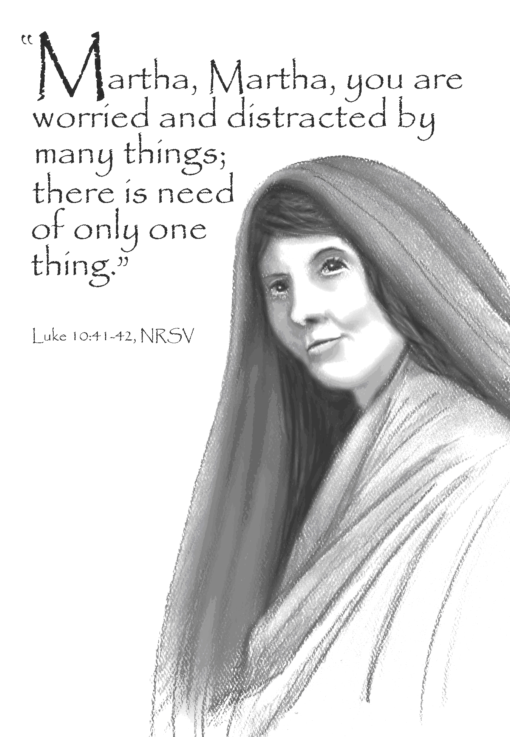

The Valleys
Evangelical Covenant Church
Halifax, PA

Church Office Hours: Mon. thru Fri. - 10AM to 3PM
Church Office(717-896-3118)
Web Site & Email - http://valleysecc.org valleysecc@verizon.net

Pastor’s Hours: Mon., Tues., Thurs.; 10:00AM - 1:00PM
Office (896-3118), Cell (717-818-3041), home (717-422-5788)
Email - KOHeckard@aol.com

CHURCH CALENDAR
July 21 - 9:00AM - Sunday School
10:00AM -Traditional Worship
2:00-3:00PM - Zumba 3:15-4:00PM - Zumba Gold
July 22 - 9:00AM-1:00PM - Halifax Senior Center open Mon-Fri
10:00AM - Bible Study
July 27 - 9:00AM-2:00PM - One Day Bible School - lunch and snacks will be served
July 28 - 9:00AM - Sunday School
10:00AM - Traditional Worship Mission Offering - (Christmas Fund, Special Needs)
2:00-3:00PM - Zumba 3:15-4:00PM - Zumba Gold
July 29 - 9:00AM-1:00PM - Halifax Senior Center open Mon-Fri
10:00AM - Bible Study
Aug. 1 - 12:00Noon - Senior Citizens - covered dish meal & Bingo
Aug. 3 - 7:00AM -Trim shrubbery in front of church
Aug. 4 - 9:00AM - Sunday School
10:00AM - Traditional Worship-Food Offering and Mission Moment (will focus on Pilgrim Pines Camp)
Fellowship Covered Dish Meal - Please bring a meat or vegetable dish and a dessert to share
2:00-3:00PM - Zumba 3:15-4:00PM - Zumba Gold
Aug. 5 - 9:00AM-1:00PM - Halifax Senior Center open Mon-Fri
10:00AM - Bible Study
5:30PM - Prayer Team
700PM - Strategic Planning Committee
Aug. 6 - 7:00PM - Deacons
Aug. 11 - 9:00AM - Sunday School
10:00AM -Modified Worship
2:00-3:00PM - Zumba 3:15-4:00PM - Zumba Gold
9:00AM-1:00PM - Halifax Senior Center open Mon-Fri
10:00AM - Bible Study
7:00PM - Elders
9:00AM - Community Circle of Prayer - Zion-Stone U
Aug. 18 - 9:00AM - Sunday School
10:00AM -Traditional Worship
2:00-3:00PM - Zumba 3:15-4:00PM - Zumba Gold

No Children’s Church or Youth Group in August
Giant Gift Cards available to purchase (before/after church)!
*PRAYER REQUESTS* *(indicates new)
Please remember all the people on our Prayer List with prayers, thought, and cards: Members & Friends of The Valleys: Navigate Pathway; *Will Tucci, (Harrisburg Hosp. Rm. 400, Allison [Goss] Tucci’s husband); Dennis Leitzel; Aaron Herb; Allen Goss; Elvin Lebo; Melba Croutharmel; Pauline Novinger; Nancy Groff; Glen Jones; Etta & Robert Miller; Baby Elaina Parker; Gregg Gelnett; Carley Enders; Nevin Maurer; Margie Zeigler, (Frey Village).
Missions: Covenant Missionaries: Fred & Kelly Prudek; *Eric & Heidi Krumland; *Andy & Carol Larsen; Covenant Churches & Victims & Families of Tornado in Oklahoma City;
Our Shut Ins: Minnie Baker; Anna Portzline; Lydia Peiffer;
Military: Cameron Heddings, (grandson of Bonita Heddings is stationed in Afghanistan). Wesley Eshleman, (grandson of Betty Eshleman, stationed in Kuwait).
Please inform Pastor Kris if you or a member of your family is in the hospital as the hospitals will not inform us unless you tell them to contact us. You may call the church office (896-3118) or Pastor Kris (818-3041).

Mission Meeting will be held on Wednesday, July 24 at 7:00PM.
Special Music: Next Sun., July 28 Brad Crum will share his talent with us.
Trim Shrubbery: The shrubbery will be trimmed in front of the church on Saturday, August 3rd beginning at 7:00AM. Please see Tom Hale or Charlie Shertzer if you wish to help. Please bring trimmers, etc.

VACATION BIBLE SCHOOL: Bible School will be a one day event held on Saturday, July 27 9:00AM to 2:00PM and is called “HayDay - Growing in Friendship with Jesus”. Helpers are needed for crafts, games, serving snacks. If you would like to help, please see Marie Herb. Sign up before or after church. Snacks are needed for lunch and snack time (hot dogs, buns, fruits, veggies, finger-foods. Items needed for Bible School: a cowbell, buttons-various size & colors, craft sticks, Terra Cotta pots (small size - 6 inch), sponges, potting soil (big bag). Please see Marie or the sign up sheet on the bulletin board, if you can donate any of these items.
Church Attendance for July 14, 2013 was 73.
FREE Back-to-School Yard Sale Thursday, August 15th, Friday August 16th and Saturday, August 17th 10:00AM to 2:00PM will be held at The Valleys ECC. We are asking for gently used clothing for ages Kindergarten thru 12th grade, school supplies (see list below), Wal-Mart gift cards and Smart Style Hair Salon gift cards, monetary donations, and volunteers. Please place clothing & school supplies in box in narthex, place monetary donations and gift cards in offering plate. Volunteers are needed to help sort clothing.

Blessing of the Backpacks: Blessing of the Backpacks will be held at The Valleys on Sunday, August 25 during 10:00AM Traditional Worship. We are asking for donations of the following items for the backpacks: crayons, colored pencils, regular pencils, cap erasers (to fit on pencils), rulers, vinyl protractor (no compass), tablets, pencil bag or pouch or box, tissues for Kindergarten thru 12 grade students. (Check the Staples, Office Max and Wal-Mart ads each week for specials on school supplies!)
School supply donations will be divided as needed between FREE Back-to-School Yard Sale and Blessing of the Backpacks.

Halifax Senior Center is open Monday thru Friday, 9:00AM to 1:00PM at The Valleys E. C. C. See Ann Hale or Barbara Lauver if you wish to eat at the Senior Center (meals must be ordered in advance). See the Senior Center calendar (on bulletin board in narthex) for list of activities.
Senior Center Activities
Pinochle Card Party is held at the Halifax Senior Center on the third Wednesday of the month from 1:00PM to 4:00PM.
AARP Driving Classes will be held for two consecutive Thursdays - August 22 and 29 9:00AM to 1:00 PM. Please see Ann Hale to register for the AARP Driving Classes.

Grocery Coupons for Overseas U. S. Military Families: Stop tossing those expired grocery coupons in the trash! The Senior Center is collecting grocery coupons for U. S. military families stationed overseas (they are able to use the on base for up to SIX MONTHS after the manufacturer’s expiration date). Only manufacturer’s coupons are accepted, no local or internet coupons accepted. You may cut them out (but it’s not required). Bring them in and place them in the box in the narthex.

