The Valleys Evangelical Covenant Church
The Rev. Kristine Heckard, Pastor
Choir Director, Ed Dobbin
Hymnal Technician, Aren Faust
Acolyte, Christopher Maichle
June 9, 2013
Third Sunday after Pentecost

(*Indicates all those who are able are invited to stand.)

Chimes
* Passing the Peace Greeting:
All who are able may greet those around them with an embrace or a handshake, accompanied by such words as:
Greeting: “The peace of God be with you.”
Response: “And also with you.”
Greetings and Announcements

* Call To Worship - Peggy Berra
L: Come, let all whose faith is in Christ gather now for worship!
P: We begin each day only by God’s wonderful mercy and grace.
L: And our labors are dedicated to the Lord, who has saved us from sin.
P: We come to the end of each day with the Lord, who has walked with us.
L; We have true life and joy only in Christ and the love of our God..
ALL: Blessed be the name of the Lord!
L: Come, let us worship God!

Prelude - “Tell Out My Soul of Greatness to the Lord”
* Opening Hymn - “The Family of God” Pg. 282
(Sing Twice)
* Prayer of Invocation
* Call to Confession
* Confession: (In Unison)
Lord, it has often been difficult for us to move beyond what we can see and touch and to step out in faith to be about the things You would have us do in Your Name. Too often, Lord, we allow ourselves to be enchanted by the comforts of life, as we fail to remember that we must walk in faith to know Your eternity. Forgive us, Lord, and call us again to serve You. In Christ we pray. Amen.
* Kyrie: (To Be Sung)
Leader: Lord, have mercy upon us.
People: Lord, have mercy upon us.
Leader: Christ, have mercy upon us.
People: Christ, have mercy upon us.
Leader: Lord, have mercy upon us.
People: Lord, have mercy upon us.
* Assurance of Pardon
* Gloria Patri Pg.623
* Profession of Faith: (In Unison)
I believe in God, the Father Almighty, maker of heaven and earth;
I believe in Jesus Christ, His only Son, our Lord; He was conceived by the power of the Holy Spirit and born of the Virgin Mary. He suffered under Pontius Pilate, was crucified, died, and was buried; He descended to the dead. On the third day He rose again. He ascended into heaven, and is seated at the right hand of the Father. He will come again to judge the living and the dead.
I believe in the Holy Spirit, the holy Christian Church, the communion of the Saints, the forgiveness of sins, the resurrection of the body; and the life everlasting. Amen.
Hymn of Preparation - “Jesus Paid It All” Pg. 210
Prayer cards will be collected during Second Hymn.
Morning Prayer & The Lord’s Prayer (Debts & Debtors)
Choral Response - “Hear Our Prayer O Lord” Pg. 614

Presentation of Baptism Prayers
(Please bring your Baptism cards forward and place them in Prayer Box)

Baptism - Elam Kenneth Miller

Special Music - Christa Snyder

Scripture - Galatians 2:15-21 Gerry Wiest, Lay Reader
(Found on Pg. 252 of the NT Pew Bible)
Sermon - “Graceful Living”
Our Morning Offering
Offertory - “Be Strong In The Lord”
* Offertory Response - “We Give Thee But Thine Own” Pg. 620
* Prayer of Dedication
* Closing Hymn - “Blessed Assurance” Pg. 345
* Benediction * Threefold Amen
* Extinguishing of the Candles
* Postlude - “Name of All Majesty”
Welcome: Jesus says whoever does God’s will is a member of his family. Welcome to worship and fellowship as the family of God in Christ. If you are a visitor, please take time to sign your name, address, and phone number in our guest book before you leave.

Baptism: We are privileged to witness the baptism of Elam Kenneth Miller, son of Scott and Theresa Miller. Proud grandparents are Russell and Shirley Miller; Dorothy Rand

Next Week’s Scripture Lesson: Luke 15:1-32

June Greeters: Norine Goss and Dave Novinger. Announcer: Peggy Berra. Acolyte: Christopher Maichle. June Offering Team: Renny Witmer, Carol Witmer, Charles Cichy, Neva Cichy.

Lay Readers: June 9 - Gerry Wiest; June 16 - Ed Dobbin; June 23 - Marie Herb; June 30 - Jim Davis. If you can not read on the date assigned, please call Pastor Kris at the church (896-3118) or her home (717-422-5788).

Church School Teachers (Adults): June 9 - Carol Reisch; June 16 - Father’s Day - Ed Dobbin; June 23 - Bob Endy; June 30 - Carol Reisch. If you cannot teach on your assigned Sunday, please inform Dave Novinger or Jessie Faust who will teach in your place.

Please turn off cell phones, pagers, etc. during our worship service. Thank you for your cooperation.

VALLEYS SUMMER CHURCH IS AT 10:00AM JUNE THRU LABOR DAY!

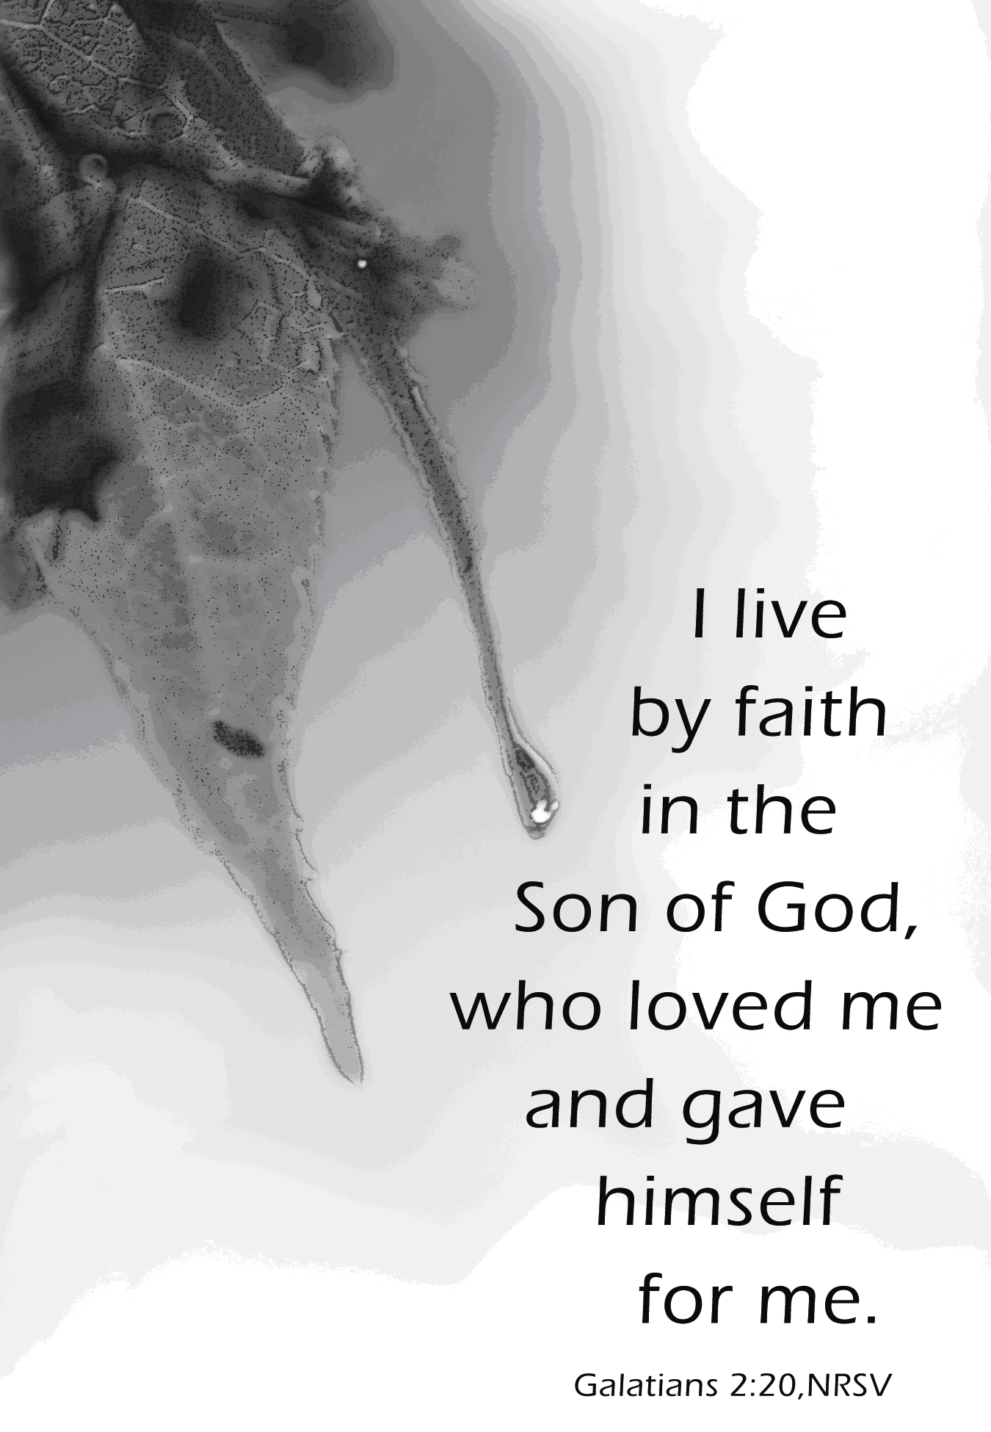

The Valleys
Evangelical Covenant Church
Halifax, PA

Church Office Hours: Mon. thru Fri. - 10AM to 3PM
Church Office(717-896-3118)
Web Site & Email - http://valleysecc.org valleysecc@verizon.net

Pastor’s Hours: Mon., Tues., Thurs.; 10:00AM - 1:00PM
Office (896-3118), Cell (717-818-3041), home (717-422-5788)
Email - KOHeckard@aol.com

CHURCH CALENDAR

June 9 - 9:00AM - Sunday School
10:00AM - Summer Church (Baptism)
2:00-3:00PM - Zumba 3:15-4:00PM - Zumba Gold
June 10 - 9:00AM-1:00PM - Halifax Senior Center is open Monday thru Friday
10:00AM - Bible Study
7:00PM - Elders
June 12 - 6:00-7:00PM - Daisy Girl Scout Troop 10753
7:00PM - Mission Committee Meeting
June 14 - 7:00PM - Ladies putting egg bake together for Father’s Day Breakfast

June 16 - 8:00AM - Father’s Day Breakfast - bring the family!
9:00AM - Sunday School
10:00AM -Summer Church
2:00-3:00PM - Zumba 3:15-4:00PM - Zumba Gold
No Youth Group
June 17 - 9:00AM-1:00PM - Halifax Senior Center is open Monday thru Friday
10:00AM - Bible Study
June 19 - 1:00-4:00PM - Pinochle Card Party
7:00PM - Council Meeting
June 20 - 9:00AM - Community Circle of Prayer (Zion-Stone UM)
June 21 - 7:00-11PM - Stamp Camp (See Joanne Enders)

June 23 - 9:00AM - Sunday School
10:00AM -Summer Church Mission Sunday (Mission Offering Pulse Survey Report
NO Zumba or Zumba Gold today
June 24 - 9:00AM-1:00PM - Halifax Senior Center is open Monday thru Friday
10:00AM - Bible Study
June 27, 28, 29, 30 - Evangelical Covenant Church Annual Meeting in Detroit, Michigan. (Pastor Kris and our Delegates Renny & Carol Witmer will attend the meeting.)

June 30 - 9:00AM - Sunday School
10:00AM -Summer Church

*PRAYER REQUESTS*
Please remember all the people on our Prayer List with prayers, thought, and cards: *(indicates new)
Members & Friends of The Valleys: Navigate Pathway; *Covenant Churches & *Victims and Families of Tornado in south Oklahoma City; *Aaron Herb; *Allen Goss, (Home); Tom & Barbara Lauver & Family; Elvin Lebo; Melba Croutharmel; Pauline Novinger; Glen Jones; Baby Elaina Parker; Etta & Robert Miller; Gregg Gelnett; Nevin Maurer; Margie Zeigler, (Frey Village).
Missions: Covenant Missionaries: Fred & Kelly Prudek; *Keith & Florence Gustafson.
Our Shut Ins: Anna Portzline; Lydia Peiffer; Minnie Baker
Military: Wesley Eshleman, (grandson of Betty Eshleman), stationed in Kuwait. Cameron Heddings, (grandson of Bonita Heddings), is stationed in Afghanistan).
Please inform Pastor Kris if you or a member of your family is in the hospital as the hospitals will not inform us unless you tell them to contact us. You may call the church office (896-3118) or Pastor Kris (818-3041).
~~~~~~~~~~~~~~~~~~~~~~~~~~~~~~~~~~~~~~~~~~~~~~~~~~~~~~~~~~~~~
Nursery: Valleys provides nursery care for children ages 5 and under. Nursery Attendants: May 26 - Shirley Miller; June 2 - Carol Cooper; June 9 - Patty Hummel; June 16 - Ann Hale. More Nursery attendants are needed! If you would like to help in the Nursery or if you cannot be there on your assigned Sunday, please see Donna Novinger.

Baby Congratulations: Congratulations to Leon and Courtney Dimpsey on the birth of twins, son - Michael Charles Edwin Dimpsey (6lb. 1oz.) and daughter - Sarah Anne Leona Dimpsey (5lb. 7oz.) born on May 29th. Grandparents: (the late Boyd Dimpsey); Leona & Larry Maus (Leon‘s parents); Michael & Leona Weeks (Courtney’s parents). Leon & Courtney’s address is on the bulletin board if you wish to send them a card.

Father’s Day Breakfast: Next Sunday, June 16th 8:00AM, please bring the family and join us! If you can help to do preparations Friday evening, June 14th and/or help to serve breakfast on Father’s Day, please see Donna Novinger.

Oklahoma City Tornado Relief: The Mission Committee will be placing a basket in the rear of the sanctuary for several weeks for donations for the Oklahoma City Tornado Relief fund. There are five Covenant Churches in that area that are helping in the recovery effort. These donations will go through our Evangelical Covenant Church Conference (Covenant World Relief). The Midsouth Conference office will be the primary conduit for these Covenant World Relief funds. Funds will be distributed to the local OKC Covenant churches for their local OKC tornado relief efforts. All donations are greatly appreciated to help the families of this devastating tornado. Please read the email on the bulletin board for more information.

Mission Committee Meeting: The Mission Committee will meet on Wednesday, June 12th at 7:00PM.

PULSE Survey Results: The Results of the PULSE Survey will be given on Mission Sunday, June 23rd.

VACATION BIBLE SCHOOL is coming!
Bible School will be a one day event held on Saturday, July 27 and is called “HayDay - Growing in Friendship with Jesus”. Teachers and helpers are needed. Please see Marie Herb if you can help. A meeting will be held soon to discuss Bible School. Sign up before or after church.

Giant Gift Cards available to purchase (before/after church)!

Church Attendance for last Sunday, June 2, 2013 was 78.

Halifax Senior Center is open Monday thru Friday, 9:00AM to 1:00PM at The Valleys Evangelical Covenant Church location. Stop in and have a cup of coffee and fellowship and see what activities are planned. Everyone is welcome! See Ann Hale or Barbara Lauver if you wish to eat at the Senior Center (meals must be ordered in advance) and see the Senior Center calendar (on bulletin board in narthex) for list of activities.
Halifax Senior Center Activities
Pinochle Card Party will be held at the Halifax Senior Center on the third Wednesday of the month beginning on June 19th from 1:00PM to 4:00PM.
Grocery Coupons for Overseas U. S. Military Families: Stop tossing those expired grocery coupons in the trash! The Senior Center is collecting grocery coupons for U. S. military families stationed overseas (they are able to use the on base for up to SIX MONTHS after the manufacturer’s expiration date). Only manufacturer’s coupons are accepted, no local or internet coupons accepted. You may cut them out (but it’s not required). Bring them in and place them in the box in the narthex.

