The Valleys Evangelical Covenant Church
The Rev. Kristine Heckard, Pastor
Choir Director, Ed Dobbin
Hymnal Technician, Aren Faust
Acolyte, Christopher Maichle
June 30, 2013
Sixth Sunday after Pentecost

(*Indicates all those who are able are invited to stand.)

Chimes
* Passing the Peace Greeting:
All who are able may greet those around them with an embrace or a handshake, accompanied by such words as:
Greeting: “The peace of God be with you.”
Response: “And also with you.”
Greetings and Announcements

* Call To Worship - Peggy Berra
L: Let us gather together, for we are the Church of the Lord Jesus Christ!
P: Throughout the ages we have stood strong to proclaim Christ’s love.
L: And in the face of evil God’s wisdom has guided us to victory.
P: In daily living the Holy Spirit has brought the wisdom of God for life.
L: Then let us celebrate the wonderful nature of God’s loving grace
ALL: Blessed be the name of the Lord!
L: Come, let us worship God!

Prelude - “Let There Be Peace on Earth”
* Opening Hymn - “Jesus Calls Us” Pg. 375
* Prayer of Invocation
* Call to Confession
* Confession: (In Unison)
Lord, we know that we are accountable for all that we do, and we confess that having heard your Word we often fail to show by our actions that we know your will for our lives. By your mercy forgive us, we pray, and enable us to live our lives in the spirit of your love. Amen.
* Assurance of Pardon: (In Unison)
Take heart: God’s Spirit empowers us to move from the ways of death to the ways of new life. Our sins are forgiven. Let us forgive one another and give ourselves to one another in the joyful community of the Risen Christ. Amen.
* Gloria Patri Pg.623
* Profession of Faith: (In Unison)
I believe in God, the Father Almighty, maker of heaven and earth;
I believe in Jesus Christ, His only Son, our Lord; He was conceived by the power of the Holy Spirit and born of the Virgin Mary. He suffered under Pontius Pilate, was crucified, died, and was buried; He descended to the dead. On the third day He rose again. He ascended into heaven, and is seated at the right hand of the Father. He will come again to judge the living and the dead.
I believe in the Holy Spirit, the holy Christian Church, the communion of the Saints, the forgiveness of sins, the resurrection of the body; and the life everlasting. Amen.

Hymn of Preparation - “Wonderful Peace” Pg. 500
Prayer cards will be collected during Second Hymn.
Morning Prayer & The Lord’s Prayer (Debts & Debtors)
Choral Response - “Hear Our Prayer O Lord” Pg. 614

Special Music - Josh Kobel

Scripture - Song of Solomon 1:9, Jim Davis Lay Reader
(Found on Pg. 735 of the OT Pew Bible)
Sermon - “Horses” Rev. Arnold Segesman
Our Morning Offering
Offertory - “In My Life be Glorified”
* Offertory Response - “We Give Thee But Thine Own” Pg. 620
* Prayer of Dedication
* Closing Hymn - “O Jesus, I Have Promised” Pg. 369
* Benediction * Threefold Amen
* Extinguishing of the Candles
* Postlude - “Freely, Freely”

Welcome: A hearty welcome to all who have come to worship. We gather in gratitude before our loving Creator and Sustainer. Let us approach God with purity of heart and reach out to each other with care and joy. If you are a visitor, please take time to sign your name, address, and phone number in our guest book before you leave.

Our Beautiful Altar Flowers are presented to God by Tom and Barbara Lauver in honor of their 50th Wedding Anniversary, which was yesterday, June 29th.

Guest Pastor: We would like to welcome and thank Rev. Arnold Segesman and his wife, Anita for sharing their talents with us today. Please be sure to greet the Segesmans after worship service today.
Rev. Arnold Segesman and his wife, Anita were both originally from Ohio. The Segesmans came to settle in Shippensburg in 1984. Rev. Segesman served as Pastor in Shippensburg for 18 years until his recent retirement. They have traveled for over 30 years as musical evangelists and Rev. Segesman has served as a minister at Adult and Youth Camp meetings, conventions and he was recognized in the 07”-08” Heritage Registry of Who’s Who for his success in his Field of Endeavor for business and community involvement. Arnold and Anita have had Radio and Television exposure and have recorded albums and tapes. The couple can play over 10 different instruments. Anita also does original chalk drawings and oil paintings occasionally during their presentations at churches. Arnold serves as Chaplain at Cumberland Valley Hose Company. Arnold Segesman was selected to Who’s Who for the Heritage Foundation in Washington, DC in 2007-2010.

VALLEYS SUMMER CHURCH IS AT 10:00AM JUNE THRU LABOR DAY!

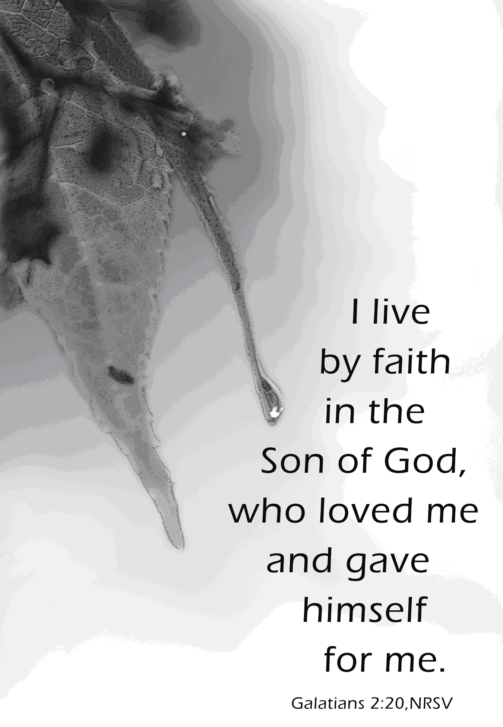

The Valleys
Evangelical Covenant Church
Halifax, PA

Church Office Hours: Mon. thru Fri. - 10AM to 3PM
Church Office(717-896-3118)
Web Site & Email - http://valleysecc.org valleysecc@verizon.net

Pastor’s Hours: Mon., Tues., Thurs.; 10:00AM - 1:00PM
Office (896-3118), Cell (717-818-3041), home (717-422-5788)
Email - KOHeckard@aol.com

CHURCH CALENDAR
June 30 - 9:00AM - Sunday School
10:00AM -Summer Worship
Following today’s worship service - Youth Group will cross the Millersburg Ferry & mini golf excursion (weather permitting) bring a bag lunch
2:00-3:00PM - Zumba 3:15-4:00PM - Zumba Gold
July 1 - 9:00AM-1:00PM - Halifax Senior Center open Mon-Fri
10:00AM - Bible Study (Leader - Pastor Mike Petresky)
5:30PM - Prayer Team
7:00PM - Strategic Planning Committee Meeting
July 2 - 7:00PM - Mission Committee Meeting
July 4 - Independence Day Holiday - Church Office/Senior Center is closed - No Meals on Wheels
July 6 - 7:45PM - Homemade Ice Cream (watch sunset/fireworks)
July 7 - 9:00AM - Sunday School
10:00AM - Traditional Worship - Mission Moment (focus on Volunteers) (Children’s Church)
No Fellowship meal or meeting in July
2:00-3:00PM - Zumba 3:15-4:00PM - Zumba Gold
(No Youth Group in July)
July 8 - 9:00AM-1:00PM - Halifax Senior Center is open Mon-Fri 10:00AM - Bible Study No Elders in July
7:30PM - Summer Dartball at St. Christopher Lutheran
Church, Lykens - Bring a snack to share
July 8 & 9 - Pastor Kris will be on vacation
July 13 - 7:00AM - Trim shrubbery around church.
July 14 - 9:00AM - Sunday School
10:00AM -Modified Worship -Communion (Child Ch) 2:00-3:00PM - Zumba 3:15-4:00PM - Zumba Gold
July 15 - 9:00AM-1:00PM - Halifax Senior Center is open Mon-Fri 10:00AM - Bible Study
7:00PM - Strategic Planning Committee Meeting
July 17 - 1:00-4:00PM - Pinochle Card Party
7:00PM - Council Meeting
July 18 - 9:00AM - Community Circle of Prayer - Zion-Stone UM
July 19 - 7:00-11PM - Stamp Camp (See Joanne Enders)
July 21 - 9:00AM - Sunday School
10:00AM -Traditional Worship

*PRAYER REQUESTS*
Please remember all the people on our Prayer List with prayers, thought, and cards: *(indicates new)
Members & Friends of The Valleys: Navigate Pathway; *Covenant Churches & *Victims and Families of Tornado in south Oklahoma City; *Dennis Leitzel, (Home); * Robin Kreiner, (Medical Procedure on July 5, Mary Zeigler’s daughter); Aaron Herb; Allen Goss; Melba Croutharmel; Pauline Novinger; Glen Jones; Baby Elaina Parker; Etta & Robert Miller; Gregg Gelnett; Nevin Maurer; Margie Zeigler, (Frey Village).
Missions: Covenant Missionaries: Fred & Kelly Prudek; *Thomas & Janice Kelly
Our Shut Ins: Anna Portzline; Lydia Peiffer; Minnie Baker
Military: Wesley Eshleman, (grandson of Betty Eshleman), stationed in Kuwait. Cameron Heddings, (grandson of Bonita Heddings), is stationed in Afghanistan).
Please inform Pastor Kris if you or a member of your family is in the hospital as the hospitals will not inform us unless you tell them to contact us. You may call the church office (896-3118) or Pastor Kris (818-3041).
~~~~~~~~~~~~~~~~~~~~~~~~~~~~~~~~~~~~~~~~~~~~~~~~~~~~~~~~~~~~~
Please turn off cell phones, pagers, etc. during our worship service. Thank you for your cooperation.

June Greeters: Norine Goss and Dave Novinger. Announcer: Peggy Berra. Acolyte: Christopher Maichle. June Offering Team: Renny Witmer, Carol Witmer, Charles Cichy, Neva Cichy.

July Greeters: Tom Hale and Ed Dobbin. Announcer: Dave Novinger. Acolyte: Lydia Faust. July Offering Team: Tom Hale, Pete Bryson, Charles Shertzer, Dave Novinger.

Lay Readers: June 30 - Jim Davis; July 7 - Jim Davis; July 14 - Brooke Croutharmel; July 21 - Diane Shaffer. If you can not read on the date assigned, please call Pastor Kris at the church (896-3118) or her home (717-422-5788).

Church School Teachers (Adults): June 30 - Carol Reisch; July 7 - Marie Herb; July 14 - Ken Bechtel II; July 21 - Ed Dobbin. If you cannot teach on your assigned Sunday, please inform Dave Novinger or Jessie Faust who will teach in your place.
Nursery: Valleys provides nursery care for children ages 5 and under. Nursery Attendants: June 30 - Neva Cichy; July 7 - Donna Motter; July 14 -Donna Novinger; July 21 - Marie Herb. More Nursery attendants are needed! If you would like to help in the Nursery or if you cannot be there on your assigned Sunday, please see Donna Novinger.

Next Week’s Scripture Lesson: Luke 10:11, 16-20

No Fellowship Meal: There will be no Fellowship Meal or meeting in July.

Watch the sunset and fireworks: Join us on Saturday, July 6 at 7:45PM for some homemade ice cream (and cake) as we watch the sunset and watch the fireworks in our church parking lot.

Mission Committee Meeting will be held on Tuesday, July 2nd at 7:00PM. The Mission Committee is looking for more members. Please prayerfully consider if God is calling you to join the Mission Committee.

Trim Shrubbery: The church shrubbery will be trimmed on Saturday, July 13 beginning at 7:00AM. Please see Tom Hale or Charlie Shertzer if you wish to help. Please bring trimmers, etc.

VACATION BIBLE SCHOOL: Bible School will be a one day event held on Saturday, July 27 9:00AM to 2:00PM and is called “HayDay - Growing in Friendship with Jesus”. Helpers are needed for crafts, games, serving snacks. If you missed the June 25 meeting and you would like to help, please see Marie Herb. Sign up before or after church. Snacks are needed for lunch and snack time (hot dogs, buns, fruits, veggies, finger-foods. Items needed for Bible School: a cowbell, buttons-various size & colors, craft sticks, Terra Cotta pots (small size - 6 inch), sponges, potting soil (big bag). Please see Marie or the sign up sheet on the bulletin board, if you can donate any of these items.

Giant Gift Cards available to purchase (before/after church)!
Church Attendance for last Sunday, June 23, 2013 was 78.
Oklahoma City Tornado Relief: The Mission Committee will be placing a basket in the rear of the sanctuary for several weeks for donations for the Oklahoma City Tornado Relief fund. There are five Covenant Churches in that area that are helping in the recovery effort. These donations will go through our Evangelical Covenant Church Conference (Covenant World Relief). The Midsouth Conference office will be the primary conduit for these Covenant World Relief funds. Funds will be distributed to the local OKC Covenant churches for their local OKC tornado relief efforts. All donations are greatly appreciated to help the families of this devastating tornado. Please read the email on the bulletin board for more information.

Halifax Senior Center is open Monday thru Friday, 9:00AM to 1:00PM at The Valleys E. C. C. See Ann Hale or Barbara Lauver if you wish to eat at the Senior Center (meals must be ordered in advance). See the Senior Center calendar (on bulletin board in narthex) for list of activities.
Senior Center Activities
Pinochle Card Party will be held at the Halifax Senior Center on the third Wednesday of the month from 1:00PM to 4:00PM.
Grocery Coupons for Overseas U. S. Military Families: Stop tossing those expired grocery coupons in the trash! The Senior Center is collecting grocery coupons for U. S. military families stationed overseas (they are able to use the on base for up to SIX MONTHS after the manufacturer’s expiration date). Only manufacturer’s coupons are accepted, no local or internet coupons accepted. You may cut them out (but it’s not required). Bring them in and place them in the box in the narthex.

Understanding MEDICARE 101: Tuesday, July 9, at 7:00PM Grace United Methodist Church, 983 Medical Road, Millersburg, will host a FREE seminar by Capital Blue Cross about Medicare (overview of Original Medicare coverage (Part A & B, Part C, Part D Prescription Drug coverage, and supplemental insurance to help you navigate through your choices and help you understand Medicare. The public is invited to attend this free seminar regarding what choices to make regarding healthcare coverage and its affordability. No reservation is needed.

