The Valleys Evangelical Covenant Church
The Rev. Kristine Heckard, Pastor
Choir Director, Ed Dobbin
Organist & Pianist, Mark & Joanne Enders
Acolyte, Cameron Crum
April 6, 2014
“Strong in the Word to Serve in the World”

(*Indicates all those who are able are invited to stand.)

Chimes
Greetings and Announcements
* Call To Worship Diane Shaffer
L: Let us gather together and declare our faith for all to hear.
P: But our faith is small and our witness seems so weak.
L: The Lord has promised to do great works with only the tiniest faith.
P: But dare we trust and truly step out; will the Lord honor our faith?
L: Step out on your faith! The Lord is faithful to all who will obey.
ALL: Blessed be the name of the Lord!
L: Come! Let us worship God!

Prelude - “I Saw the Cross of Jesus” by Robin McGee
* Praise Hymn - Pg. 9
“Praise the Lord! Ye Heavens, Adore Him”
* Prayer of Invocation
* Confession: (In Unison )
Lord, sometimes we are so timid. Even when we hear Your word clearly, we will not trust and follow. Your ways are not the world’s ways and too often we would seek the security we think we see in the world. Lord, Forgive us and help us learn how to use the grain of faith You have given us so that we might move the mountains in life. In Christ we pray. Amen.
* Kyrie: (To Be Sung responsively)
Leader/People: Lord, have mercy upon us.
Leader/People: Christ, have mercy upon us.
Leader/People: Lord, have mercy upon us.
* Assurance of Pardon
* Gloria Patri Pg. 623
* Profession of Faith - (In Unison)
We believe in God the Creator of all, known to us through perfect love, who has called forth a people of faith. We believe in Jesus Christ, the Word become flesh, crucified and resurrected, our Savior from sin, our peace, and Lord of the church. We believe in the Holy Spirit, poured out on all believers, our source of inspiration and power. We commit ourselves to follow Jesus Christ, growing by grace into the image of God, to live as faithful disciples, loving friend and enemy. Amen.

Children’s Sermon
Hymn of Preparation - “Lord, Speak to Me” Pg. 450
Prayer cards will be collected during the 2nd hymn.
Our Morning Prayer
Choral Response - “Hear Our Prayer O Lord” Pg. 614

Anthem - “Follow”

Scripture - Luke 17:1-19 (Pg. 107 of NT Pew Bible)
Ken Bechtel II, Lay Reader

Sermon - Sermon Series - “Lessons Jesus Taught His Disciples About Faith”
Week 5 - “The Request to Increase My Faith”

Mission Moment - Bethesda Mission
Our Morning Offering
Offertory - “Down at the Cross” by Lani Smith
* Offertory Response - “We Give Thee But Thine Own” Pg. 620
* Prayer of Dedication
* Closing Hymn - “Rise Up, O Church of God” Pg. 293

* Benediction/Threefold Amen/Extinguishing of the Candles
* Passing the Peace Greeting: All may greet those around them with an embrace or a handshake, accompanied by such words as:
Greeting: “The peace of God be with you.”
Response: “And also with you.”
* Postlude -
“Must Jesus Bear the Cross Alone” by Robert Hughes, ASCAP

Welcome: Welcome to worship, one and all! We gather as brothers and sisters in Christ to hear his Word and grow in faith and discipleship. God bless you during this holy time. If you are a visitor, please take time to sign your name, address, and phone number in our guest book before you leave.

Our Beautiful Altar Flowers are presented to the glory of God by Matt and Jessi Faust in honor of Lydia’s 12th birthday.

April Greeters: Wanda Hendershot and Leon Shaffer. Announcer: Diane Shaffer.
Acolyte: Cameron Crum.
April Offering Team: Diane Shaffer, (Captain), Leon Shaffer, Carolyn Ney, Ken Bechtel II. Please tell the Captain if you are unable to be there for a Sunday in your month. The Captain is responsible to get someone to help with the Offering Team if a member of the team cannot be there. On the 1st Sunday of the month, Offering team is to bring the food baskets to the altar with offering to be blessed.

Lay Readers: Apr. 6 - Ken Bechtel II; Apr. 13 - Ed Dobbin; Apr. 20 - Laura Roush; Apr. 27 - Sandy Zimmerman. If you cannot read on the date assigned, please call Pastor Kris at the church (896-3118) or her home (717-422-5788).

Nursery: Valleys provides nursery care for children ages 5 and under. Apr. 6 - Tracey Cooper; Apr. 13 - Shirley Miller; Apr. 20 - Patty Hummel; Apr. 27 - Theresa Miller. If you wish to help in the Nursery or if you cannot be there on your assigned Sunday, please see Donna Novinger.

Church School Teachers (Adults): Apr. 6 - Ed Dobbin; Apr. 13 - Sharon Fetterhoff; Apr. 20 - Easter Program; Apr. 27 - Ann Cooper. If you would like to help in the Nursery or if you cannot be there on your assigned Sunday, please see Donna Novinger..

Please turn off cell phones, pagers, etc. during our worship service. Thank you for your cooperation.

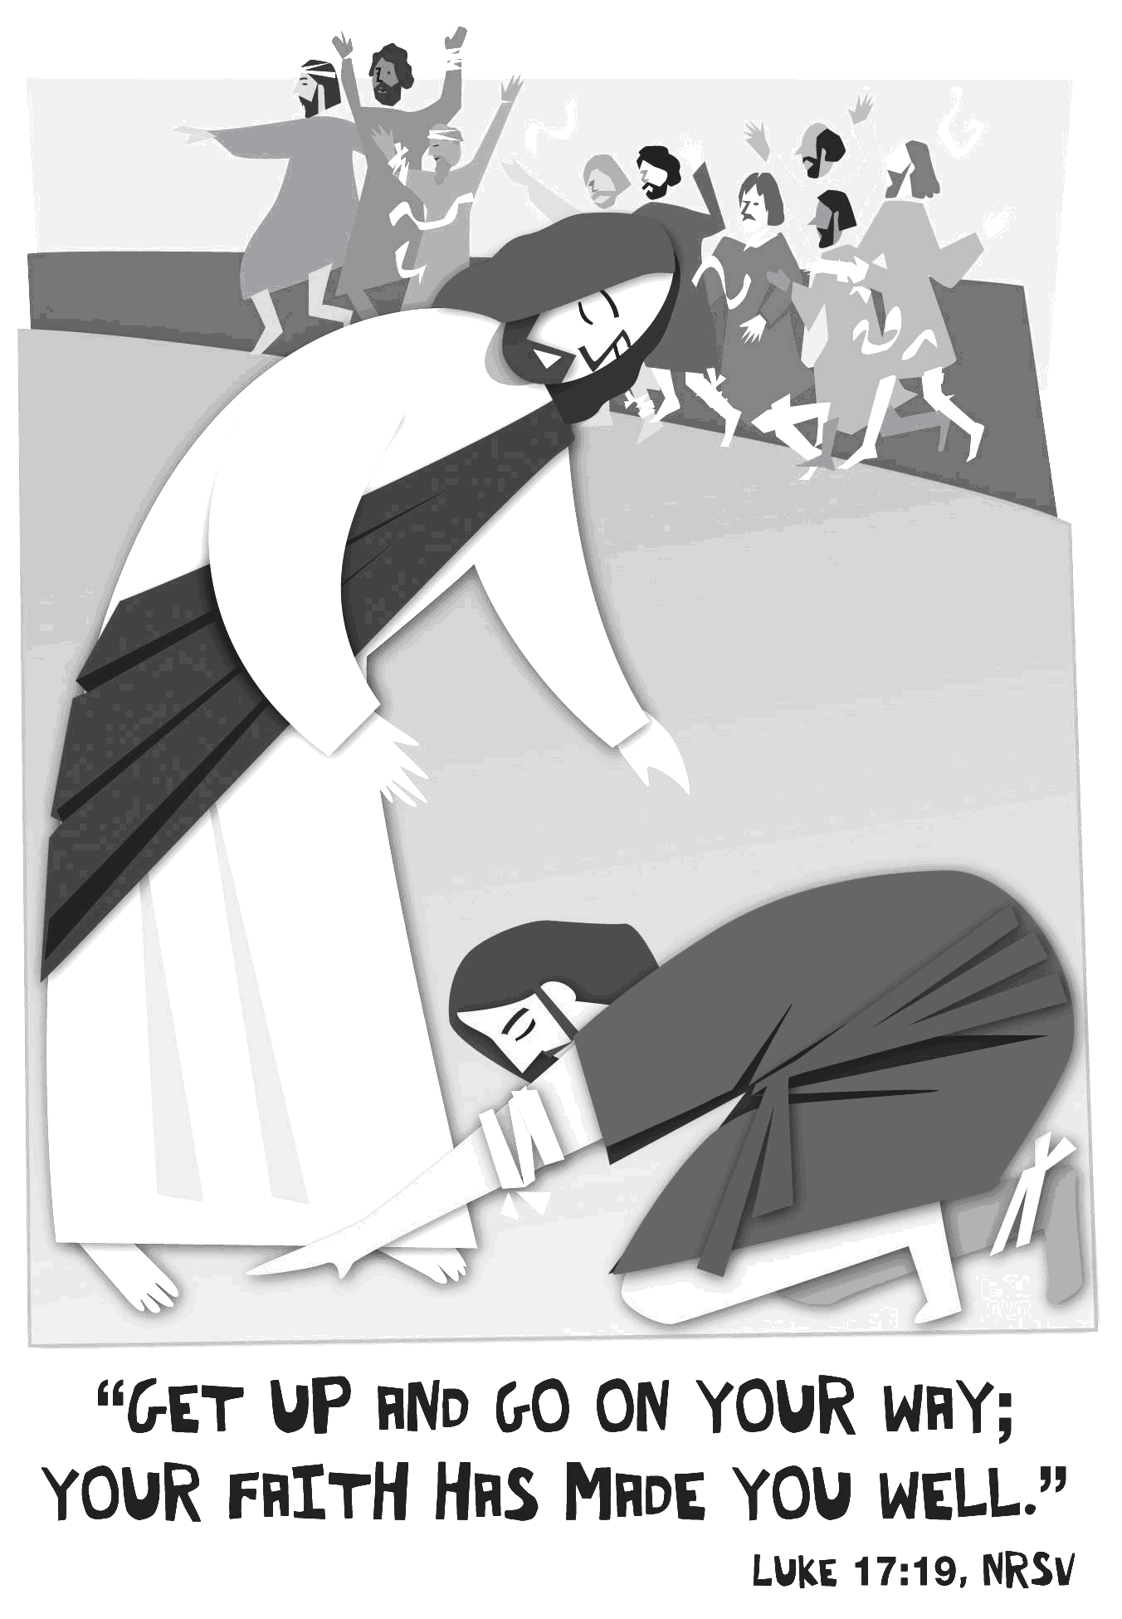

The Valleys
Evangelical Covenant Church
Halifax, PA

Church Office Hours: Mon. thru Fri. - 10AM to 3PM
Church Office(717-896-3118)
Web Site - ValleysEcc.Org Email - valleysecc@verizon.net

Pastor’s Hours: Mon., Tues., Thurs.; 10:00AM - 1:00PM
Office (896-3118), Cell (717-818-3041), home (717-422-5788)
Email - KOHeckard@aol.com

CHURCH CALENDAR
Apr. 6 - 9:00AM - Sunday School (youth - Easter practice)
10:15AM - Traditional Worship - Food Offering Mission Moment -Bethesda Mission (Children’s Ch)
Fellowship Covered Dish Meal, Confirmation following meal
Apr. 7 - 9:00AM-1:00PM - Halifax Senior Center open Mon-Fri
10:00AM - Bible Study (Jerry Hile, Leader)
5:30PM - Prayer Team
6:00-8PM - Girl Scout Leaders
7:00PM - Dartball Banquet at Valleys
Apr. 8 - 5:30-7:00PM - FREE Community Meal at Valleys
6:00-8PM - Girl Scout Trp. 10738
Apr. 9 - 7:30PM - Choir
Apr. 10 - 11:30AM - Senior Citizens Meeting/Meal (covered dish)
7:00PM - Community Lenten Service at Valleys ECC
(Pastor David Layser, Speaker)

Apr. 13 - 9:00AM - Sunday School (youth - Easter practice)
10:15AM - Traditional Worship - Palm Sunday
2:00-3PM - Zumba
Apr. 14 - 9:00AM-1:00PM - Halifax Senior Center open Mon-Fri
10:00AM - Bible Study (Jerry Hile, Leader)
6:00-7PM - Girl Scout Trp. 10737
6:30-7:30PM - Girl Scout Trp. 10774
Apr. 15 - 6:30-7:30PM - Girl Scout Trp. 104563
Apr. 16 - Noon-3:00PM - Pinochle Card Party
7:30PM - Choir
Apr. 17 - 7:30PM - Maundy Thursday Service at Valleys
Apr. 18 - 12:00Noon - Good Friday Service at Valleys
(Senior Center will close at 12:00Noon)
7:00-8:30PM - Youth Easter Program practice (color eggs for Easter egg hunt)

Apr. 20 - 6:30AM Easter Sunrise Service at Camp Hebron
9:00AM - Youth Easter Program (egg hunt after program)
10:15AM - Easter Worship Service - Communion
(served in pews)

Church Attendance for last Sunday, Mar. 31st was 69.
*PRAYER REQUESTS* *(indicates new)
Please remember all the people on our Prayer List with prayers, thoughts, cards: Members & Friends of The Valleys: Navigate Pathway; *Gail Shertzer; Elmer Feidt, (The Manor); Chet Gelnett; Bill Motter; Kenneth Bechtel (Sr.); Russ Miller; Allen Goss; Dennis Leitzel; Melba Croutharmel; Gary Noblit; Gregg Gelnett; Ted Keiter.
Missions: Covenant Missionaries: *Fred & Kelly Prudek;
*Carl & Karen Groot.
Our Shut Ins: Minnie Baker; Anna Portzline; Lydia Peiffer
Please inform Pastor Kris if you or a member of your family is in the hospital as the hospitals will not inform us unless you tell them to contact us. You may call the church office (896-3118) or Pastor Kris (818-3041).
~~~~~~~~~~~~~~~~~~~~~~~~~~~~~~~~~~~~~~~~~~~~

Halifax Senior Center is open Monday thru Friday, 9:00AM to 1:00PM at The Valleys E. C. C. Special Activities: Wed. Apr. 16th from 12:00Noon to 3:00PM a Pinochle Card Party will be held at the Center.

FREE Community Meal will be held at Valleys on Tuesday, April 8th from 5:30 to 7:00PM. A sign up sheet is in the narthex for donations and volunteers.

_________________________________________________________________________
Community Meal Coordinator: The Mission Committee is looking for a Coordinator for the Community Meals. Listed below is a brief description of the position . . .
- Plan economical and nutritious meals with options for Children. Include quantities needed for meal preparation. (Currently
planning for 50)
- Coordinate a yearly calendar of Hosting Groups (Scouts, Lions Club, Churches, Communities Service Club, etc.) Meals will be held the 2nd Tuesday of every Month.
If you are interested in the position, see Ed Dobbin.
_________________________________________________________________________

Senior Citizens Meeting: Due to a scheduling conflict the Senior Citizens Meeting will be held on Thursday, April 10th at 11:30AM instead of April 3rd (Covered Dish Meal at 12:00Noon)
~~~~~~~~~~~~~~~~~~~~~~~~~~~~~~~~~~~~~~~~~~~~~~~~~~~~~~~~~~~~~~
2014 Community Lenten Series (Sponsored by the Halifax Ministerium, Light refreshments follow the service)

Date/Time Place/Speaker

Thursday, April 10 at Valleys Evangelical Covenant Church
7:00PM Speaker, David Layser
Scripture John 10:11 Theme “I Am the Good Shepherd

Easter Sunday, April 20 at Camp Hebron
6:30AM (Easter Dawn) Speaker, Pastor Denise Haskins
Scripture John 11:25 Theme “I Am the Resurrection and the Life”
(Breakfast at Camp Hebron following the service)

~~~~~~~~~~~~~~~~~~~~~~~~~~~~~~~~~~~~~~~~~~~~~~~~~~~~~~~~~~~~~~

Maundy Thursday and Good Friday Services at Valleys:

Thurs. Apr. 17, Maundy Thursday Service will be held at 7:30PM.

Fri. Apr. 18, Good Friday Service will be held at 12:00Noon.
~~~~~~~~~~~~~~~~~~~~~~~~~~~~~~~~~~~~~~~~~~~~~~~~~~~~~~~~~~~~~~

Youth Easter Program: The Valleys Youth will present the Easter Program on Sunday, April 20th at 9:00AM. There will be an egg hunt for children nursery age thru 5th grade immediately following the program. Youth will Practice during Sunday School and also on Good Friday, April 18th from 7:00-8:30PM (youth will also color eggs for egg hunt. If you wish to donate eggs (colored or not colored), please see Marie Herb.

Mr. Sticky will be at Valleys on Tuesday, April 22nd and Wednesday, April 23rd. Order forms are in the narthex - White forms are for Tues. Apr. 22nd and Colored forms are for Wed. Apr. 23rd. Cost is $3.00 per bun. Pick up your sticky buns from 6:00AM to 2:00PM! Buns will be available for pick-up both days.
Valleys Pictorial Directory – Sign up in the narthex to set up your appointment for the new Valleys Pictorial Directory (Pictures will be taken on Friday, May 9th and Saturday, May 10th) by Lifetouch. If you have any digital pictures that you are willing to share, we would appreciate it. See Peggy Berra or Nancy Yutronich if you have pictures or any questions.

Walk for Life: The 2014 Walk for Life will be held at Lifeline Pregnancy Care Center in Millersburg on Saturday, May 17th. Registration is at 9:00AM; the Walk is at 10:00AM. Please see Marie Herb if you are interested in walking or sponsoring walkers.

Hoagie Sale: Order blanks are in the social hall. All orders are due by Sunday, May 11th. Delivery date will be on May 21st. Please give orders to Mike Crum or a member of the Deacons.

Mother’s Day Breakfast: The men of the Valleys will serve Mother’s Day Breakfast on Sunday, May 13th at 8:00AM. Bring mom, aunt, sister, daughter and the whole family and celebrate the wonderful women in our lives with a delicious breakfast!

Youth Group Fundraiser 2014 wall calendars and notepads. Calendars-$5.00 donation; Notepads-$2.00 donation. Samples are on the table in the social hall. See a youth member, Donna Novinger or Marie Herb to purchase items.

Mats for Homeless: A box is in the social hall to place plastic shopping bags, (bags are used to make sleeping mats for the homeless).

Devotionals: Pick up a Free copy of “Our Daily Bread” devotional as you come into the church narthex

Giant Gift Cards available to purchase (before/after church)!
By purchasing Giant gift cards, you can help raise money for Valleys.
Valleys receives $5 for every $100 Giant gift card purchased.

SERMON QUESTIONS

April 6, 2014
“The Request to Increase My Faith”
Luke 17:1-19

Questions for Reflection . . .

1. There is no magical formula for increased faith or a “quick-fix” for getting more faith. Can you list the events or situations that God has used to increase your faith in Him over recent weeks, months, or years?

2. The Samaritan recognized his condition and was not content with it. Do you desire to engage God day by day and to please Him in all that you do? Do you recognize the ways that the Father draws you to Himself? How does James 4:8 (“Draw near to God and He will draw near to you”) describe your responsibility?

3. Sometimes, we must “love by faith.” What is the meaning of that phrase? For instance, how do you love the “takers,” the “schemers,” the “lepers of our day” and the “drainers” of life? Recount some events where you had to “love by faith.”

