The Valleys Evangelical Covenant Church
The Rev. Kristine Heckard, Pastor
Praise Band
Worship Technicians: Aren Faust & Bridget Campbell
April 27, 2014 - Modified Worship, 10:15AM

“Strong in the Word to Serve in the World”

(*Indicates all those who are able are invited to stand.)

Pre-Service Music -
“Christ Is Risen”
“Your Grace Still Amazes Me”
“We Fall Down”
Greetings and Announcements Diane Shaffer

Praise Hymn (follow screen)
* “Crown Him (Majesty)” Chris Tomlin
“On Christ The Solid Rock I Stand”

Opening Prayer
* Confession & Assurance (follow Screen)

* Profession of Faith (follow Screen)

Collection of “Ask the Lord of the Harvest” Cards
How Goes Your Walk?
Morning Prayer & The Lord’s Prayer (Debts & Debtors)

Scripture & Sermon - 1 Corinthians 12:1-11 Sermon Series - “Spiritual Gifts”
Week 1 -“Unwrapping Your
Spiritual Gifts”

Our Morning Offering
Offertory - “ Who Am I” Casting Crowns
Prayer of Dedication

Closing Hymn (follow screen)
“Worship Christ the Risen King”

* Commissioning
* Passing the Peace Greeting:
All who are able may greet those around them with an embrace or a handshake, accompanied by such words as:
Greeting: “The peace of God be with you.”
Response: “And also with you.”

* Post-Service Music - “Glorious Day”

Welcome: Welcome to worship as we joyfully join our voices in song to praise God. May we each be open to discovering our ”spiritual gift”. If you are a visitor, please take time to sign your name, address, and phone number in our guest book before you leave.

April Greeters: Wanda Hendershot and Leon Shaffer. Announcer: Diane Shaffer. Acolyte: Cameron Crum.
April Offering Team: Diane Shaffer, (Captain), Leon Shaffer, Carolyn Ney, Ken Bechtel II.
May Greeters: Sue Faust and Ron Zimmerman.
Announcer: Arletta Thomas. Acolyte: Aaron Herb.
May Offering Team: Sue Faust, (Captain), Dale Faust, Carol Cooper, Jim Davis. Please tell the Captain if you are unable to be there for a Sunday in your month. The Captain is responsible to get someone to help with the Offering Team if a member of the team cannot be there. On the 1st Sunday of the month, Offering team is to bring the food baskets to the altar with offering to be blessed.

Lay Readers: May 4 - Bridget Campbell; May 11 -Ann Cooper; May 18 -Aaron Herb; May 23 - Michelle Cooper. If you cannot read on the date assigned, please call Pastor Kris at the church (896-3118) or her home (717-422-5788).

Nursery: Valleys provides nursery care for children ages 5 and under. Apr. 27 - Shirley Miller; May 4 - Theresa Miller; May 11 - Patty Hummel; May 18 - Neva Cichy. If you wish to help in the Nursery or if you cannot be there on your assigned Sunday, please see Donna Novinger.
Church School Teachers (Adults): Apr. 27 - Ken Bechtel II; May 4 - Dave Novinger; May 11 - Mother’s Day - Bob Endy; May 18 - To Be announced. If you cannot be there on your assigned Sunday, please inform Dave Novinger or Jessie Faust who will teach in your place

~~~~~~~~~~~~~~~~~~~~~~~~~~~~~~~~~~~~~~~~~~~~~~~~~~~~~~~~~~~~~~
Fundraiser for Upper Dauphin Human Services Food Bank at Burger King tomorrow Monday, April 28th ~ 5:00-8:00PM. See the information flier and certificates on the bulletin board. Please help support the U. D. Food Bank.
~~~~~~~~~~~~~~~~~~~~~~~~~~~~~~~~~~~~~~~~~~~~~~~~~~~~~~~~~~~~~~~

Senior Citizens Meeting: The Senior Citizens Meeting will be held on Thursday, May 1st at 11:30AM. Meal at 12:00Noon (Hot dogs & sauerkraut will be provided, please bring a dessert).

Worship Committee Meeting will be held on Wednesday, May 7th at 6:00PM.

Valleys Pictorial Directory – If you haven’t signed up for your appointment for the new Valleys Pictorial Directory, Please see Ed or Peggy Berra. (Pictures will be taken on Thursday, May 8th, Friday, May 9th and Saturday, May 10th) by Lifetouch. If you have any digital pictures that you are willing to share, we would appreciate it. See Peggy Berra or Nancy Yutronich if you have pictures or any questions.

Mother’s Day Breakfast: The men of the Valleys will serve Mother’s Day Breakfast on Sunday, May 11th at 8:00AM. Bring mom, aunt, sister, daughter and the whole family and celebrate the wonderful women in our lives with a delicious breakfast! (The men will put the breakfast together on May 10th, see Dave Novinger for time if you wish to help.)

Hat Day: On Mother’s Day, May 11th Men, Women, Children are invited to wear their prettiest, favorite hats to church on Mother’s Day! Grab a hat (and decorate it if you want) and join us as we fill the sanctuary with a sea of hats!

Please turn off cell phones, pagers, etc. during our worship service. Thank you for your cooperation.

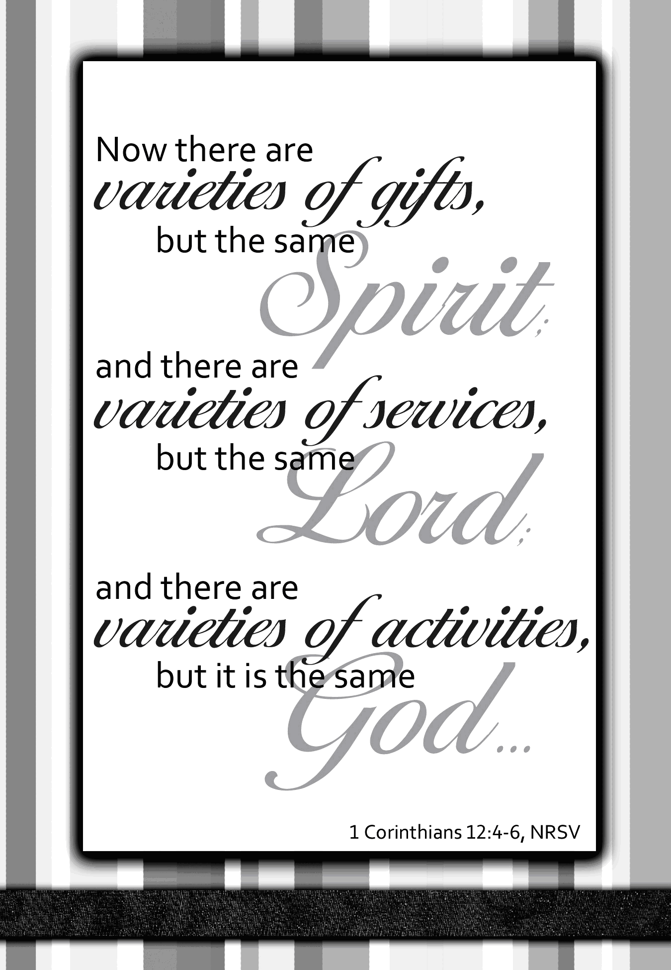

Church Office Hours: Mon. thru Fri. - 10AM to 3PM
Church Office(717-896-3118)
Web Site - ValleysEcc.Org Email - valleysecc@verizon.net

Pastor’s Hours: Mon., Tues., Thurs.; 10:00AM - 1:00PM
Office (896-3118), Cell (717-818-3041), home (717-422-5788)
Email - KOHeckard@aol.com

CHURCH CALENDAR
Apr. 27 - 9:00AM - Sunday School
10:15AM - Modified Worship - Mission Offering 12:30-5:30PM - Girl Scout Healthy Promise Event
(No Zumba today)
Apr. 28 - 9:00AM-1:00PM - Halifax Senior Center open Mon-Fri
10:00AM - Bible Study (Jerry Hile)
6:00-7PM Girl Scout Trp. 10737
6:30-7:30PM - Girl Scout Trp. 10774
Apr. 29 - 6:00-7:00PM - Weight Loss Challenge group
7:00PM - S. S. Superintendents Meeting
Apr. 30 - 6:00-7:30PM - Girl Scout Trp. 10753
7:00PM - April Council Meeting
May 1 - 11:30AM - Senior Citizens meeting (meal at Noon - bring a dessert)
6:10AM - Zumba Gold; 7:00PM - Zumba
May 2 & 3 - ECC East Coast Conference (Manchester, CT)

May 4 - 9:00AM - Sunday School
10:15AM - Traditional Worship - Food Offering Mission Moment (Children’s Church)
Fellowship Covered Dish Meal, Confirmation
6:30PM - Youth Group
May 5 - 9:00AM-1:00PM - Halifax Senior Center open Mon-Fri
10:00AM - Bible Study (Pastor Bill Krentz)
5:30PM - Prayer Team
6:00-8:00PM - Girl Scout Leaders
7:00PM - Elders Meeting
May 6 - 6:30-7:30PM - Girl Scout Troop 10463
7:00PM - Deacons
May 7 - 6:00PM - Worship Committee Meeting
6:00-7:00PM - Girl Scout Troop 10753
7:30PM - Choir
May 8 - 6:10PM - Zumba Gold; 7:00PM - Zumba
May 8, 9 & 10 - Pictures being taken for Pictorial Directory
May 10 - Men will put Mother’s Day Breakfast together

May 11 - 8:00AM - Mother’s Day Breakfast
9:00AM - Sunday School
10:15AM - Modified Worship - Wear a Hat Day
*PRAYER REQUESTS*
Please remember all the people on our Prayer List with prayers, thought, and cards: *(indicates new)
Members & Friends of The Valleys: Navigate Pathway; *Bill Motter, (Home); Allen Goss; Gail Shertzer; Elmer Feidt; Chet Gelnett; Melba Croutharmel; Dennis Leitzel; Russ Miller; Kenneth Bechtel (Sr.); Gary Noblit; Gregg Gelnett.
Missions: Covenant Missionaries: Fred & Kelly Prudek; *Keith & Florence Gustafson; *Jay & Ellen Haworth; *Mandy Hjelm.
Our Shut Ins: Minnie Baker; Anna Portzline; Lydia Peiffer
Please inform Pastor Kris if you or a member of your family is in the hospital as the hospitals will not inform us unless you tell them to contact us. You may call the church office (896-3118) or Pastor Kris (818-3041).

~~~~~~~~~~~~~~~~~~~~~~~~~~~~~~~~~~~~~~~~~~~~~~~~~~~~~~~

Church Attendance last Sunday, April 20, 2014 was 133.

Hoagie Sale: All orders are due Sunday, May 11th! Hoagies and 12” Traditional Pizzas - $7.00 donation for each; 12” Specialty Pizzas - $8.00 donation for each. Please give orders to Mike Crum or a member of the Deacons. Delivery date is May 21st.

FREE Community Meal will be held at Valleys on Tuesday, May 13 from 5:30 to 7:00PM. Menu: Hot dogs, Baked Beans, Potato Salad or Macaroni Salad, dessert and drinks. A sign up sheet is in the narthex for donations and volunteers.

Walk for Life: The 2014 Walk for Life will be held at Lifeline Pregnancy Care Center in Millersburg on Saturday, May 17th. Registration is at 9:00AM; the Walk is at 10:00AM. Please see Marie Herb if you are interested in walking or sponsoring walkers.

Community Fun Day will be held at the Halifax High School on Saturday, May 17th from 10:00AM to 2:00PM. The Valleys is participating with a stand for the Community Fun Day and we are looking for volunteers to help at the stand. If you are interested in helping (for an hour or more or the whole time, please see Donna Motter or call the church office.

Worship Team, Volunteers, Teachers List is on the bulletin board in the narthex. Worship Team includes Greeters, Announcer, Acolyte, Lay Readers, Offering Team; Volunteers includes Nursery Attendants & Flower Sponsors; Teachers - Sunday School Teachers. If you would like a copy, please see Donna Novinger.

~~~~~~~~~~~~~~~~~~~~~~~~~~~~~~~~~~~~~~~~~~~~~~~~~~~~~~~
Community Meal Coordinator: The Mission Committee is looking for a Coordinator for the Community Meals. Listed below is a brief description of the position . . .

- Plan economical and nutritious meals with options for Children. Include quantities needed for meal preparation. (Currently
planning for 50)

- Coordinate a yearly calendar of Hosting Groups (Scouts, Lions Club, Churches, Communities Service Club, etc.) Meals will be held the 2nd Tuesday of every Month.

If you are interested in the position, see Ed Dobbin.
~~~~~~~~~~~~~~~~~~~~~~~~~~~~~~~~~~~~~~~~~~~~~~~~~~

Halifax Senior Center is open Monday thru Friday, 9:00AM to 1:00PM at The Valleys E. C. C. Place expired coupons in box in the social hall (for U. S. military families stationed overseas). Check the calendar on bulletin board) for list of activities. See Ann Hale or Barbara Lauver to sign up for meals at Senior Center.

Mats for Homeless: A box is in the social hall to place plastic shopping bags, (grocery bags - Giant, Weis, Wal-Mart work best), which will be used to make sleeping mats for the homeless.

Youth Group Fundraiser (Prices reduced!) 2014 Wall Calendars ($4); Notepads ($1) donation. Samples are on the table in the narthex. See a youth member, Donna Novinger or Marie Herb to purchase items.

Giant Gift Cards available to purchase (before/after church)!
By purchasing Giant gift cards, you can help raise money for Valleys.
Valleys receives $5 for every $100 Giant gift card purchased.
MEMORIAL DAY HONOR ROLL
On Sunday, May 25, 2014 The Valleys ECC will have a Memorial Day Honor Roll printed in the church bulletin for the Memorial Day Sunday Service. The deadline for these listings is Sunday, May 18, 2014 to be placed on the Memorial Day Honor Roll. This honor roll may be used to remember those family members or friends who have gone to be with our Heavenly Father, or it may commemorate a recent birth, or honor a graduate from high school or college or to honor a special anniversary as well.
A donation of any amount to the “Memorial Fund” is requested for each published listing “IN HONOR OF” or “IN LOVING MEMORY OF”. Please place donations and the listing information in a separate envelop and mark it “Memorial Fund”. Donation amounts will not be published in the listings.
If you wish to give a donation and have a listing on the MEMORIAL DAY HONOR ROLL, please fill out the form and return it to the church office by Sunday, May 18, 2014.
Your Name ______________________________________________
IN LOVING MEMORY OF … ______________________________
________________________________________________________
________________________________________________________
IN HONOR OF … ________________________________________
________________________________________________________

2014 GRADUATES
The Valleys ECC would like to congratulate our 2014 Graduates (also any graduates since last June) by recognizing them during the worship service on June 1st. They will also be listed in the June newsletter. Please complete the form and return it to the church office (or Donna Novinger) no later than Mother’s Day, Sunday, May 11th.
Name_____________________ Parents________________________
School or College__________________________________________
________________________________________________________
College Degree____________________________________________
Activities & Special Honors received in school or college:
_________________________________________________________
_________________________________________________________

SERMON REFLECTIONS

April 27, 2014
“Unwrapping Your Spiritual Gift”
I Corinthians 12:1-11

Things to do . . .

1. Read. Read the four key chapters on Spiritual Gifts - Romans 12, I Corinthians 12, Ephesians 4, and I Peter 4.

2. Pray. Ask God to show you what spiritual gifts he has given you. You might pray, "Open my eyes and show me where I fit in the body of Christ.”

3. Ask. Simply go to several friends who know you well and ask them to tell you what spiritual gifts they think you have. You may be surprised at the answer you receive. Your friends may have seen evidence of a spiritual gift at work in your life that you never even considered.

ASK THE LORD OF THE HARVEST
In Luke 10, Jesus sends out 72 of his followers to preach the gospel to every town and place where He was about to go. Like these early followers of Jesus, God invites us to be a part of His redemption in the lives of those we know and love.
For more than 20 years, Covenanters have made a commitment to “ask the Lord of the Harvest” or “pray” for the salvation of those in need of Jesus, and also ourselves and others as we help in this redemptive process. Our East Coast Conference is asking that our delegates bring our prayer requests to the Annual meeting on May 3rd.
You will find a prayer card in your bulletin. Please place the names for which you would like our conference to pray. After being collected during our worship service, these cards will be taken to the Annual Meeting on May 3rd.

___________________________________________________

Ask the Lord of the Harvest . . .

Please place the names of individuals who you know that . . .

- need to experience new life in Jesus Christ

- need God’s help as they work in the redemptive process.

