The Valleys Evangelical Covenant Church
The Rev. Kristine Heckard, Pastor
Choir Director, Ed Dobbin
Hymnal Technician, Aren Faust
Acolyte, Brooke Croutharmel
March 17, 2013
Fifth Sunday in Lent

(*Indicates all those who are able are invited to stand.)

Chimes
* Passing the Peace Greeting:
All who are able may greet those around them with an embrace or a handshake, accompanied by such words as:
Greeting: “The peace of God be with you.”
Response: “And also with you.”
Greetings and Announcements

* Call To Worship - Dave Novinger
L: Come, let us gather together this day and worship the Lord!
P: Let us lift our praise to God in our songs and our anthems!
L: Let us praise the Lord in our words and our readings,
P: And let us turn our hearts to the Lord whose love has made us whole.
L: God’s love is so real that Jesus would even suffer the cross for us.
ALL: Blessed be the name of the Lord!
L: Come, let us worship our Lord!

Prelude - “At The Name of Jesus”
* Opening Hymn - “All Creatures of Our God and King” Pg. 64
* Prayer of Invocation
* Call to Confession
* Confession: (In Unison)
Lord, so often we seem to let the demands of life be more important than spending personal time in prayer and worship. Always there are tasks to be done, errands to be about, even the busy pace that caring for others can demand; yet somehow time with You gets forgotten. Forgive us, Lord, and hear our hearts as we seek Your love. In Christ we pray. Amen.
* Kyrie: (To Be Sung)
Leader: Lord, have mercy upon us.
People: Lord, have mercy upon us.
Leader: Christ, have mercy upon us.
People: Christ, have mercy upon us.
Leader: Lord, have mercy upon us.
People: Lord, have mercy upon us.
* Assurance of Pardon
* Gloria Patri Pg.623
* Profession of Faith: (In Unison)
We believe in God who created and is creating the world, who came to us in His Son, Jesus; To reconcile and save. Who works by His Spirit. Who calls us into His church to celebrate His presence, to join hands and hearts in service. To proclaim Jesus Christ - crucified and risen - our only hope, in life and in death, and unto the life everlasting. These things we believe in our hearts, and will proclaim with our voices. Amen.
Children’s Sermon
Hymn of Preparation - “Near To The Heart of God” Pg. 497
Prayer cards will be collected during Second Hymn.
Morning Prayer & The Lord’s Prayer (Debts & Debtors)
Choral Response - “Hear Our Prayer O Lord” Pg. 614
Anthem - “Were You There?”

Scripture - John 12:1-8 Heidi Erb, Lay Reader
(Found on Pg. 142 of the NT Pew Bible)

Sermon - “Giving God Our Best”

Our Morning Offering
Offertory - “More Love to Thee”
* Offertory Response - “We Give Thee But Thine Own” Pg. 620
* Prayer of Dedication
* Closing Hymn - “To God Be The Glory” Pg. 66
* Benediction * Threefold Amen
* Extinguishing of the Candles
* Postlude - “I Am Thine, O Lord”
Welcome: During this Lenten season we praise God for his righteous Son, who perfectly kept all of God's commandments for us and paid the full price for our disobedience. Let us praise him with hearts filled with Christ's spirit of obedience. If you are a visitor, please take time to sign your name, address, and phone number in our guest book before you leave.

Our beautiful Altar Flowers are presented to the glory of God by Bob and Dixie Endy in honor of their 40th Wedding Anniversary on March 31st.

March Greeters: Brandi Crum and June Gelnett. Announcer: Dave Novinger. Acolyte: Brooke Croutharmel. March Offering Team: Ron Zimmerman, Christopher Maichle, Mike Crum, Aaron Herb.

Lay Readers: Mar. 17 - Heidi Erb; Mar. 24 - Ron Zimmerman.; Mar. 31 - Bob End; Apr. 7 - Ken Bechtel II. If you can not read on the date assigned, please call Pastor Kris at the church (896-3118) or her home (717-422-5788).

Church School Teachers (Adults): Mar, 17 - Ed & Peggy Berra; Mar. 24 - Boyd Dimpsey; Mar. 31 - Easter Program; Apr. 7 - Bob Endy. If you cannot teach on your assigned Sunday, please inform Dave Novinger or Jessie Faust who will teach in your place.

Nursery: Valleys provides nursery care for children ages 5 and under. Nursery Attendants: Mar. 17 - Neva Cichy; Mar. 24 - Ann Hale; Mar. 31 - Mary Zeigler; Apr. 7 - Carol Cooper. More Nursery attendants are needed! If you would like to help in the Nursery or if you cannot be there on your assigned Sunday, please see Donna Novinger.

Please turn off cell phones, pagers, etc. during our worship service. Thank you for your cooperation.

SERVICE CANCELLATION POLICY
***************************************************************
If a service or activity has to be cancelled due to adverse weather conditions during the winter, please check the following TV stations - WHTM Channel 27 and WHP Channel 21 to see if Valleys appears on their cancellation display.
***************************************************************

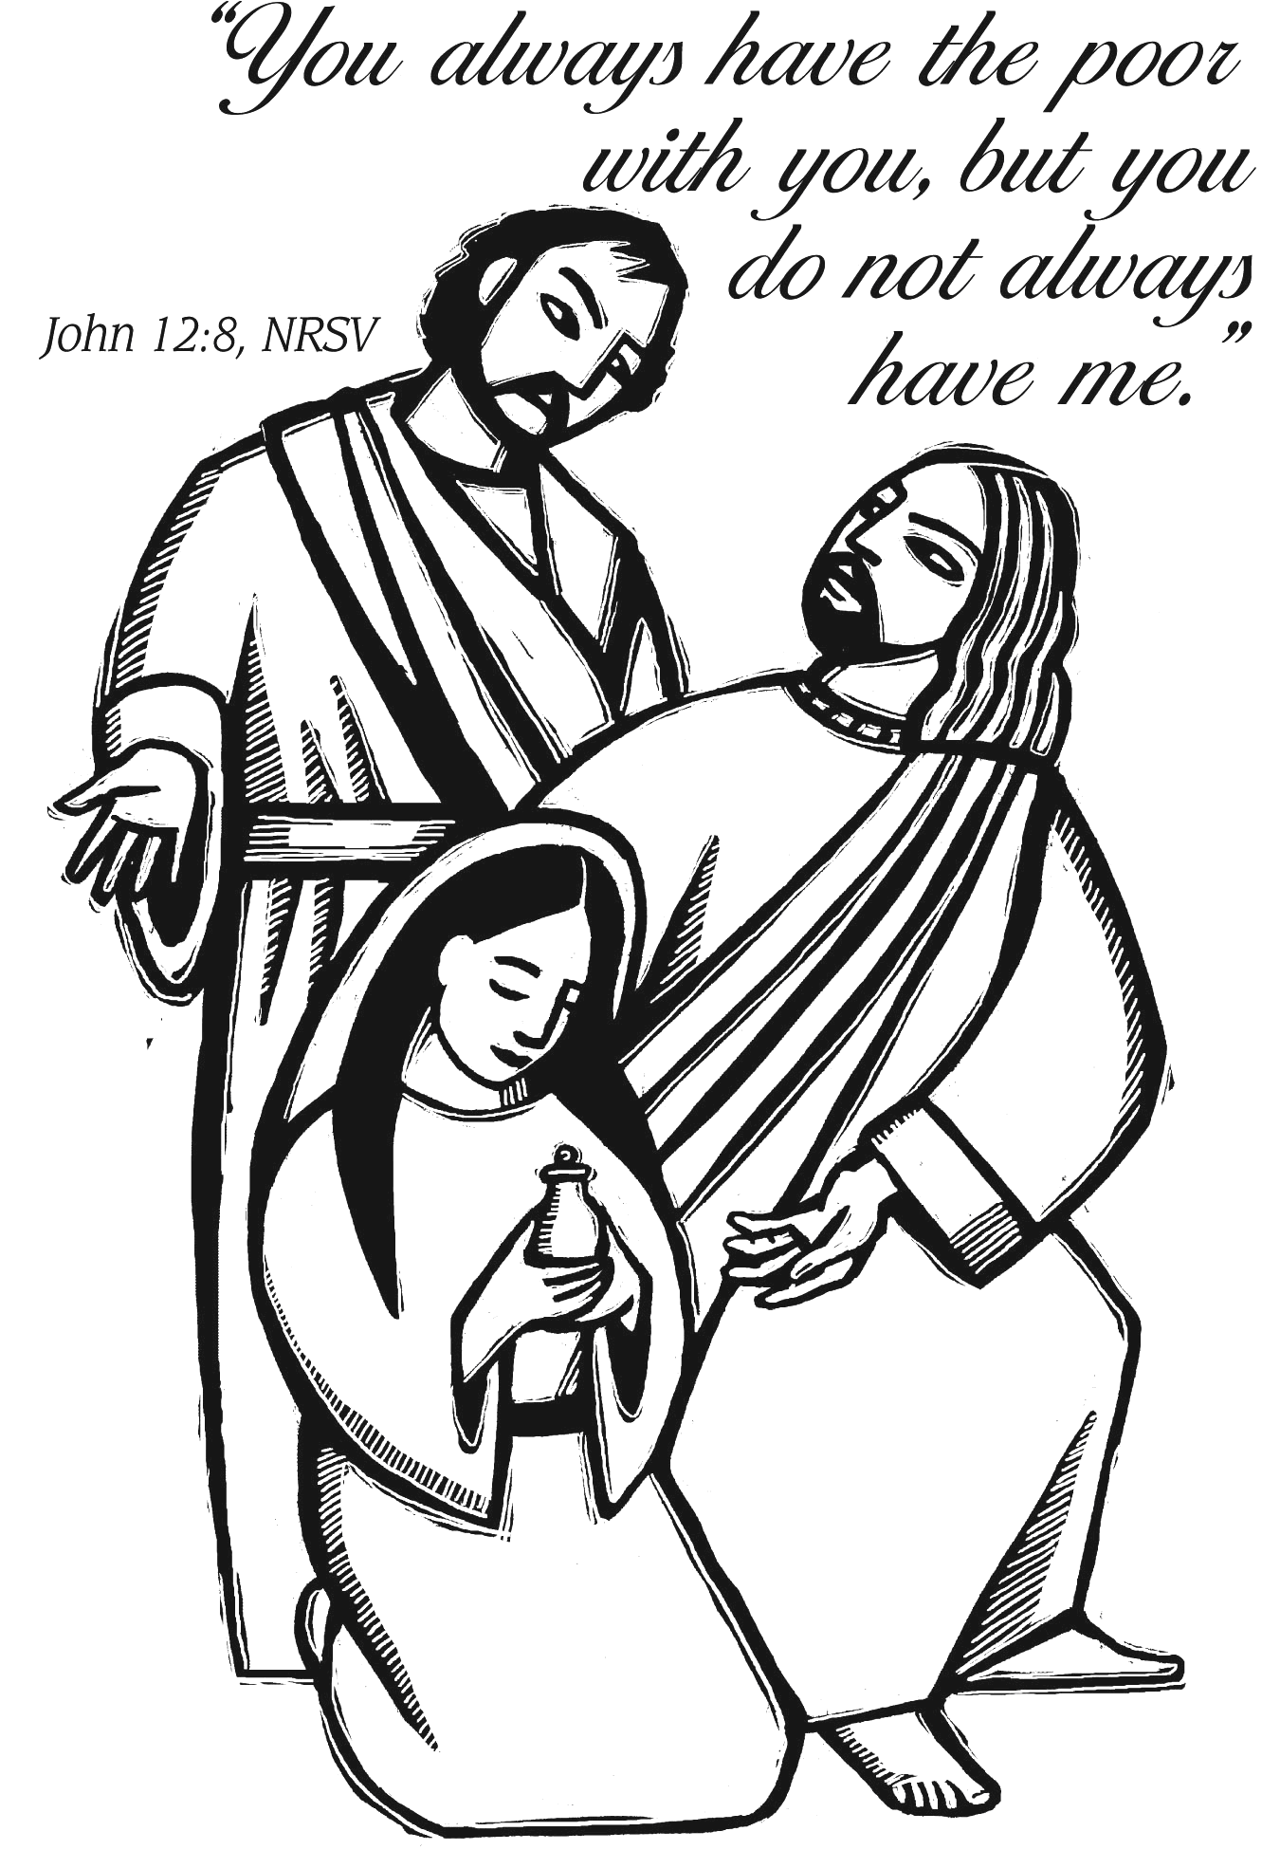

The Valleys
Evangelical Covenant Church
Halifax, PA

Church Office Hours: Mon. thru Fri. - 10AM to 3PM
Church Office(717-896-3118)
Web Site & Email - http://valleysecc.org valleysecc@verizon.net

Pastor’s Hours: Mon., Tues., Thurs.; 10:00AM - 1:00PM
Office (896-3118), Cell (717-818-3041), home (717-422-5788)
Email - KOHeckard@aol.com

CHURCH CALENDAR
Mar. 17 - 9:00AM - Sunday School
10:15PM - Church (Children’s Choir)
Confirmation Class after church (bag lunch)
1:30PM - Dartball Tournament -Valleys provides paper products, chips/pretzels, drink (social hall). Give your reservation for Dartball Banquet to Pete Bryson by today
Cost: $8.00-per person; 4-9 yrs.-$4.00 (3 & under-Free).
2:00-3PM - Zumba 3:15-4PM - Zumba Gold (Meeting Rm.)
Articles for April/May Newsletter are due today!
Mar. 18 - 10:00AM - Bible Study
Mar. 19 - 7:30PM - Choir
Mar. 20 - 6:00PM - Calendar Meeting (First Day of Spring)
7:00PM - Council Meeting
Mar. 21 - 9:00AM - Comm. Circle of Prayer at Zion-Stone U. M.
1:00-2:00PM - “In It Together” (“Jesus & The Parables”)
6:00-8:00PM - Girl Scout Troop 10728 (1, 3, 5 Thurs.)
7:00PM - Community Lent Service at Zion-Stone
Methodist - Pastor Mike Petresky, Speaker on “Bare Branch”
Light refreshments follow the service.
Mar. 24 - 9:00AM - Sunday School (Palm Sunday)
10:15AM - Church (No Mission Sun. Service in March)
Mission Offering
Mar. 25 - 10:00AM - Bible Study
7:00PM - Dartball Awards Banquet at St. Christopher (Lykens)
Mar. 26 - 6:00-8:00PM - Girl Scout Troop 10738
Mar. 27 - 1:00-6:00PM - Halifax Band Boosters Fundraiser Pickup
6:00-7:00PM - Girl Scout Troop 10753
7:30PM - Choir
Mar. 28 - 7:30PM - Maundy Thursday Service (Communion)
Mar. 29 - 7:00-8:30PM - Rehearsal for Youth Easter Program (eggs to be colored during rehearsal, see Marie, Rachael, or Donna)
Mar. 31 - Easter - 6:30AM - Community Sunrise Service at Camp Hebron - Pastor Ron Reitz - Speaker - “Butterfly” (Breakfast will be served following Sunrise service).
9:00PM - Youth Easter Program (egg hunt follows) 10:15AM - Easter Communion
Giant Gift Cards available to purchase (before/after church)!
Church Attendance last Sunday, Mar. 10, 2013 was 58.
*PRAYER REQUESTS*
Please remember all the people on our Prayer List with prayers, thought, and cards: *(indicates new)
Members & Friends of The Valleys: Navigate Pathway; *Joan Deibler; Marie Herb; Elvin Lebo; Melba Croutharmel; Lindsey Motter, (Billy Motter’s wife); Donald Hoke; Richard Hoke; Sandy Zimmerman; Marion Etzweiler; Allen Goss; Pauline Novinger; Glen & Brenda Jones; Baby Elaina Parker; Gregg Gelnett; Romanie Deitrich; Nevin Maurer; Carley Enders; Margie Zeigler, (Frey Village).
Missions: Covenant Missionaries: Fred & Kelly Prudek; *Nils & Erika Clauson.
Our Shut Ins: Anna Portzline; Lydia Peiffer; Minnie Baker
Military: Wesley Eshleman, (grandson of Betty Eshleman), stationed in Kuwait. Cameron Heddings, (grandson of Bonita Heddings), is stationed in Afghanistan).
Please inform Pastor Kris if you or a member of your family is in the hospital as the hospitals will not inform us unless you tell them to contact us. You may call the church office (896-3118) or Pastor Kris (818-3041).
~~~~~~~~~~~~~~~~~~~~~~~~~~~~~~~~~~~~~~~~~~~~~~~~~~~~~~~~~~~~~
Mr. Sticky will be at Valleys Monday, April 22nd & Tuesday, April 23rd! White forms are for Mon., Apr. 22nd (personal or individuals) and colored forms are for Tues. Apr. 23rd (business/ large orders). Cost is $3.00 per bun. Buns will be available both days. Order sheets or sign up sheet to help available in the narthex. (Sponsored by the Fellowship Group, proceeds go to the General Fund.) See Ron Zimmerman if you have any questions.
~~~~~~~~~~~~~~~~~~~~~~~~~~~~~~~~~~~~~~~~~~~~~~~~~~~~~~~~~~~~~~
Halifax Area Senior Center (Possible re-opening)
Would you be willing to come to the center for more than the monthly meeting of the Halifax Area Senior Citizens?
Possible programs: Computer classes for Seniors, Cards, Bingo, Board games, Chess/checkers, Dominos, Jig saw puzzles, AARP Driving Classes, Crafts, Line dancing, Book exchange, Coupon exchange, and Much, much more!
See Ann Hale (896-3573) or Barbara Lauver if you have any suggestions/questions or you are interested.
Youth Group Lock-In on Fri. Apr. 12 7:00PM to Sat. Apr. 13 9:00AM. See Donna Novinger or Marie Herb for info and forms.

