The Valleys Evangelical Covenant Church
The Rev. Debra Gustafson, Interim Pastor
Worship Technicians: Bridget Campbell & Neva Cichy
March 13, 2016 - Blended Worship, 10:15AM

“Strong in the Word to Serve in the World”

(*Indicates: Stand as you are able.)

Sing a New Song -
“Lord of Lords (Prince of Peace) Michael W. Smith
“10,000 Reasons (Bless the Lord)
Matt Redman
“Good, Good Father” Chris Tomlin

Welcome and Opening Prayer Pastor Deb
* “I Give You My Heart” Hillsong (projected)
* Confession/Assurance of Pardon (projected)
CONFESSION: (Unison)
Most merciful God, We confess that we have sinned against you in thought, word, and deed, by what we have done, and by what we have left undone. We have not loved you with our whole heart; we have not loved our neighbors as ourselves. We are truly sorry and we humbly repent. For the sake of your Son Jesus Christ, have mercy on us and forgive us; that we may delight in your will, and walk in your ways, to the glory of your Name. Amen.
ASSURANCE: (Responsively)
Leader: Our God, the God of all ages has promised forgiveness and He is faithful!
All: In the name of Christ, we are forgiven. Amen.

How Goes your Walk with God? (Testimonies)
Prayer with Lord’s Prayer (Debts/Debtors) (projected)

“Spirit of God, Descend Upon My Heart” Page 249

New Testament Reading: John 11:54-12:1-11 (projected) Bob Endy, Lay Reader

Meditation - “Giving Extravagantly to Jesus”

Our Morning Offering
Offertory - “Break Every Chain” Jesus Culture Prayer of Dedication
Announcements Diane Shaffer

* “’Tis So Sweet to Trust in Jesus” Page 350
* Benediction
* Greeting: “The peace of God be with you.”
Response: “And also with you.”
* Passing the Peace: Please greet those around you.
* Post-Service Music - “Go Now and Live for the Savior”

Welcome to Worship at the Valleys. We want to personally welcome all visitors. Please take time to sign our guest book located in the foyer as you leave or introduce yourself to our pastor.

OUR BEAUTIFUL ALTAR FLOWERS are presented to the glory of God by Wanda Hendershot in loving memory of her husband Charles.

GIRL SCOUT SUNDAY: We welcome Girl Scouts from troops 10738, 10740, 10753, 10737, and 10728 this morning as they worship with us.

MEMORY VERSE OPPORTUNITY: Luke 10:27 (NIV) Jesus answered, “ ‘Love the Lord your God with all your heart and with all your soul and with all your strength and with all your mind’; and, ‘Love your neighbor as yourself.’” Pastor Deb invites you to join her in memorizing scripture.

March 2016 Greeters: Shirley Miller and Bob Endy.
Mar. Acolyte: Lydia Faust Mar. Announcer: Diane Shaffer
MARCH OFFERING TEAM (Team 3): Mike Crum, (Captain), Cameron Crum, Aaron Herb, To be announced.
Please tell the Captain if you are unable to be there for a Sunday in your month.

LAY READERS: Mar. 13 - Bob Endy; Mar. 20 - June Wiest; Mar. 27 - Ken Bechtel. If you cannot read on the date assigned, please call the church office (896-3118).

NURSERY: Valleys provides nursery care for children ages 5 and under. Mar. 13 - Shirley Miller; Mar. 20 - Marie Herb; Mar. 27 - Donna Motter. If you wish to help in the Nursery or if you cannot be there on your assigned Sunday, please contact Donna Novinger (896-3118).

CHURCH SCHOOL TEACHERS (Adults): Mar. 13 - Dave Novinger; Mar. 20 - Marie Herb; Mar. 27 - Youth Easter Program.. If you cannot be there on your assigned Sunday, please inform Jessie Faust who will teach in your place.
9:00AM Sunday School Class Options:
Adult Class - Social Hall Choices - Multi-purpose Room Friends In Faith - Computer Room
Confirmation Age Class - Library

PRAYER TEAM will meet tomorrow night, Mar. 14th at 5:30PM.

COUNCIL MEETING is on Wed. March 16th at 7:ooPM.

HALIFAX MINISTERIUM COMMUNITY LENTEN SERVICE
will be held at Zion Stone U Methodist Church at 7:00PM ON Thursday, March 17th. Pastor Dave Layser will be the speaker.

DARTBALL TOURNAMENT: Valleys will host the Upper Dauphin Dartball League Tournament on Sunday, March 20th at 1:30PM. Valleys’ Dartball team is responsible for drinks and paper products.

MAUNDY THURSDAY SERVICE will be held at Valleys on March 24th at 7:00PM. Holy Communion will be administered.

GOOD FRIDAY SERVICE will be held at Valleys on March 25th at 12:00Noon.

PRACTICE FOR EASTER PROGRAM will be held on during Sunday School hour today, Mar. 13th and Mar. 20th, and Friday, March 25th at 6:30PM.
EGGS FOR EASTER: If anyone wishes to donate eggs for the children to color, please bring them in by Friday at Noon. (Please put a note on eggs if they are not hardboiled.)

NEWSLETTER ARTICLES ARE DUE Tuesday, March 15th!

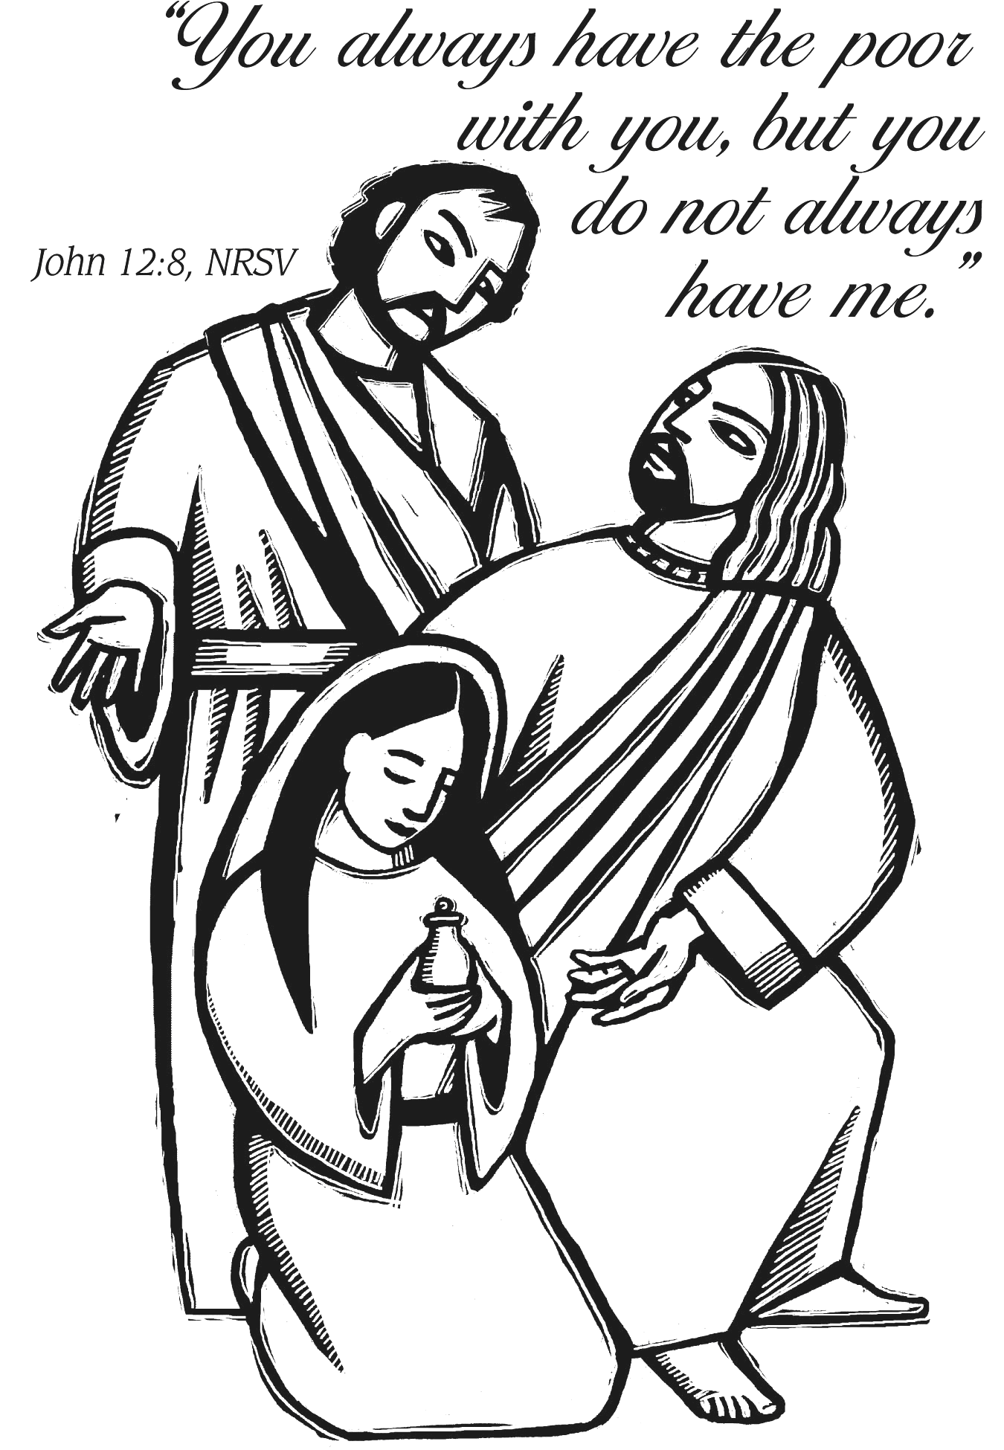

The Valleys
Evangelical Covenant Church
Halifax, PA

Church Office Hours: Mon. thru Fri. - 10AM to 3PM
Church Office(717-896-3118)
Web Site - ValleysEcc.Org Email - valleysecc@verizon.net

CHURCH CALENDAR
Mar. 13 - 9:00AM - Sunday School, Confirmation Class-(library)
10:00AM - Pre-Music
10:15AM - Blended Worship (Praise Team & Hymnal) -
Girl Scout Sunday (Children’s Church)
2:00PM - Zumba
6:30PM - Youth Group
Mar. 14 - 8:30AM-Noon - Halifax Senior Center open Mon.-Thurs.
10:00AM - Bible Study (Pastor Deb Haskins, Leader)
Mar. 15 - 6:00-8PM - Girl Scout Troops 10738 & 10740
Newsletter Articles are due today!
Mar. 16 - Noon to 3:00PM - Senior Center Pinochle Card Party
6:00PM - G. S. Trps. 10753 & 10737; 6:30PM Trp. 10728
6:10PM - Zumba Gold; 7:00PM - Zumba
7:00PM - Council Meeting
Mar. 17 - 7:00PM - Community Lenten Service at Zion Stone UM
Mar. 20 - 9:00AM - Sunday School, Confirmation Class-(library)
10:15AM - Palm Sunday - Traditional Worship (Enders)
1:30PM - Dartball Tournament at Valleys (No Zumba)
Mar. 21- 8:30AM-Noon - Halifax Senior Center open Mon.-Thurs.
10:00AM - Bible Study (Pastor Deb Haskins, Leader)
Mar. 24 - 7:00PM - Maundy Thursday Service at Valleys
Mar. 25 - 12:00Noon - Good Friday Community Service at Valleys
Mar. 26 - 11:00AM - Memorial Service for Jim Davis
Mar. 27 - 6:30AM - Easter Sunrise Service at Camp Hebron (Valleys serves breakfast)
9:00AM - Youth Easter Program
10:15AM - Easter Service - Traditional Worship (Enders) - Holy Communion (Children’s Church)
Mar. 28 - 8:30AM-Noon - Halifax Senior Center open Mon.-Thurs.
10:00AM - Bible Study (Pastor Deb Haskins, Leader)
7:00PM - Dartball Banquet at St. Christopher Lutheran
Mar. 29 - 6:00-8PM - Girl Scout Troops 10738 & 10740
Mar. 30 - 6:00PM - G. S. Trps. 10753 & 10737; 6:30PM Trp. 10728
6:10PM - Zumba Gold; 7:00PM - Zumba
7:30PM - Choir
Apr. 3 - 9:00AM - - Sunday School, Confirmation Class-(library)
10:00AM - Pre-Music
10:15AM - Blended Worship (Praise Team & Hymnal) -
Blessing of Food; Fellowship Meal follows Worship
*PRAYER REQUESTS* *(indicates new)
Please remember the people on our Prayer List with prayers, thoughts, and cards: *Sandy Zimmerman, (Pinnacle Health West Shore); *Allen Goss, (Hershey Med. Center); Donna Donahue-Moorhead; Kermit Masser, (Tremont Health & Rehabilitation Center); Ron Zimmerman; Aliyia Shoop, (Brian & Nicole’s Daughter); Ken Klett; June Wiest; Gail Shertzer; Gary Fetterhoff; Jane Baker; Esther Masser; Nancy & Elmer Feidt; Hannah Klinger; Tom Lauver; John Shoop; Tom Hale; Etta & Bob Miller; Dave Miller Sr.; Pastoral Search Committee.
MISSIONS: Covenant Missionaries: Fred & Kelly Prudek;
*Ruth & Peter Dutton.
OUR SHUT INS: Lydia Peiffer; Myra Hoffman
Please remember to inform The Valleys if you or a member of your family is in the hospital as the hospitals will not inform us unless you tell them to contact us. You may call the church office (896-3118) or Donna (717-362-8870) if it is after office hours. ~~~~~~~~~~~~~~~~~~~~~~~~~~~~~~~~~~~~~~~~~~~~~~~~~~~~~~~~~~~~~~

MEMORIAL SERVICE FOR JIM DAVIS will be held at Valleys on Saturday, March 26th at 11:00AM. A light lunch will follow the service.

MARCH 27th EASTER SERVICES:
6:30AM - Easter Sunrise Service at Camp Hebron (Valleys serves breakfast following the service)
9:00AM - Youth Easter Program at Valleys - Egg hunt will follow program.
10:15AM - Easter Worship Service (Traditional) - Holy Communion

MR. STICKY: Order Mr. Sticky buns by Sunday, April 3rd! Order forms are in the church narthex. Forms are for Mon. Apr. 11th and Tues. Apr. 12th. A sign up sheet will be in the narthex for helpers needed both days. Order forms may be given to Jessi Faust or put the form under the church office door. Bulk Orders should be turned in by Sunday, April 3^{rd!} Mr. Sticky buns can be picked up on Monday, April 11th (6:00AM to 1:00PM) or Tuesday, April 12th (6:00AM to 1:00PM) at The Valleys! Have questions? Call the Valleys Church Office at 717-896-3118 or Jessi (717-362-1162) or Ed Berra (717-599-5103).
PLEASE TURN OFF CELL PHONES, PAGERS, ETC. during our worship service. Thank you for your cooperation.

CHURCH ATTENDANCE on Sunday, Mar. 6 was 76.

GIANT GIFT CARDS are available to purchase (before/after church). Valleys receives $5 for every $100 Giant gift card purchased.

AFFIRMATION OF THE INFANT BAPTISMAL COVENANT:
If you were baptized as an infant and wish to give a public, adult witness of your faith in the Lord Jesus Christ in our worship service at Valleys ECC, please call Pastor Deb at the church office (717-896-3118). These are profound and precious events in the Body of Christ where adult believers who were baptized as infants have an opportunity to give a clear witness of their faith in Christ and commitment to continue to follow Him as Lord and Savior.

__________________________________________________________________________________

ASSISTANT CHURCH SECRETARY: The Valleys EC Church is looking for a qualified candidate for the position of Assistant Church Secretary. Hours are limited and will be on an as needed basis. The individual will fill-in for the Church Secretary when she is unavailable. Good computer and phone skills are a priority for this position. Qualified candidates may submit a letter of interest to the church office.
___________________________________________________________________

HALIFAX SENIOR CENTER is open 8:30AM-Noon Mon. thru Thurs. Senior Center is open at 8:30 to 10:00AM for anyone who wishes to play card games in the Multipurpose (meeting) Room. Mar. Bible Study Leader is Pastor Denise Haskins. Calendar is on Bulletin board in narthex. Place coupons for U. S. military families on top of bookcase in the multipurpose (meeting) room.

DEVOTIONALS: Pick up a Free copy of the (Mar., Apr. May)“Our Daily Bread” devotional (available in the church narthex and at the sanctuary door. “These Days” devotional ($5 yearly subscription) is also available. These Days $5 subscription. Please put it in your offering envelope (mark “These Days”).

