The Valleys Evangelical Covenant Church
The Rev. Kristine Heckard, Pastor
Choir Director, Ed Dobbin
Hymnal Technician, Aren Faust
Acolyte, Brooke Croutharmel
March 10, 2013
Fourth Sunday in Lent

(*Indicates all those who are able are invited to stand.)

Chimes
* Passing the Peace Greeting:
All who are able may greet those around them with an embrace or a handshake, accompanied by such words as:
Greeting: “The peace of God be with you.”
Response: “And also with you.”
Greetings and Announcements

* Call To Worship - Dave Novinger
L: Let us come together as part of God’s beloved family.
P: We are indeed God’s children. Let us gather today in God’s house.
L: We have been faithful at times and we have strayed at times from God’s love.
P: But God has never given up on us, always awaiting our return home.
L: God’s love for us is so real that Jesus came to lead the lost home.
ALL: Blessed be the name of the Lord!
L: Come, let us worship our Lord!

Prelude - “Surely the Presence of the Lord Is In This Place”
* Opening Hymn - “He Keeps Me Singing” Pg. 488
* Prayer of Invocation
* Call to Confession
* Confession: (In Unison)
Lord, so many times we have wandered off in our own directions, chasing after our dreams, only to wake up and find ourselves completely lost without You. We have focused only on the present, and forgotten You are the God of Eternity. We have failed You, yet You love us still. Forgive us, Lord, and lead us lovingly home. In Christ we pray. Amen.
* Kyrie: (To Be Sung)
Leader: Lord, have mercy upon us.
People: Lord, have mercy upon us.
Leader: Christ, have mercy upon us.
People: Christ, have mercy upon us.
Leader: Lord, have mercy upon us.
People: Lord, have mercy upon us.
* Assurance of Pardon
* Gloria Patri Pg.623
* Profession of Faith: (In Unison)
We believe in God who created and is creating the world, who came to us in His Son, Jesus; To reconcile and save. Who works by His Spirit. Who calls us into His church to celebrate His presence, to join hands and hearts in service. To proclaim Jesus Christ - crucified and risen - our only hope, in life and in death, and unto the life everlasting. These things we believe in our hearts, and will proclaim with our voices. Amen.
Children’s Sermon
Hymn of Preparation - “He Lifted Me” Pg. 522
Prayer cards will be collected during Second Hymn.
Morning Prayer & The Lord’s Prayer (Debts & Debtors)
Choral Response - “Hear Our Prayer O Lord” Pg. 614
Anthem - “More Love to Thee”

Scripture - Luke 15:1-3, 11b-32
(Found on Pg. 105 of the NT Pew Bible)
Sermon - “God Doesn‘t Play by Our Rules”

Our Morning Offering
Offertory - “I Surrender All”
* Offertory Response - “We Give Thee But Thine Own” Pg. 620
* Prayer of Dedication
* Closing Hymn - “O Jesus, I Have Promised” Pg. 369
* Benediction * Threefold Amen
* Extinguishing of the Candles
* Postlude - “Great Is Thy Faithfulness”
Welcome: On this fourth Sunday in Lent, let us continue to grow stronger spiritually. And let us show our love for one another. We welcome all in the name of our Lord and Savior. If you are a visitor, please take time to sign your name, address, and phone number in our guest book before you leave.

Our beautiful Altar Flowers are presented to the glory of God by Wanda Hendershot in loving memory of her husband Charles.

March Greeters: Brandi Crum and June Gelnett. Announcer: Dave Novinger. Acolyte: Brooke Croutharmel. March Offering Team: Ron Zimmerman, Christopher Maichle, Mike Crum, Aaron Herb.

Lay Readers: Mar. 10 -Pastor Kris; Mar. 17 - Heidi Erb; Mar. 24 - Ron Zimmerman.; Mar. 31 - Bob Endy. If you can not read on the date assigned, please call Pastor Kris at the church (896-3118) or her home (717-422-5788).

Church School Teachers (Adults): Mar. 10 - Dave Novinger; Mar, 17 - Ed & Peggy Berra; Mar. 24 - Boyd Dimpsey; Mar. 31 - Easter Program. If you cannot teach on your assigned Sunday, please inform Dave Novinger or Jessie Faust who will teach in your place.

Nursery: Valleys provides nursery care for children ages 5 and under. Nursery Attendants: Mar. 10 -Brandi Crum; Mar. 17 - Neva Cichy; Mar. 24 - Ann Hale; Mar. 31 - Mary Zeigler. More Nursery attendants are needed! If you would like to help in the Nursery or if you cannot be there on your assigned Sunday, please see Donna Novinger.

Please turn off cell phones, pagers, etc. during our worship service. Thank you for your cooperation.

SERVICE CANCELLATION POLICY
***************************************************************
If a service or activity has to be cancelled due to adverse weather conditions during the winter, please check the following TV stations - WHTM Channel 27 and WHP Channel 21 to see if Valleys appears on their cancellation display.
***************************************************************

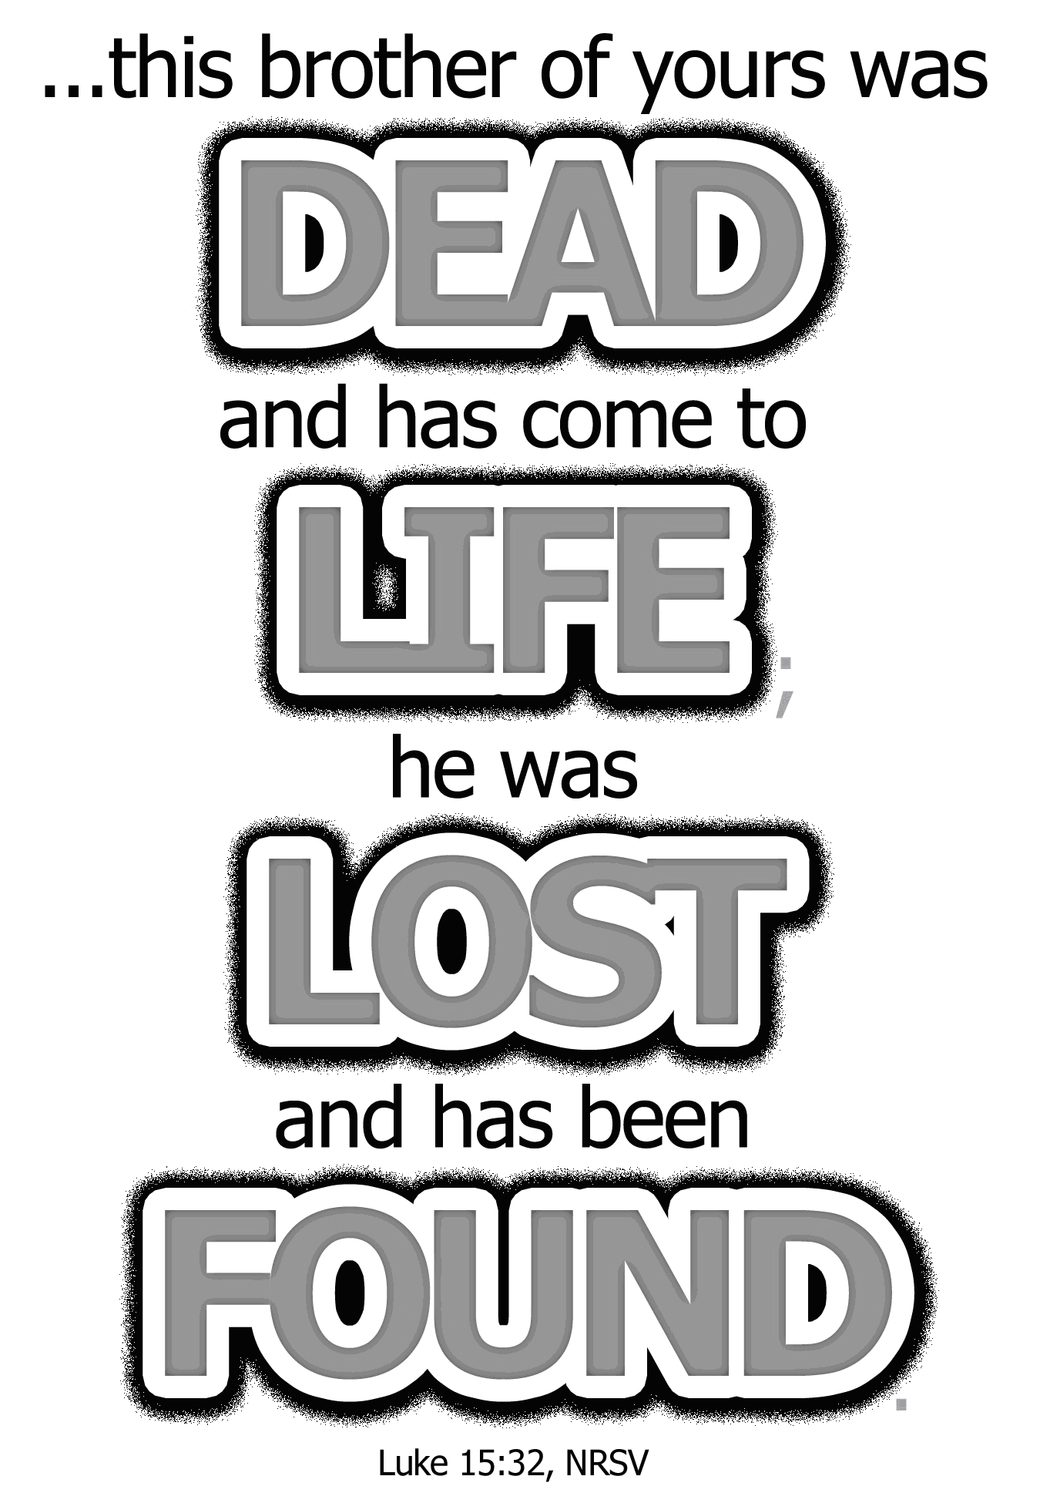

The Valleys
Evangelical Covenant Church
Halifax, PA

Church Office Hours: Mon. thru Fri. - 10AM to 3PM
Church Office(717-896-3118)
Web Site & Email - http://valleysecc.org valleysecc@verizon.net

Pastor’s Hours: Mon., Tues., Thurs.; 10:00AM - 1:00PM
Office (896-3118), Cell (717-818-3041), home (717-422-5788)
Email - KOHeckard@aol.com

CHURCH CALENDAR
Mar. 10 - 9:00AM - Sunday School
10:15AM - Church (Children’s Church)
2:00-3:00PM - Zumba, 3:15-4:00PM - Zumba Gold
Mar. 11 - 10:00AM - Bible Study
6:30PM - Worship Committee (postponed last week) 7:30PM - Dartball - St. Christopher at Valleys
Mar. 12 - 6:00-8:00PM - Girl Scout Troop 10738 (2 & 4 Tuesday)
Mar. 13 - 6:00-7:00PM - Girl Scout Daisy Trp. 10753 (2 & 4 Wed.)
NO Choir practice this week!
Mar. 14 - 1:00-2:00PM - “In It Together” (“Jesus & The Parables”)
7:00PM - Community Lent Service at Messiah Lutheran - Pastor Kris Heckard, Speaker on “Seeds”
Mar. 15 - 7:00-11PM - Stamp Camp (Contact Joanne Enders for info)
Mar. 17 - 9:00AM - Sunday School
10:15PM - Church (Children’s Choir)
Confirmation Class after church (bag lunch)
1:30PM - Dartball Tournament (social hall) (No Youth Grp.)
2:00-3PM - Zumba 3:15-4PM - Zumba Gold (Meeting Rm.)
Mar. 18 - 10:00AM - Bible Study
Mar. 19 - 7:30PM - Choir
Mar. 20 - 6:00PM - Calendar Meeting (First Day of Spring)
7:00PM - Council Meeting
Mar. 21 - 9:00AM - Comm. Circle of Prayer at Zion-Stone U. M.
1:00-2:00PM - “In It Together” (“Jesus & The Parables”)
6:00-8:00PM - Girl Scout Troop 10728 (1, 3, 5 Thurs.)
7:00PM - Community Lent Service at Zion-Stone
Methodist - Pastor Mike Petresky, Speaker on “Bare Branch”
Mar. 24 - 9:00AM - Sunday School (Palm Sunday)
10:15AM - Church (No Mission Sun. Service in March)
Mission Offering

Holy Week Services at Valleys:
Maundy Thursday Service, March 28th will be held at Valleys at 7:30PM. More details in upcoming bulletins.
Easter Sunday, March 31st:
Youth Easter Program will be held at 9:00AM. (Egg hunt follows program. Final Rehearsal will be held on Friday, Mar. 29th 7:00-8:30PM)
Easter Communion will be held at 10:15AM.
*PRAYER REQUESTS*
Please remember all the people on our Prayer List with prayers, thought, and cards: *(indicates new)
Members & Friends of The Valleys: Navigate Pathway; *Melba Croutharmel (Home); *Lindsey Motter, (Billy Motter’s wife); *Glen & Brenda Jones; Marie Herb; Donald Hoke & Richard Hoke; Baby Elaina Parker; Sandy Zimmerman; Marion Etzweiler; Allen Goss; Pauline Novinger; Elvin & Betty Lebo; Gregg Gelnett; Romanie Deitrich; Nevin Maurer; Carley Enders; Margie Zeigler, (Frey Village).
Missions: Covenant Missionaries: Fred & Kelly Prudek; *Cheryll Anderson Clark.
Our Shut Ins: Anna Portzline; Lydia Peiffer; Minnie Baker
Military: Wesley Eshleman, (grandson of Betty Eshleman), stationed in Kuwait. Cameron Heddings, (grandson of Bonita Heddings), is stationed in Afghanistan).
Please inform Pastor Kris if you or a member of your family is in the hospital as the hospitals will not inform us unless you tell them to contact us. You may call the church office (896-3118) or Pastor Kris (818-3041).
~~~~~~~~~~~~~~~~~~~~~~~~~~~~~~~~~~~~~~~~~~~~~~~~~~~~~~~~~~~~~
Community Lent Services (sponsored by Halifax Ministerium) Light refreshments will follow the service.
Thursday, Mar. 14 (7:00PM) - at Messiah Lutheran Church -
Pastor Kris Heckard - Speaker - “Seeds”
Thursday, Mar. 21 (7:00PM) - at Zion-Stone U Methodist Church - Pastor Mike Petresky, Speaker - “Bare Branch”
Easter Sunday, Mar. 31 - (Easter Sunrise Service 6:30AM) - at Camp Hebron - Pastor Ron Reitz - Speaker - “Butterfly” (Breakfast will be served following Sunrise service).
~~~~~~~~~~~~~~~~~~~~~~~~~~~~~~~~~~~~~~~~~~~~~~~~~~~~~~~~~~~~~~
Mr. Sticky will be at Valleys Monday, April 22nd & Tuesday, April 23rd! White forms are for Mon., Apr. 22nd (personal or individuals) and colored forms are for Tues. Apr. 23rd (business/ large orders). Cost is $3.00 per bun. Buns will be available both days. Order sheets or sign up sheet to help available in the narthex. (Sponsored by the Fellowship Group, proceeds go to the General Fund.) See Ron Zimmerman if you have any questions.

Giant Gift Cards available to purchase (before/after church)!
Church Attendance last Sunday, Mar. 3, 2013 was 79.

Halifax Area Senior Center
Possible re-opening of the center
Would you be willing to come to the center for more than the monthly meeting of the Halifax Area Senior Citizens?

Possible programs: Computer classes for Seniors, Cards, Bingo, Board games, Chess/checkers, Dominos, Jig saw puzzles, AARP Driving Classes, Crafts, Line dancing, Book exchange, Coupon exchange, and Much, much more!

See Ann Hale or Barbara Lauver if you have any suggestions/ questions or you are interested.

Thank you:
March 5, 2013
Dear Valleys Congregation:
I do want to thank you for participating in the 2013 Baby Bottle Campaign for Lifeline, and then for allowing me to share with you. It was a joy for me to be with you. I felt very at home there. I also know for sure that God wanted me to share with you that day!
Once again you proved my observations to be correct - the smallest churches have the biggest hearts. It is true all though the valley, and we just feel deeply blessed by your support for us and our clients. You have been a tremendous blessing to us and we thank God for you.
We praise the Lord for the initial count on February 18, 2013; we had received $242.71 from your church. Please feel free to return any bottles; we will continue to add to our totals. In this economic time, we feel blessed.
We are very appreciative to everyone who has helped support this campaign. We cannot continue with our ministry without the support of all our friends.
May God continue to bless you and your ministry.
In His Service,
Jennifer Leshko
Executive Director
Dartball: Give your reservation for the Dartball banquet (March 25th, 7:00PM at St. Christopher (Lykens) to Pete Bryson by next Sunday, Mar. 17th! Cost: $8.00 per person, 9-4 yrs. $4.00, 3 & under Free. Valleys is providing paper products, chips/pretzels, drink for the Dartball Tournament next Sun. Mar. 17th!

