The Valleys Evangelical Covenant Church
Rev. David Guertin, Pastor
Worship Technicians: Bridget Campbell & Neva Cichy
February 26, 2017 - Worship, 10:15AM
Transfiguration Of Our Lord
“Strong in the Word to Serve in the World”

(*Indicates: Stand as you are able.)

ANNOUNCEMENTS Bob Endy

* “Blessed Be Your Name” Brenton Brown
“10,000 Reasons (Bless the Lord)” Matt Redman
“In Christ Alone” Matt Redman

* PRAYER
* CONFESSION: (In Unison)
God, you speak to us in so many ways, but we are not listening because we hear only what we want to hear and listen only to those voices with which we agree. You show yourself to us in so many people, but we do not see because in our eyes these persons do not appear to be worthy. Cure our deafness and heal our blindness, we pray, that we may behold the glory of your love and hear the voice that will direct us in the path that leads to your kingdom. Amen.

* ASSURANCE: (Responsively)
L: The grace of God not only cleanses us but also changes us.
P: His love renews us as well as restores.
ALL: When we ask for forgiveness we are also submitting ourselves for reformation.

* AFFIRMATION OF FAITH: (Responsively)
L: We celebrate the resurrected Jesus, who lives among us,
P: whose Spirit empowers us to remove barriers, tear down walls, heal divisions, and seek peace within.
L: We celebrate the resurrected Jesus, who lives among us,

P: whose Spirit empowers us to see our sister’s good as our own, to be our brother’s advocate, to love our neighbor as ourselves, and to contribute to the well-being of every part of Christ’s body,
ALL: so that indeed we can build up, and grow up, and be joined together into a new structure: where Christ’s Spirit empowers us to be peace-seekers, peace-finders, and peace-makers.

HYMN - “Be Thou My Vision” Page 382

PRAYER REQUESTS/JOYS

PRAYER / LORD’S PRAYER
Our Father, who art in heaven, Hallowed be thy Name. Thy kingdom come. Thy will be done, on earth as it is in heaven. Give us this day our daily bread. And forgive us our debts, as we forgive our debtors. And lead us not into temptation, but deliver us from evil. For thine is the kingdom, and the power, and the glory, for ever. Amen.

SCRIPTURE - Matthew 17:1-9 (follow screen)
Bob Endy, Lay Reader

MESSAGE- “Listen To Him”

OFFERING
OFFERTORY- “Joy of the Lord” Rend Collective
PRAYER OF DEDICATION

* HYMN - “Fairest Lord Jesus” Page 88
* BENEDICTION
* GREETING: “The peace of God be with you.”
RESPONSE: “And also with you.”
* PASSING THE PEACE: Please greet those around you.
* POST-SERVICE MUSIC

Welcome to Worship at the Valleys. We want to personally welcome all visitors. Please take time to sign our guest book located in the foyer as you leave.

WORSHIP PARTICIPANTS
Feb. Greeters  Dale Faust, Gerry Wiest | Mar. Greeters: Shirley Miller, Donna Motter, Dave Novinger
Feb. Acolyte  Alaina Snyder | Mar. Acolyte  Brooke Croutharmel
Feb. Announcer  Bob Endy | Mar. Announcer  Diane Shaffer
Feb. Offering Team (Team 2)*  Shirley Miller, (Capt.), Carol Knight, Rachael Bryson, To be announced | Mar. Offering Team (Team 3)*  Mike Crum, (Capt.), Cailey Crum, Chris Herb, Sr., Aaron Herb

*Please tell the Captain if you are unable to be present for a Sunday in your month as the Captain will need to get someone to help with the offering if you cannot be there. On the 1st Sunday of the month, Offering team is to take the food baskets to the altar to be blessed.

 | Feb. 26 | Mar. 5 | Mar. 12 | Mar. 19
Lay Readers | Bob Endy | Gary Fetterhoff | Laurel Guertin | Ken Bechtel
Nursery Attendants | Ann Hale | Patty Hummel | Shirley Miller | Neva Cichy
Adult Sun. School Teachers | Bob Endy | Donna Novinger | Marie Herb | Dave Novinger

Please call the church office (717-896-3118) if you are unable to be Lay Reader or Nursery Attendant on your scheduled Sunday or if you would like to be a Worship Participant, please see Donna Novinger or Pastor Dave. Please tell Ken Bechtel who will teach Sunday School if you cannot be there on your assigned Sunday.

9:00AM Sunday School Class Options:
Adult Class - Social Hall Choices - Multi-purpose Room Friends In Faith - Computer Room
Confirmation class – Library

PLEASE TURN OFF CELL PHONES, PAGERS, ETC. during our worship service. Thank you for your cooperation.

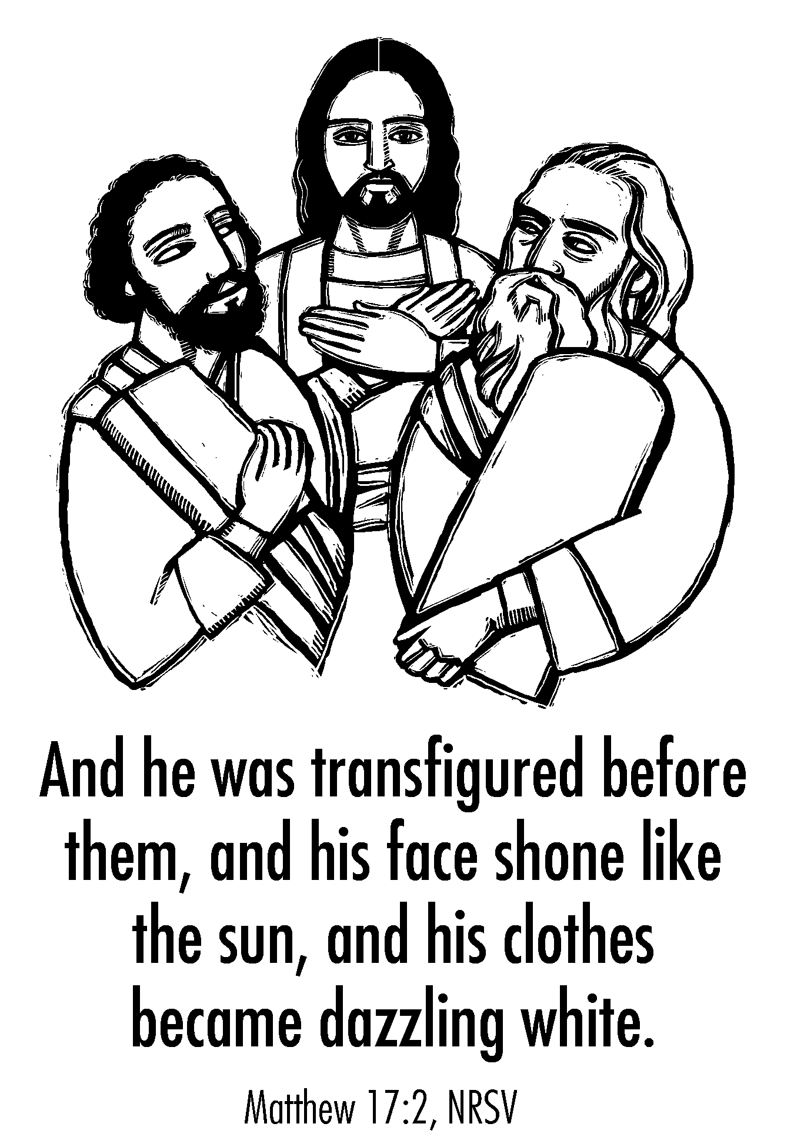

The Valleys
Evangelical Covenant Church
Halifax, PA

Pastor David Guertin
Office (717-896-3118), Cell (1-715-497-4310)
Email - daveguertin64@gmail.com

Church Office Hours: Mon. thru Fri. - 10AM to 3PM
Church Office (717-896-3118)
Web Site - ValleysEcc.Org Email - valleysecc@verizon.net

CHURCH CALENDAR
Feb. 26 - 9:00AM - Sunday School/Confirmation Class
10:15AM - Blended Worship - Praise Team & Hymnal -
Mission Offering
2:00PM - Zumba
Feb. 27 - Halifax Senior Center open Mon.-Thurs. -
(Yoga Exercise 9:00AM at Senior Center Mon.-Wed.)
10:00AM - Bible Study (Pastor Mike Petresky, Leader)
7:30PM - Dartball - Lykens U. M. at Valleys
Feb. 28 - 6:00-8PM - G. S. Trps. 10738 & 10740
Mar. 1 - 7:00PM - ASH WEDNESDAY SERVICE at Valleys
(No Choir, Girl Scouts or Zumba)
Mar. 5 - 9:00AM - Sunday School/Confirmation Class
10:15AM - Traditional Worship - Hymnal - Holy
Communion (Altar )- Food Offering; Special Offering
Fellowship Covered Dish Meal follows Worship Service
2:00PM - Zumba
Mar. 6 - Halifax Senior Center open Mon.-Thurs. -
(Yoga Exercise 9:00AM at Senior Center Mon.-Wed.)
10:00AM - Bible Study (Dave Novinger, Leader)
5:30PM - Prayer Team
6:00-8PM - G. S. Leaders
7:00PM - Elders Meeting
7:30PM - Dartball - St. John’s Lutheran at Valleys
Mar. 7 - 6:00-8PM - G. S. Trps. 10738 & 10740
7:00PM - Deacons Meeting
Mar. 8 - 6:10PM - Zumba Gold; 7:00PM – Zumba
No Choir
Mar. 9 - 7:00PM - Community Lenten Service at Halifax U. Methodist Church, (Pastor Mike Petresky, Speaker)
Mar. 12 - 9:00AM - Sunday School/Confirmation Class
10:15AM - Blended Worship - Praise Team & Hymnal
1:00-5PM - G. S. Sister-to-Sister Event

Praise Team Rehearsal - To be announced for March.

CHURCH ATTENDANCE on Sunday, Feb. 19 - 71.

Turn your clocks ahead one hour on Saturday, March 11th!

*PRAYER REQUESTS* *(indicates new)
Please remember all the people on our Prayer List with prayers, thoughts, cards: MEMBERS & FRIENDS OF THE VALLEYS:
*Don Markel, Jr., (Pat Snyder’s son-in-law); Ann Cooper; Ron & Sandy Zimmerman; Elmer Feidt; Tom Hale; Ritchie Moorhead; Gary Fetterhoff; Jane Baker; Esther Masser; Hannah Klinger; Gail Shertzer; Tom Lauver; Vickie Shoffler; Bob Knight; Pat & Richard Snyder; Everly Shoop, (Jan Quinn’s Granddaughter); Ben Baker, (Dennis &Barbara Croutharmel’s grandson).
OUR SHUT INS: Myra Hoffman, June Wiest
MISSIONS: Covenant Missionaries: Fred & Kelly Prudek;
*Aleta & Roy Danforth; *Jen & Minh Dao; *Jenifer & Rudel DeCastro; *Central African Republic (CAR); Center for Experimentation & Formation in Agriculture in Gamboula (CEFA) and Serve Globally; Covenanters in World Mission.

Please remember to inform The Valleys if you or a member of your family is in the hospital as the hospitals will not inform us unless you tell them to contact us. You may call the church office (896-3118) or or Donna (717-362-8870) if it is after office hours. ~~~~~~~~~~~~~~~~~~~~~~~~~~~~~~~~~~~~~~~~~~~~~~~~~~~~~~~~~~~~~~

~~~~~~~~~~~~~~~~~~~~~~~~~~~~~~~~~~~~~~~~~
TREASURER: The Valleys is seeking someone to assume the duties of Treasurer due to the retirement of the current Treasurer, Mrs. Rachael Bryson. This is a paid position which involves approximately 6 hours of work a month. Persons interested in assuming this ministry, please contact Pastor Dave or Dave Novinger, Council President.
~~~~~~~~~~~~~~~~~~~~~~~~~~~~~~~~~~~~~~~~~

ASH WEDNESDAY SERVICE will be held at Valleys on March 1st at 7:00PM to begin the Lenten Season.

HALIFAX MINISTERIUM COMMUNITY LENT SERVICES will begin on Thursday March 9th at 7:00PM at Halifax United Methodist Church. Pastor Mike Petresky will be the speaker.

TURN YOUR CLOCKS AHEAD! Don’t forget to turn your clocks ahead one hour on Saturday, March 11th!

SPECIAL OFFERING: On Sunday, March 5th there will be a “Special Offering” for Covenant World Relief MENA (Middle East, North Africa) Mission.

MR. STICKY will be at Valleys on Mon., March 27th and Tues., March 28th. Order forms are available in the church foyer. Bulk Orders need to be in by Sun., March 19th. Helpers are needed for both days! See Ed Berra (717-599-5103) if you have questions.

“THESE DAYS” DEVOTION BOOKS RENEWAL ($5.00 yearly subscription is due.) Please put it in your offering envelope (mark “These Days”) or give it to Donna Novinger.

GIANT GIFT CARDS are available to purchase (before/after church).Valleys receives $5 for every $100 Giant gift card purchased.

MISSION OFFERING for January thru April goes to Community Meals. Donations may be put in your offering envelope or in the basket in the rear of the sanctuary.

HALIFAX SENIOR CENTER is open 8:30AM-Noon Mon. and Thurs. Between the hours of 8:30 to 10:00AM anyone who wishes, is invited to play card games in the Multipurpose (meeting) Room. February Leader is Pastor Mike Petresky. Calendar is on Bulletin board in foyer.
NEW FOR THOSE WHO WISH SOME GENTLE EXERCISE: Yoga Exercise for Seniors (and anyone else who wishes to come) is held Monday, thru Wednesday at 9:00AM (except the week of the card party or if the Senior Center is closed) - everyone is welcome!

SERVICE CANCELLATION POLICY
**************************************************************
If a service or activity has to be cancelled due to adverse weather conditions during the winter, please check the following TV stations - WHTM Channel 27 and WHP Channel 21 to see if Valleys appears on the their cancellation display. ***************************************************************

DONATIONS FOR PARAMENTS are being accepted to replace Valleys worn out paraments for the altar table, pulpit and lectern (cost is approximately $260). If you wish to give a donation, please mark “Paraments” on your offering envelope.

2017 HALIFAX MINISTERIUM
COMMUITY LENTEN SERVICES

DATE | LOCATION | PREACHER | Person/SCRIPTURE
Thurs.,Mar. 9  7:00pm | Halifax United Methodist Church | Pastor  Mike Petresky | Mary, Mother of Jesus
Thurs.,Mar. 16  7:00pm | Zion Stone United Methodist Church | Pastor  Dale  Parker | Simon Peter
Thurs.,Mar 23  7:00pm | St. Peter (Fetterhoff’s) Lutheran Church | Pastor  April  Ocasio | The Passersby
Thurs.,Mar 30  7:00pm | Faith United Methodist Church | Pastor  John  Lesher | Simon the Cyrean
Thurs.,Apr. 6  7:00pm | Uplift Community Church of God &  Isaiah 61 | Pastor  Dave  Layser | Roman Centurion
Friday,  Apr. 14  12:00 Noon | Valleys  Evangelical Covenant Church | Pastor  Dave Guertin | Community Good Friday Service
Sunday  Apr. 16  Easter Sunrise Service 6:30am | Camp Hebron  (Breakfast served by Halifax U. M. after service) | Pastor Ron  Reitz | Jesus Christ

