The Valleys Evangelical Covenant Church
The Rev. Kristine Heckard, Pastor
Song Leader, Ed Dobbin
Worship Technicians:
Aren Faust, Aaron Herb, & Cameron Crum
February 24, 2013
Second Sunday in Lent

(*Indicates all those who are able are invited to stand.)

Pre-Service Music -
“Jesus My Friend” Phillip Keveren
“Hymns of the Cross” Phillip Keveren
“I Believe” Hughes Brothers

* Passing the Peace Greeting:
All who are able may greet those around them with an embrace or a handshake, accompanied by such words as:
Greeting: “The peace of God be with you.”
Response: “And also with you.”
Greetings and Announcements Peggy Berra

* Praise Hymns - (Follow Screen)
“All Things Bright and Beautiful”
“I Sing the Mighty Power of God”
* Opening Prayer
* Confession: (In Unison)
Holy Lord, in Christ you gave us the complete model of how to be people of faith. You showed us the way of faith is to follow you completely, even unto darkness, trusting that your grace and power can overcome anything. You showed this to be true in Jesus, who said to you, “not my will, but thy will be done,” and you responded with the glory of resurrection. This same offer of hope and glory is given to us, but we let fear be our god. We shy away from making a true commitment of sacrificing our lives to you and trusting you in everything. As a result, we only rarely discover the fullness of life that you offer us. Help us to be more committed to you so we can live lives filled with you. In Christ’s name we pray. Amen.
* Assurance:
Leader:
The promise of the gospel is sure and true. Though we may experience times of darkness and struggle, if we turn our lives over to Christ and rejoice in the Lord, God will give us feet like a deer that tread upon the high places. God gives the gift of joy to those who persevere.

* Profession of Faith: (In Unison)
Pastor: Let us declare our faith in God.
All: We believe in God the Father, from whom every family in heaven and on earth is named.
We believe in God the Son, who lives in our hearts through faith, and fills us with his love.
We believe in God the Holy Spirit, who strengthens us with power from on high.
We believe in one God; Father, Son and Holy Spirit. Amen.
How Goes Your Walk?
Morning Prayer & The Lord’s Prayer (Debts & Debtors)
Hymn - “Jesus Loves Me” (Follow Screen)

Scripture - Jeremiah 1:5, Psalm 139:13-16 (Follow Screen)
Christopher Maichle, Lay Reader
Meditation: “God’s Precious Children”

Mission Highlight Lifeline Pregnancy Care Center
Jennifer Leshko, Executive Director
Our Morning Offering
Offertory - “In His Hands“ Hughes Brothers
Prayer of Dedication

* Closing Hymn (Follow screen)
“O, How He Loves You and Me”
“Grace, Love & Fellowship”
* Commissioning
* Post-Service Music
“Hymns of Creation” Phillip Keveren
Welcome: We welcome you to our Mission Sunday service. We are all children of God; let us reach out in love to help others. If you are a visitor, please take time to sign your name, address, and phone number in our guest book before you leave.

Our Beautiful Altar Flowers are presented to the glory of God by Clarence and Laura Roush in honor of their 51st Wedding Anniversary which was February 17th.

February Greeters: Gerry Wiest and Mike Crum. Announcer: Peggy Berra. Acolyte: Whitney Faust. February Offering Team: Ken Breeman, Shirley Miller, Carol Knight, To be announced.
March Greeters: Brandi Crum and June Gelnett. Announcer: Dave Novinger. Acolyte: Brooke Croutharmel. March Offering Team: Ron Zimmerman, Christopher Maichle, Mike Crum, Aaron Herb.

Lay Readers: Feb. 24 - Christopher Maichle; Mar. 3 - Cameron Crum; Mar. 10 - Karla Lesher; Mar.17 - Heidi Erb. If you cannot read on the date assigned, please call Pastor Kris at the church (896-3118) or her home (717-422-5788).

Church School Teachers (Adults): Feb. 24 - Ann Cooper; Mar. 3 - Ed Dobbin; Mar. 10 - Dave Novinger; Mar. 17 - Ed & Peggy Berra. If you cannot teach on your assigned Sunday, please inform Dave Novinger or Jessie Faust.

Please turn off cell phones, pagers, etc. during our worship service. Thank you for your cooperation.

Giant Gift Cards available to purchase (before/after church)!
Church Attendance last Sunday, Feb. 10, 2013 was 79.

SERVICE CANCELLATION POLICY
********************************************************************************************
If a service or activity has to be cancelled due to adverse weather conditions during the winter, please check the following TV stations - WHTM Channel 27 and WHP Channel 21 to see if Valleys appears on their cancellation display.
*******************************************************************************************

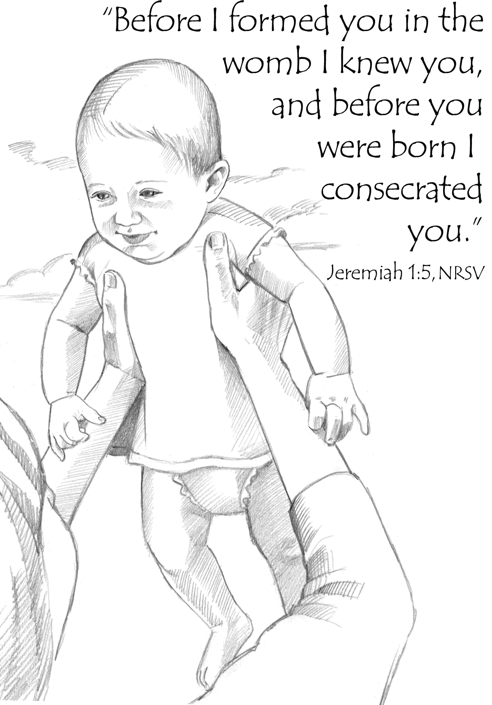

The Valleys
Evangelical Covenant Church
Halifax, PA

Church Office Hours: Mon. thru Fri. - 10AM to 3PM
Church Office(717-896-3118)
Web Site & Email - http://valleysecc.org valleysecc@verizon.net

Pastor’s Hours: Mon., Tues., Thurs.; 10:00AM - 1:00PM
Office (896-3118), Cell (717-818-3041), home (717-422-5788)
Email - KOHeckard@aol.com

CHURCH CALENDAR
Feb. 24 - 9:00AM - Sunday School
10:15AM - Church - Mission Sunday - focus on Lifeline Pregnancy Center Baby Bottles Mission Offering
2:00-3:00PM - Zumba 3:15-4:00PM - Zumba Gold
Feb. 25 - 10:00AM - Bible Study (Loretta & Wilbur Prouse)
6:30-7:30PM - Girl Scout Troop 10463
7:30PM - Dartball - Valleys at Lykens UM
Feb. 26 - 6:00-8:00PM - Girl Scout Trp. 10738 (meets 2 & 4 Tuesdays)
Feb. 27 - 6:00-7:00PM - Daisy Girl Scout Troop 10753
7:30PM - Choir
Feb. 28 - 1:00-2:00PM -“In It Together”-“Jesus &The Parables”
7:00PM - Community Lent Service at Valleys ECC - Dale Parker, Speaker on “Salt”
Mar. 3 - 9:00AM - Sunday School
10:15AM - Church (Children’s Church) Fellowship Covered dish Meal after church; Confirmation Class meets
2:00-3:00PM - Zumba, 3:15-4:00PM - Zumba Gold
6:30PM - Youth Group
Mar. 4 - 10:00AM - Bible Study (Lanny Millette)
5:30PM - Prayer Team
6:00-9:00PM - Girl Scout Leaders Meeting
7:30PM - Dartball - St. John’s Lutheran at Valleys
Mar. 5 - 6:30-7:30PM - Girl Scout Troop 10463 (1& 3 Tues.)
Mar. 6 - 6:30PM - Worship Committee Meeting
7:30PM - Choir
Mar. 7 - 12:00Noon - Senior Citizens (covered dish meal at Valleys) 1:00-2:00PM -“In It Together”-“Jesus &The Parables”
6:00-8:00PM - Girl Scout Troop 10728
7:00PM - Community Lent Service at Faith U. Methodist - David Layser, Speaker on “Water”
Mar. 10 - 9:00AM - Sunday School (Daylight Savings Time Begins!)
10:15AM - Church (Children’s Church)
Mar. 11 - 10:00AM - Bible Study
7:30PM - Dartball - St. Christopher at Valleys
Mar. 13 - 6:00-7PM - Girl Scout Trp. 10753 7:30PM - Choir
Mar. 14 - 1:00-2:00PM -“In It Together”-“Jesus &The Parables”
7:00PM - Community Lent Service at Messiah Lutheran -
Kris Heckard, Speaker on “Seeds”
Mar. 15 - 7:00-11:00PM - Stamp Camp (See Joanne Enders for info)
Mar. 17 - 9:00AM - Sunday School 10:15AM - Church (Children’s Choir)
Confirmation Class meets following church
1:30PM - until? - Dartball Tournament at Valleys
*PRAYER REQUESTS*
Please remember all the people on our Prayer List with prayers, thought, and cards: *(indicates new)
Members & Friends of The Valleys: Navigate Pathway; *Sandy Zimmerman, (Home); Marion Etzweiler; Sarah Graff; Ed Berra; Marie Herb; Allen Goss; Elvin & Betty Lebo; Pauline Novinger; Melba Croutharmel; Romanie Deitrich, (Gloria Duttry‘s sister); Galen Snyder; Edna Crum; Bob Hawk; Larry Croutharmel, (Dennis’s brother); Gregg Gelnett; Carley & Paul Enders; Shirley Harris; Nevin Maurer; Margie Zeigler, (Frey Village)
Missions: Covenant Missionaries: Fred & Kelly Prudek; *Gary & Pauline Carlson.
Our Shut Ins: Minnie Baker; Anna Portzline; Lydia Peiffer
Military: Cameron Heddings, (grandson of Bonita Heddings is stationed in Afghanistan). Wesley Eshleman, (grandson of Betty Eshleman is stationed in Kuwait).
Please inform Pastor Kris if you or a member of your family is in the hospital as the hospitals will not inform us unless you tell them to contact us. You may call the church office (896-3118) or Pastor Kris (818-3041).
Nursery: Valleys provides nursery care for children ages 5 and under. Nursery Attendants: Feb. 24 - Ann Hale; Mar. 3 - Tracey Cooper; Mar. 10 -Brandi Crum.; Mar. 17 - Neva Cichy. If you would like to help in the Nursery or if you cannot be there on your assigned Sunday, please see Donna Novinger.
Easter Flowers: See Gloria Duttry to order Easter Flowers by Sun., March 3rd (list of flowers/prices is on bulletin board).
Fellowship Meal: Please join us for our covered dish Fellowship Meal on Sunday, Mar. 3rd. Please bring a meat dish or vegetable casserole and a dessert and join us in a time of fellowship.
Community Lenten Services at 7:00PM at the following churches (sponsored by Halifax Ministerium).
Thurs., Feb. 28 - at The Valleys E. C. C. - Dale Parker - Speaker - Salt
Thurs., Mar. 7 - at Faith U. M. C. - David Layser - Speaker -Water
Thurs., Mar. 14 - at Messiah L. C. - Kris Heckard - Speaker - Seeds
Thurs., Mar. 21 - at Zion-Stone U. M. C. - Mike Petresky - Speaker - Bare Branch
Easter Sunday, Mar. 31 - at Camp Hebron (Easter Sunrise Service 6:30AM) - Ron Reitz - Speaker - Butterfly (Breakfast follows)
Mr. Sticky will be at Valleys Mon. Apr. 22nd & 23rd!

