The Valleys Evangelical Covenant Church
The Rev. Kristine Heckard, Pastor
Worship Technicians: Aren Faust & Bridget Campbell
February 22, 2015 - Blended Worship, 10:15AM

“Strong in the Word to Serve in the World”

(*Indicates all those who are able are invited to stand.)

Sing a New Song -
“Rejoice in the Lord Always” Page 489
“Jesus Loves Me”
“Proof of Your Love” For King & Country

Greetings and Announcements Peggy Berra

* Praise Hymn - (follow screen)
“I Love You, Lord” (Sing Twice) Page 80

* Opening Prayer
* Confession/Assurance of Pardon (follow screen)
* Profession of Faith (follow screen)
Prayer Request

Morning Prayer and Lord’s Prayer

Hymn - (follow screen)
“The Bond of Love” Page 281

Scripture - I Corinthians 13:1-13 (follow screen) Ron Zimmerman, Lay Reader

Meditation - “Learning How To Love”

Our Morning Offering
Offertory - “We Believe” Newsboys
Prayer of Dedication
* Closing Hymn (follow screen)
“Love Divine, All Loves Excelling” Page 92

* Commissioning
* Passing the Peace Greeting:
All who are able may greet those around them with an embrace or a handshake, accompanied by such words as:
Greeting: “The peace of God be with you.”
Response: “And also with you.”
* Post-Service Music - “Behold, What Manner of Love“”

Welcome: A joyous greeting to all who have come to worship. It is our hope that each of you may find encouragement, inspiration and direction for living. Above all, we pray that you may sense the loving presence of God. If you are a visitor, please take time to sign your name, address, and phone number in our guest book before you leave.

February 2015….
Greeters: Gerry Wiest and Arletta Thomas.
Announcer: Peggy Berra. Acolyte: Alaina Snyder.
Offering Team: Shirley Miller, (Captain), Carol Knight, Rachael Bryson, To be announced.

March 2015….
Greeters: Shirley Miller and Donna Motter
Announcer: Bob Endy. Acolyte: Brooke Croutharmel.
Offering Team: Ron Zimmerman, (Captain), Aaron Herb, Mike Crum, Cameron Crum.
Please tell the Captain if you are unable to be there for a Sunday in your month. The Captain is responsible to get someone to help with the Offering Team if a member of the team cannot be there.

Lay Readers: Feb. 22 - ; Mar. 1 - Cameron Crum; Mar. 8 - Sharon Fetterhoff; Mar. 15 - Heidi Erb. If you cannot read on the date assigned, please call Pastor Kris at the church (896-3118) or her home (717-422-5788).

Nursery: Valleys provides nursery care for children ages 5 and under. Feb. 22 - Carol Cooper; Mar. 1 - Neva Cichy; Mar. 8 - Patty Hummel; Mar. 15 - Shirley Miller. If you wish to help in the Nursery or if you cannot be there on your assigned Sunday, please see Donna Novinger.

Church School Teachers (Adults): Feb. 22 - Carol Reisch; Mar. 1 - Ann Cooper; Mar. 8 - Ed Dobbin; Mar. 15 - Dave Novinger. If you cannot be there on your assigned Sunday, please inform Jessie Faust who will teach in your place.

9:00AM Sunday School Class Options:
Adult Class - Social Hall
Choices - Multi-purpose Room
Friends In Faith - Library

Please turn off cell phones, pagers, etc. during our worship service. Thank you for your cooperation.

2015 Flower Chart is on the bulletin board if you wish to sign up for flowers. The cost for Altar Flowers is $30.00.

LifeLine Pregnancy Center Baby Bottle Campaign: Due to church being cancelled last Sunday LifeLine granted a week extension for Baby bottles to be returned by today, Sunday, Feb. 22nd.

Council Meeting will be held on Wednesday, February 25 at 7:00PM instead of Feb. 18

HALIFAX MINISTERIUM COMMUITY LENTEN SERVICE begins on Wednesday, February 26th at 7:00PM at Halifax United Methodist Church. Pastor Mike Petresky will be the speaker on “I Am Crucified with Christ - Galatians 2:20, 5:24; and 6:14. Please make every effort to go to as many Lenten Services as possible.

Fellowship Covered Dish Meal: Please join us for our Fellowship Covered Dish Meal on Sunday, March 1st following Traditional Worship. Please bring a covered dish (meat or vegetable dish and a dessert) to share and join us in fellowship.

Order Easter Flowers: Gloria Duttry will take orders for Easter Flowers on Mar. 1st, Mar. 8th, and Mar. 15th. Flowers and prices are posted on the bulletin board in the Narthex.

Church Attendance for Sunday, Feb. 8th was 56; Church was cancelled last Sunday, Feb. 15 due to weather.

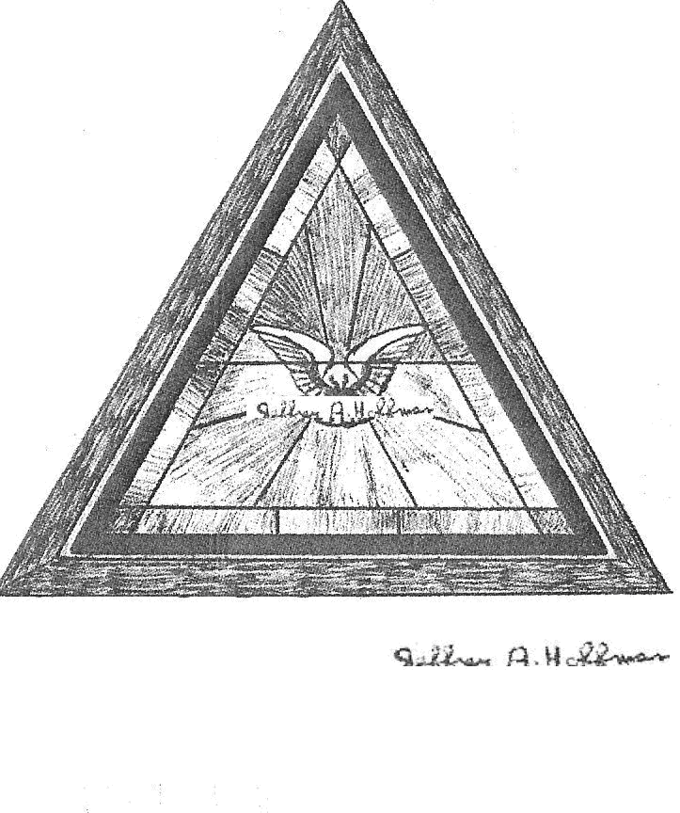

The Valleys
Evangelical Covenant Church
Halifax, PA

Church Office Hours: Mon. thru Fri. - 10AM to 3PM
Church Office(717-896-3118)
Web Site - ValleysEcc.Org Email - valleysecc@verizon.net

Pastor’s Hours: Mon., Tues., Thurs.; 10:00AM - 1:00PM
Office (896-3118), Cell (717-818-3041), home (717-422-5788)
Email - KOHeckard@aol.com

CHURCH CALENDAR
Feb. 22 - 9:00AM - Sunday School
10:00-10:15AM - Learn Praise Hymns
10:15AM Blended Worship (Praise Team & Hymnal) -
Mission Offering
2:00PM - Zumba
Feb. 23 - 9:00AM-Noon - Halifax Senior Center open Mon..-Thurs.
10:00AM - Bible Study (Loretta & Wilbur Prouse, Leaders)
10:00AM - Web Meeting
6-7:30PM - Girl Scout Trp. 10737;6-8PM - Girl S Trp. 774
7:30PM - Dartball - St. Christopher at Valleys
Feb. 24 - 6:00-8PM - Girl Scout Troops 738 & 740
7:00-9:00PM - Grief Share Support Group Seminar
Feb. 25 - 6:10PM - Zumba Gold; 7:00PM - Zumba
6:30-7:30PM - Girl Scout Troop 10728
7:00PM - Feb. Council Meeting
Feb. 26 - 7:00PM - Community Lenten Service at Halifax UM
Mar. 1 - 9:00AM - Sunday School
10:15AM - Traditional Worship (Enders) - Baptism
Fellowship Covered Dish Meal follows Worship
2:00PM - Zumba
6:30PM - Youth Group
Mar. 2 - 9:00AM-Noon - Halifax Senior Center open Mon..-Thurs.
10:00AM - Bible Study (Pastor Kris Heckard, Leader)
5:30PM - Prayer Team (No Elders in March)
6:00-8PM - Girl Scout Leaders
7:30PM - Dartball - Valleys at Messiah Lutheran
Mar. 3 - 6:00-8PM - Girl Scout Troop 10463
7:00PM - Deacons
7:00-9:00PM - Grief Share Support Group Seminar
Mar. 4 - 6:10PM - Zumba Gold; 7:00PM - Zumba
7:30PM - Choir
Mar. 5 - 11:30AM - Senior Citizens Meeting (12Noon - Meal)
7:00PM - Comm. Lenten Service at Zion Stone UM
Mar. 8 - 9:00AM - Sunday School
10:00-10:15AM - Learn Praise Hymns
10:15AM Blended Worship (Praise Team & Hymna

The following groups meet at Valleys: Mondays - Victory Group (Weight Loss) - 5:30PM; Tuesdays - Weight Loss Challenge Group - 5:30-7:00PM
Praise Team Rehearsal: (Weeks 2, 4 at church)
*PRAYER REQUESTS*
Please remember all the people on our Prayer List with prayers, thought, and cards: *(indicates new)
Members & Friends of The Valleys: Navigate Pathway; *Tom Lauver, (Harrisburg Hosp. ICU); *Vickie Shoffler, (Home); *June Wiest, (Home); *Ellen Snyder, (Gail Shertzer’s sister); Allen Goss, (Stonebridge Health & Rehabilitation, Rm. 48, Chandra Drive, Duncannon, PA 17020); Sandy Zimmerman; Betty Lebo; ; Gail Shertzer; Nicole & Brian Shoop; Dean Etzweiler; Tom Hale; John Shoop; Ken Breeman; Elmer Feidt; Pam Arsonaul.
Missions: Covenant Missionaries: Fred & Kelly Prudek; *Linda Carolson; *Heather & Dennis Choate; *Cheryll Anderson Clark; *Erika & Nils Clauson.
Our Shut Ins: Minnie Baker; Lydia Peiffer; Myra Hoffman;
Please inform Pastor Kris if you or a member of your family is in the hospital as the hospitals will not inform us unless you tell them to contact us. You may call the church office (896-3118) or Pastor Kris (818-3041).
~~~~~~~~~~~~~~~~~~~~~~~~~~~~~~~~~~~~~~~~~~~~~~~~~~~~~

Free Community Meal on Tuesday, March 10th 5:30-7:00PM. Menu: Fish, Tropical Fruit Salad, Dessert, Drink. Please see the sign up sheet in the narthex for donations and helpers.

GriefShare seminar: The Valleys EC Church is hosting a GriefShare Support Group seminar. GriefShare meets on Tuesdays (7:00-8:30PM) and will continue each week thru Tues., May 12th. There will be 13 sessions with an introduction, a half hour video and about a half hour table discussion. If you are interested, call Ritchie R. Moorhead or Donna Donahue-Moorhead at: Home – 717-896-8515 or Cell (Ritchie) – 570-517-6787. You can also contact us after church. Brochures are available in the narthex.

SERVICE CANCELLATION POLICY
**************************************************************
If a service or activity has to be cancelled due to adverse weather conditions during the winter, please check the following TV stations - WHTM Channel 27 and WHP Channel 21 to see if Valleys appears on their cancellation display.
**************************************************************
PULSE SURVEY: Every living being and every living church has a Pulse. It is an indication of health. Pulse helps us confront our current reality with truth and grace, and measure our progress in becoming a healthy missional church. Two years ago we took the Pulse Survey and it is time again to take our Pulse. There are two ways that you can take the survey. (1) You can take it on-line by using your computer in your own home, by supplying the church with your e-mail addresses. You will then be sent a link to (pulse@covchurch.org). (2) Or you can sign-up to take it at the church on March 8th, 11th, or 15th either by use of the church computer or by hardcopy. Either way we need some information from you. Please see Bob Endy in the Narthex before or after church. We cannot underscore strongly enough the importance of this task. As we seek the Lord’s leading for our church we need the participation of all or our active members and attendees. We ask that you give your prayerful, thoughtful responses to the questions posed in this survey.

Youth Group Fundraiser: The Youth Group is selling wall calendars ($6 each). 2015-2016 Pocket Planner calendars ($3) are also available. Samples are in the narthex.

Giant Gift Cards available to purchase (before/after church)!
By purchasing Giant gift cards, you can help raise money for Valleys. Valleys receives $5 for every $100 Giant gift card purchased.

Halifax Senior Center is open 9:00AM-Noon Mon. thru Thurs. The Senior Center meets in the Multipurpose (meeting) Room. Feb. Mon. morning Bible Study Leaders - Loretta & Wilbur Prouse. Check the calendar on Bulletin board in narthex for list of activities. Place coupons for U. S. military families in the green box in the multipurpose (meeting) room.

Devotionals: Pick up a Free copy of “Our Daily Bread” (December, January, February) devotional as you come into the church narthex.
“These Days” devotional ($5.00 subscription) are also available.

T-Shirts: If you ordered a Valleys T-Shirt (2nd ordering), you can pick it up (and pay for it) in the church office.

