The Valleys Evangelical Covenant Church
The Rev. Kristine Heckard, Pastor
Choir Director, Ed Dobbin
Hymnal Technician, Aren Faust
Acolyte, Whitney Faust
February 10, 2013
Transfiguration of the Lord

(*Indicates all those who are able are invited to stand.)

Chimes
* Passing the Peace Greeting:
All who are able may greet those around them with an embrace or a handshake, accompanied by such words as:
Greeting: “The peace of God be with you.”
Response: “And also with you.”
Greetings and Announcements

* Call To Worship - Peggy Berra
L: Come, let the light of God’s love shine through us now as we worship!
P: We carry the light of Christ into all the nations of the world.
L: And we carry the light of Christ into our everyday lives as well.
P: For we are the living witnesses that God’s forgiveness and love are real.
L: Then let us sing and give praise for our redemption and salvation.
ALL: Blessed be the name of the Lord!
L: Come, let us worship our Lord!

Prelude - “Christ Whose Glory Fills the Skies”
* Opening Hymn - Pg. 284
“They’ll Know We Are Christians By Our Love”
* Prayer of Invocation
* Call to Confession
* Confession: (In Unison)
O Lord, sometimes we have used the light You have given us only for our own purposes instead of trying to lead others out of their darkness to You. Too often, Lord, we have even tried to snuff out our light so we would not be responsible before You. Forgive us, Lord, and restore within us the light of Your love so we might end darkness all over the world. In Christ we pray. Amen.
* Kyrie: (To Be Sung)
Leader: Lord, have mercy upon us.
People: Lord, have mercy upon us.
Leader: Christ, have mercy upon us.
People: Christ, have mercy upon us.
Leader: Lord, have mercy upon us.
People: Lord, have mercy upon us.
* Assurance of Pardon
* Gloria Patri Pg.623
* Profession of Faith: (In Unison)
I believe in God the Father, who made me and all the world. I believe that he loves us and longs for our love. I believe that God so loved the world that he sent his Son Jesus Christ to rescue us from sin and to win the love of our hearts. I believe that he was born at Bethlehem, that he lived and worked in Galilee, that he was put to death by his enemies at Jerusalem, and that he rose alive from the tomb where he was buried and finally disappeared from human sight. I believe that he is living and reigning now, my Saviour, my master, and my friend.
I believe in God’s Holy Spirit, who fires our hearts, inspires our minds, and strengthens our souls and bodies. I believe in the wide fellowship of Christians, the instrument of his power and love, and the home of his people. I believe that through his redeeming love and forgiveness the gate of death will bring us to the eternal happiness of the life to come.
Children’s Sermon
Hymn of Preparation - “The Family of God” Pg. 282
(Sing Twice)
Prayer cards will be collected during Second Hymn.
Morning Prayer & The Lord’s Prayer (Debts & Debtors)
Choral Response - “Hear Our Prayer O Lord” Pg. 614
Anthem - “Brighter Than Snow”

Scripture - 2 Corinthians 3:12-4:2 Donna Novinger, Lay Reader
(Found on Pg. 241 of the NT Pew Bible)

Sermon - “Mister, Are You Jesus?”

Our Morning Offering
Offertory - “Here I Am Lord”
* Offertory Response - “We Give Thee But Thine Own” Pg. 620
* Prayer of Dedication
* Closing Hymn - “Make Me a Blessing” Pg. 452
* Benediction * Threefold Amen
* Extinguishing of the Candles
* Postlude - “Majesty, Worship His Majesty”

Welcome: Welcome, everyone, to the family of God! Greet one another in the fellowship of the Holy Spirit. If you are a visitor, please take time to sign your name, address, and phone number in our guest book before you leave.

February Greeters: Gerry Wiest and Mike Crum. Announcer: Peggy Berra. Acolyte: Whitney Faust. February Offering Team: Ken Breeman, Sandy Zimmerman, Shirley Miller, Carol Knight.

Lay Readers: Feb. 10 - Donna Novinger; Feb. 17 - Ron Zimmerman; Feb. 24 - Christopher Maichle; Mar. 3 - Cameron Crum. If you can not read on the date assigned, please call Pastor Kris at the church (896-3118) or her home (717-422-5788).

Church School Teachers (Adults): Feb. 10 - Ken Bechtel II; Feb. 17 - Donna Novinger; Feb. 24 - Ann Cooper; Mar. 3 - Ed Dobbin. If you cannot teach on your assigned Sunday, please inform Dave Novinger or Jessie Faust who will teach in your place.

SERVICE CANCELLATION POLICY
*****************************************************************
If a service or activity has to be cancelled due to adverse weather conditions during the winter, please check the following TV stations - WHTM Channel 27 and WHP Channel 21 to see if Valleys appears on their cancellation display.
*****************************************************************

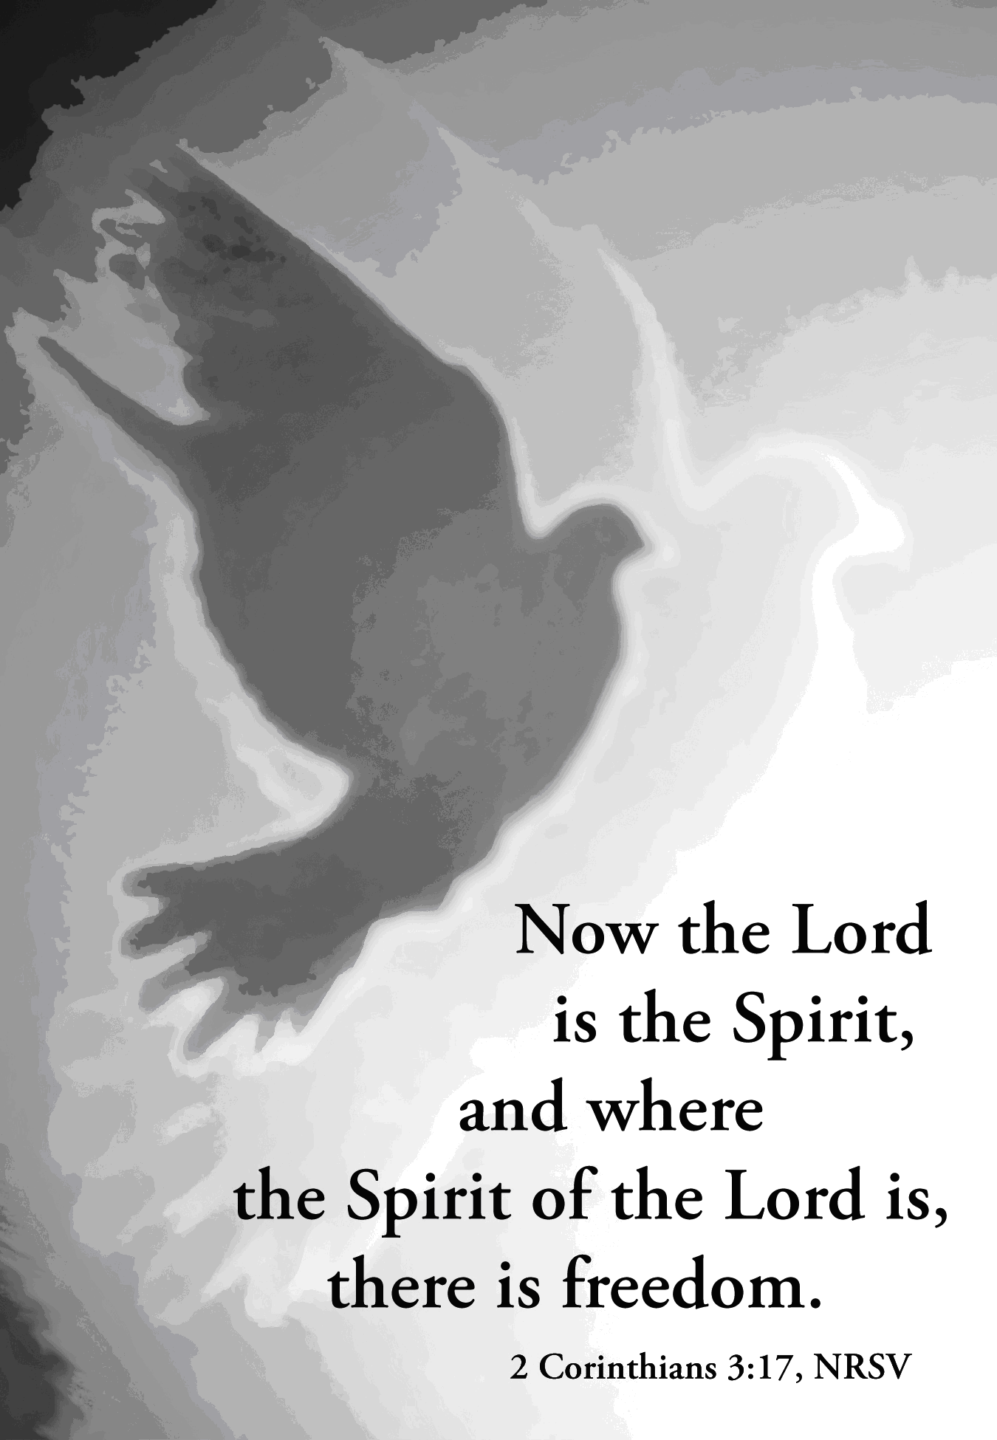

The Valleys
Evangelical Covenant Church
Halifax, PA

Church Office Hours: Mon. thru Fri. - 10AM to 3PM
Church Office(717-896-3118)
Web Site & Email - http://valleysecc.org valleysecc@verizon.net

Pastor’s Hours: Mon., Tues., Thurs.; 10:00AM - 1:00PM
Office (896-3118), Cell (717-818-3041), home (717-422-5788)
Email - KOHeckard@aol.com

CHURCH CALENDAR
Feb. 10 - 9:00AM - Sunday School
10:15AM - Church (Children’s Church)
PULSE Survey following church
2-3PM - Zumba, Kid’s Zumba 3:15-4PM - Zumba Gold
Feb. 11 - 10:00AM - Bible Study
6:30-7:30PM - Girl Scout Brownie Troop 10774
7:00PM - Elders
7:30PM - Valleys at Messiah Lutheran (Fisherville)
Feb. 12 - 7:30PM - Choir
Feb. 13 - 7:30PM - Ash Wednesday Service
Feb. 14 - 9:00AM - Community Circle of Prayer, Zion-Stone U.M.
6:30-7:30PM - Girl S. Daisy Troop 0753* ( special night)
Feb. 16 - 9:00AM-12:00Noon - Media Coaching - (learn how to down load video and photos and music to make a movie)
Feb. 17 - 9:00AM - Sunday School
10:15AM - Church (Children’s Choir)
Confirmands & Sponsors Dinner following Church
12:30-5:00PM - Girl Scout Father/Daughter Dance
2-3PM - Zumba, 3:15-4PM - Zumba Gold
Feb. 18 - No Meals-On-Wheels or Bible Study
7:30PM - Dartball - Valleys at Faith UM (Fisherville)
Feb. 19 - 6:30-7:30PM - Girl Scout Troop 10463
Feb. 20 - 7:00PM - Council Meeting
Feb. 21 - 9:00AM - Community Circle of Prayer at Zion-Stone UM
1:00-2:00PM - “In It Together” - “Jesus and The Parables”
6:00-8:00PM - Girl Scout Troop 10728
7:00PM - Community Lent Service at Halifax UM - Lanny Millette, Speaker on “Light”
Feb. 23 - 10:00AM to 3:00PM - ONE (Navigate) Workshop held at Wolf’s Church, York, PA
Feb. 24 - 9:00AM - Sunday School
10:15AM - Church - Mission Sunday - focus on Lifeline Pregnancy Center Baby Bottles Mission Offering
2:00-3:00PM - Zumba 3:15-4PM - Zumba Gold
Wed. Mar. 6th - Worship Committee Meeting will be held at 6:30PM.
Giant Gift Cards available to purchase (before/after church)! *PRAYER REQUESTS*
Please remember all the people on our Prayer List with prayers, thought, and cards: *(indicates new)
Members & Friends of The Valleys: Navigate Pathway; *Betty Lebo; Sandy Zimmerman; Melba Croutharmel; Marion Etzweiler; Marie Herb; Ed Berra; Allen Goss; Pauline Novinger; Elvin Lebo; Dorothy Rand, (Theresa Millers’s mother); Joseph Bryson, (Pete’s father); Larry Croutharmel, (Dennis brother); Gregg Gelnett; Glen Jones; Carley & Paul Enders; Shirley Harris; Nevin Maurer; Margie Zeigler, (Frey Village).
Missions: Covenant Missionaries: Fred & Kelly Prudek; *Christine Buettgen and *Kristi Byford.
Our Shut Ins: Anna Portzline; Lydia Peiffer; Minnie Baker
Military: Wesley Eshleman, (grandson of Betty Eshleman), stationed in Kuwait. Cameron Heddings, (grandson of Bonita Heddings), is stationed in Afghanistan).
Please inform Pastor Kris if you or a member of your family is in the hospital as the hospitals will not inform us unless you tell them to contact us. You may call the church office (896-3118) or Pastor Kris (818-3041).

Please turn off cell phones, pagers, etc. during our worship service. Thank you for your cooperation.

Nursery: Valleys provides nursery care for children ages 5 and under. Nursery Attendants: Feb. 10 - Carol Cooper; Feb. 17 - Brandi Crum; Feb. 24 - Ann Hale; Mar. 3 - Tracey Cooper. More Nursery attendants are needed! If you would like to help in the Nursery or you cannot be there on your assigned Sunday, please see Donna Novinger.

Pick up a Lifeline Pregnancy Center Baby Bottle and fill it with change, dollars or a check and return it to the church by Sunday, February 17!

Easter Flowers: See Gloria Duttry to order Easter Flowers by Sun., March 3rd (list of flowers/prices is on bulletin board).

~~~~~~~~~~~~~~~~~~~~~~~~~~~~~~~~~~~~~~~~~~~~~~~~~~
Church Attendance last Sunday, Feb. 3, 2013 was 58.

one
A Unifying Approach
to
Strategic Ministry
Planning:
A workshop that helps congregation seeking to take steps forward in the Congregational Vitality Pathway. Acts 4:32 says, “The whole congregation of believers was united as one - one heart, one mind!” Strategic ministry planning requires unity, and can be a unifying process guided by the Holy Spirit, so that we can be about our Father’s business - just like Jesus.

10:00AM to 3:00PM - ONE (Navigate) Workshop held at Wolf’s Church, York, PA

See Pastor Kris if you will be attending the ONE Workshop

Souper Bowl of Caring: Thank you for your generosity for the Souper Bowl of Caring donations last Sunday! The youth group collected $132 ($65 for the 49ers and $67 for the Ravens) which will be given to the Upper Dauphin Human Services Food Bank. We appreciate your support!



