The Valleys Evangelical Covenant Church
The Rev. Kristine Heckard, Pastor
Song Leader, Ken Bechtel II
Worship Technicians:
Chris Maichle, Cameron Crum, & Aren Faust
December 30, 2012
First Sunday After Christmas

(*Indicates all those who are able are invited to stand.)

Pre-Service Music -
“Carol Medley” Gaithers
“Christ Is Born” Karen Carpenter
“Away In A Manger” Gaithers
“The Little Drummer Boy” Johnny Matthis

* Passing the Peace Greeting:
All who are able may greet those around them with an embrace or a handshake, accompanied by such words as:
Greeting: “The peace of God be with you.”
Response: “And also with you.”

Greetings and Announcements Dave Novinger

* Carol Medley - (1st verse of each)
“Joy to the World”
“The First Noel”
“I Heard the Bells”
“While Shepherds Watched Their Flocks”
“O Little Town of Bethlehem”
“Good Christian Men Rejoice”
(follow screen)
* Opening Prayer
* Confession: (In Unison)
Lord, so often we have heard the story of Christmas, yet we hardly take the time to hear the message of Your love it proclaims. So often, Lord, we have been more concerned with our programs and decorations than the wonderful news of personal mercy and grace Christmas calls us to hear. Forgive us, Lord, and fill our hearts with love. In Christ we pray. Amen.

* Assurance:
Leader: By God’s grace you are forgiven.
People: By God’s grace you are forgiven.

* Profession of Faith: (In Unison)
We celebrate the baby Jesus, who lives among us, whose Spirit empowers us to remove barriers, tear down walls, heal divisions, and seek peace without and within. Whose Spirit empowers us to see our sister’s good as our own, to be our brother’s advocate, to love our neighbor as ourselves, and to contribute to the well-being of every part of Christ’s body, so that indeed we can build up, and grow up, and be joined together into a new structure: where Christ’s Spirit dwells, where Christ’s Spirit empowers us to be peace-seekers, peace finders, and peace-makers!

How Goes Your Walk?

Morning Prayer & The Lord’s Prayer (Debts & Debtors)

Hymn - “Turn Your Eyes Upon Jesus” Traditions

Scripture - I Corinthians 13:11-12, Hebrews 13:8
Carol Knight, Lay Reader
(follow screen)

Mediation - “Yesterday, Today, and Tomorrow”

Mission Highlight - Bethesda Mission
(video)

Our Morning Offering
Offertory - “My Heart Would Be Your Bethlehem” Gaithers
Prayer of Dedication

* Closing Hymn - “Mary‘s Little Boy-Child”
(follow screen)
* Commissioning:
L: May the Spirit of the Lord anoint you to provide strength to the weak, freedom to the oppressed, food to the hungry, and good news to the poor.
All: Blest be the name of the Lord! Amen.

* Post-Service Music -
“Angels We Have Heard on High” Birian Setzer

Welcome: Welcome to worship! May this time of prayer and praise help you hold on a bit longer to Christmas joy and carry it into the new year. If you are a visitor, please take time to sign your name, address, and phone number in our guest book before you leave.

December Greeters: Sue Faust and June Gelnett. Announcer: Dave Novinger. Acolyte: Cameron Crum. December Offering Team: Tom Lauver, Barbara Lauver, Mike Crum, Cameron Crum.

Lay Readers: Dec. 30 - Carol Knight; Jan. 6 - Dave Novinger; Jan. 13 - Doris Hand; Jan. 20 - Renny Witmer. If you cannot read on the date assigned, please call Pastor Kris at the church (896-3118) or her home (717-422-5788).

Church School Teachers (Adults): Dec. 30 - Donna Novinger; Jan. 6 - Marie Herb; Jan. 13 - Ed & Peggy Berra; Dec. 20 - Boyd Dimpsey. If you cannot teach on your assigned Sunday, please inform Dave Novinger or Jessie Faust.

Please turn off cell phones, pagers, etc. during our worship service. Thank you for your cooperation.

SERVICE CANCELLATION POLICY
*****************************************************************
If a service or activity has to be cancelled due to adverse weather conditions during the winter, please check the following TV stations - WHTM Channel 27 and WHP Channel 21 to see if Valleys appears on their cancellation display.
*****************************************************************

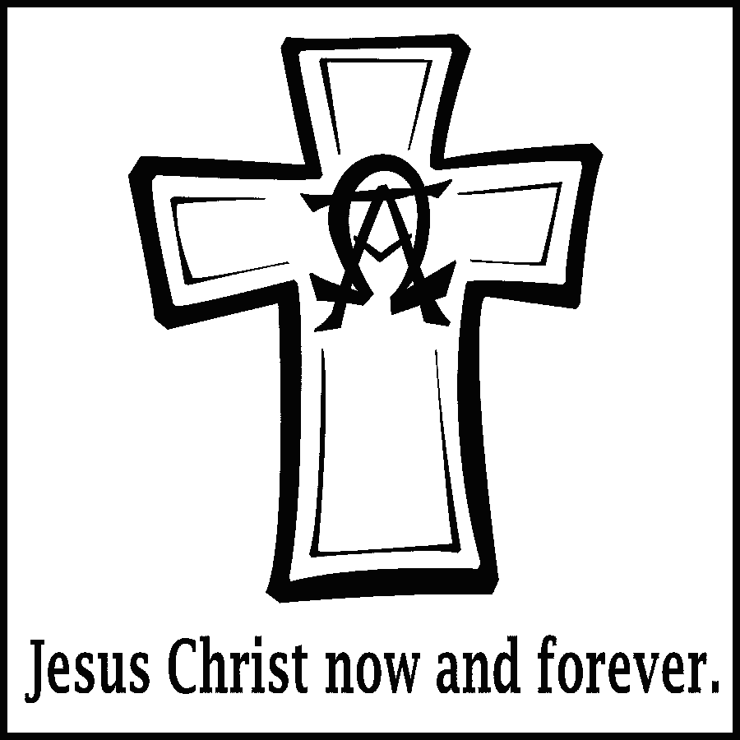

The Valleys
Evangelical Covenant Church
Halifax, PA

Church Office Hours: Mon. thru Fri. - 10AM to 3PM
Church Office(717-896-3118)
Web Site & Email - http://valleysecc.org valleysecc@verizon.net

Pastor’s Hours: Mon., Tues., Thurs.; 10:00AM - 1:00PM
Office (896-3118), Cell (717-818-3041), home (717-422-5788)
Email - KOHeckard@aol.com

CHURCH CALENDAR
Dec. 30 - 9:00AM - Sunday School
10:15AM - Church - Ken Bechtel II, Lay Speaker - Mission Sunday (Focus -Bethesda Mission) Mission Offering
2-3PM - Zumba, Kids Zumba 3:15-4PM - Zumba Gold
5:30PM -Youth Christmas Party (all school age youth)
Jan. 1, 2013 - Happy New Year’s Day! (Church office closed)
Jan. 2 - 6:00-8:00PM - Girl Scout Troop 10728
Jan. 3 - 7:00-8PM - Zumba
Jan. 6 - 9:00AM - Sunday School
10:00AM -Church - Service of Consecration and Communion (Children’s Church); Fellowship Meal after church Confirmation Class meets after meal
2:00-4:30PM - Girl Scout Leadership Journey
2-3PM - Zumba, Kid’s Zumba 3:15-4PM - Zumba Gold
6:30PM - Youth Group
Jan. 7 - 10:00AM - Bible Study - Jan. Leader Pastor Mike Petresky
5:30PM - Prayer Team
Jan. 9 - 7:30PM - Choir
Jan. 10 - 7:00-8PM - Zumba
Jan. 13 - 9:00AM - Sunday School
10:15AM - Church - (Children’s Church)
Noon-5PM - G. S. Sock Hop/Cookie Bake
2-3PM - Zumba, Kid’s Zumba 3:15-4PM - Zumba Gold
Jan. 14 - 10:00AM - Bible Study
5:00AM - Vitality Team Meeting
6:30-7:30PM - Girl Scout Troop 10774
7:00PM - Elders
7:30PM - Dartball - Faith U. Methodist at Valleys
Jan. 15 - 6:30-7:30PM - Girl Scout Troop 10463
Jan. 16 - 6:00-8:00PM - Girl Scout Troop 10728
7:30PM - Choir
Jan. 17 - 900AM - Community Circle of Prayer at Zion-Stone U. Methodist Church
Jan. 20 - 9:00AM - Sunday School
10:15AM - Church Annual Congregation Meeting and Meal will follow church. No Confirmation Class
2:00-3PM - Zumba, Kids Zumba 3:15-4PM -Zumba Gold
*PRAYER REQUESTS*
Please remember all the people on our Prayer List with prayers, thought, and cards: *(indicates new)
Members & Friends of The Valleys: Navigate Pathway; Allen Goss; Elvin Lebo; Pauline Novinger; Gail Shertzer; Melba Croutharmel; Minnie Baker; Elizabeth Yutronich; Harriet Sheetz; Roy & Verna Miller; Gregg Gelnett; Carley & Paul Enders; Shirley Harris; Nevin Maurer; Charles “Cappy” Reisch; Margie Zeigler, (Frey Village)
Missions: Covenant Missionaries: Fred & Kelly Prudek; *Ronald & Janet Ziegelbaur.
Our Shut Ins: Anna Portzline; Lydia Peiffer
Military: James Lesh, (grandson of Ed & Pat Dobbin) in Afghanistan. Wesley Eshleman, (grandson of Betty Eshleman), stationed in Kuwait.
Please inform Pastor Kris if you or a member of your family is in the hospital as the hospitals will not inform us unless you tell them to contact us. You may call the church office (896-3118) or Pastor Kris (818-3041).

Nursery: Valleys provides nursery care for children ages 5 and under. Nursery Attendants: Dec. 30 - Tracey Cooper; Jan. 6 - Neva Cichy; Jan. 13 - Ann Hale; Jan. 20 -Tracey Cooper. If you would like to help in the Nursery or if you cannot be there on your assigned Sunday, please see Donna Novinger.

Valleys Youth Christmas Party: All school age youth from The Valleys are invited to a Christmas Party on Sunday, December 30th 5:30PM to 7:30PM. The Youth Group will provide pizza and drink. Please bring a snack to share and join us for an evening of fun and games!

Offering Envelopes: Please pick up your 2013 offering envelopes. If you wish to have envelopes, please see Diane Shaffer.

Christmas Cards: Please check to see if you have some Christmas cards to be picked up on the table in the narthex.

Fellowship Meal: Following our Service of Consecration and Communion on Sunday, January 6th please join us for our covered dish Fellowship Mea. Please bring a meat dish or vegetable casserole and a dessert and join us in a time of fellowship.

Annual Reports are due!: Reports are due from the following Annual Reports are due from committees: Pastor, Council President, Worship Committee, Elders, Deacons, Property Committee, Mission Committee, Youth Group, Choir, Fellowship Group. Please give the reports to the church secretary by January 9, 2013 for sufficient time to prepare reports for the Annual Congregational Meeting held on Sunday January 20th.

Valleys Annual Congregational Meeting: The Valleys Annual Congregational Meeting and meal will be held following the worship service on Sunday, January 20th. Please bring a vegetable or casserole dish and a dessert to share. The meat will be provided by the church.

Council Re-organization Meeting: Council Re-0rganization meeting will be held Wednesday, January 23, 2013 at 7:00PM.

Senior Citizens: There will be no Senior Citizens Meeting in January or February 2013. They will meet again in March.

These Days Devotional Booklets: Subscription payment for These Days Devotional booklets ($5-Regular $7-Large Print) is due. Please see Jane Baker to pay your subscription

Giant Gift Cards available to purchase (before/after church)!

~~~~~~~~~~~~~~~~~~~~~~~~~~~~~~~~~~~~~~~~~~~~~
Church Attendance last Sunday, Dec. 23, 2012 was 119.

We wish you a safe and Happy New Year!

