The Valleys Evangelical Covenant Church
The Rev. Kristine Heckard, Pastor
Choir Director, Ed Dobbin
Organist& Pianist, Mark & Joanne Enders
Acolyte, Cameron Crum
October 20, 2013
Twenty-second Sunday After Pentecost

(*Indicates all those who are able are invited to stand.)

Chimes
Greetings and Announcements
* Call To Worship Peggy Berra
L: Christ died once and for all time to remove the barrier of sin that keeps us from God,
P: and to demonstrate the forgiving and loving nature of our Heavenly Father.
L: Christ continues to stand at the doorways of our hearts,
P: pleading for us to let him enter and thus accept God’s love.
L: Come, let us worship our merciful God made known to us through Jesus Christ!

Prelude - “Two Spirituals“ by Eugene Butl
* Praise Hymn - “How Great Thou Art“ Pg. 4
* Opening Prayer
* Call to Confession
* Confession: (In Unison )
Merciful God of compassion and justice, take pity on us as we confess our sin. We are not the stewards Christ calls us to be. Riches possess us while others go hungry. We mismanage creation with our pollution and strife. Your goodness is betrayed by our lust for power. We abuse your provision for us by our selfish desires. Help us hear once again Christ’s call to be faithful, and through him forgive us as we repent of our sin and turn from it. May our commitment to do your will be complete, and may we find joy in the full use of all that we are and have in the service of our Savior, Jesus Christ. Amen.
* Kyrie: (To Be Sung)
Leader: Lord, have mercy upon us.
People: Lord, have mercy upon us.
Leader: Christ, have mercy upon us.
People: Christ, have mercy upon us.
Leader: Lord, have mercy upon us.
People: Lord, have mercy upon us.
* Assurance of Pardon
* Gloria Patri Pg. 623
* Profession of Faith - (In Unison)
We believe in one God, maker and ruler of all things, Father of all people, The source of all goodness and beauty, all truth and love. We believe in Jesus Christ, God manifest in the flesh, our Teacher, Example, and Redeemer, the Savior of the world. We believe in the Holy Spirit, God present with us for guidance, for comfort and for strength. We believe in the Word of God contained in the Old and New Testaments as the rule both of faith and of practice. We believe in the church as the fellowship for worship and service of all who are united in the Living Lord. This we believe!
Hymn of Preparation - “Near to the Heart of God” Pg. 497
Prayer cards will be collected during the 2nd hymn.
Our Morning Prayer
Choral Response - “Hear Our Prayer O Lord” Pg. 614
Anthem - “Now Is The Time”

Scripture - Isaiah 53:1-12 Norine Goss, Lay Reader
(Found on Pg. 800 of OT Pew Bible)

Sermon - “The Perfect Gift for All Time”
Sermon Text: Hebrews 9:23-28 (Fd. on Pg. 304 of NT Pew Bible)

Our Morning Offering
Offertory - “Thou Art The Way” by David Paxton
* Offertory Response - “We Give Thee But Thine Own” Pg. 620
* Prayer of Dedication
* Closing Hymn - Pg. 284
“Lord, Dismiss Us With Thy Blessing”
* Benediction
* Threefold Amen
* Extinguishing of the Candles
* Passing the Peace Greeting: All may greet those around them with an embrace or a handshake, accompanied by such words as:
Greeting: “The peace of God be with you.”
Response: “And also with you.”
* Postlude - “I Would Be True” Samuel Wellman

Welcome: Welcome to worship! Our gracious, all-forgiving God receives you with open arms. May his love strengthen you today. If you are a visitor, please take time to sign your name, address, and phone number in our guest book before you leave.

We welcome Rev. Keith Dimpsey as our Guest Speaker today. (Ed Dobbin is the Liturgist.)

Pastor Kris is on vacation Monday, October 14th thru Sunday, October 27th. Please call the church office for any pastoral needs during that time. Rev. Fred Walthour will be the Guest Speaker next Sunday, October 27th (Dave Novinger, Liturgist).

October Greeters: Sue Faust and Charlie Shertzer. Announcer: Peggy Berra. Acolyte: Cameron Crum. October Offering Team: Dan Yutronich, Nancy Yutronich, Sharon Fetterhoff, Gary Fetterhoff

Lay Readers: Oct. 20 - Norine Goss; Oct. 27 - Theresa Miller; Nov. 3 - Rachael Bryson; Nov. 10 - Whitney Faust. If you cannot read on the date assigned, please call Pastor Kris at the church (896-3118) or her home (717-422-5788).

Nursery: Valleys provides nursery care for children ages 5 and under. Oct. 20 - Carol Cooper; Oct. 27 - Shirley Miller; Nov. 3 - Donna Motter; Nov. 10 - Ann Hale. If you wish to help in the Nursery or if you cannot be there on your assigned Sunday, please see Donna Novinger.

Church School Teachers (Adults): Oct. 20 - Carol Reisch; Oct. 27 - Carol Reisch; Nov. 3 - Ed & Peggy Berra; Nov. 10 - Dave Novinger. If you cannot teach on your assigned Sunday, please inform Dave Novinger or Jessie Faust who will teach in your place

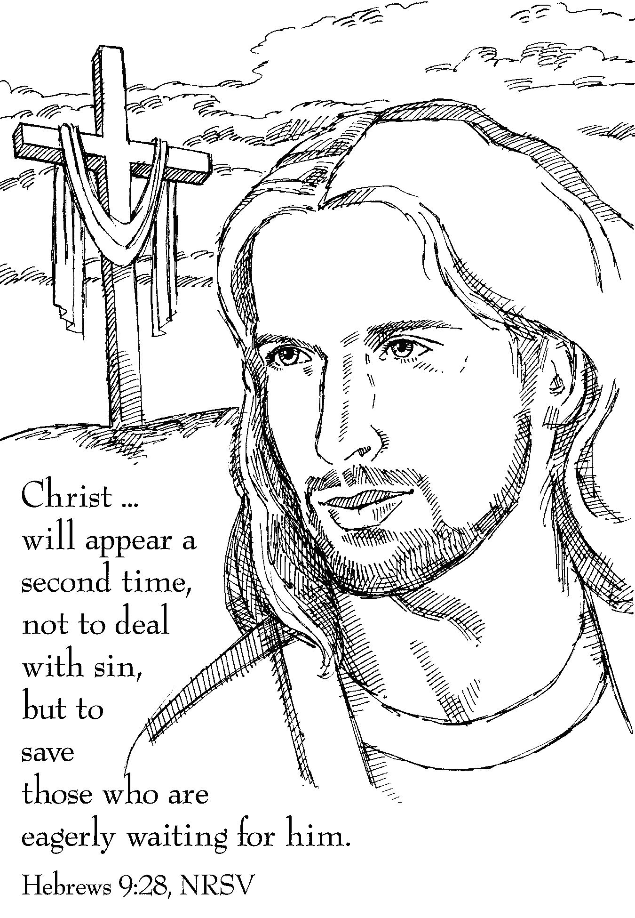

The Valleys
Evangelical Covenant Church
Halifax, PA

Church Office Hours: Mon. thru Fri. - 10AM to 3PM
Church Office(717-896-3118)
Web Site & Email - http://valleysecc.org valleysecc@verizon.net

Pastor’s Hours: Mon., Tues., Thurs.; 10:00AM - 1:00PM
Office (896-3118), Cell (717-818-3041), home (717-422-5788)
Email - KOHeckard@aol.com

CHURCH CALENDAR
Pastor Kris is on vacation Oct. 14 thru Oct. 27

Oct. 20 - 9:00AM - Sunday School
10:15AM -Traditional Worship - Rev. Keith Dimpsey, Guest Speaker (Ed Dobbin, Liturgist) Ch. C
Confirmation Class meets following Worship
Noon-6:30PM - Girl S. Halloween Party/Fall Festival
2:00-3:00PM - Zumba; NO Zumba Gold
4:00PM - CROP WALK at Halifax Memorial Park
6:30PM - Youth Group
Oct. 21 - 9:00AM-1:00PM - Halifax Senior Center open Mon-Fri
10:00AM - Bible Study (Leader Pastor Ron Reitz)
6:30PM - Strategic Planning Committee
7:30PM - Dartball - Lykens U. Methodist at Valleys
Oct. 22 - 6:00-8:00PM - Girl Scout Troop 10738
Oct. 23 - 6:00-7:30PM - Girl Scout Troop 10753
Oct. 24 - 7:00-8:00PM - Zumba

Oct. 27 - 9:00AM - Sunday School
10:15AM -Traditional Worship - Rev. Fred Walthour, Guest Speaker (Dave Novinger, Liturgist)
Mission Offering (Christmas Offering, Special Needs)
2:00-3:00PM - Zumba; 3:15-4:00PM - Zumba Gold
4:30-5:30PM - Girl Scout Daisy Troop 10737
Oct. 28 - 9:00AM-1:00PM - Halifax Senior Center open Mon-Fri
10:00AM - Bible Study (Leader Pastor Ron Reitz)
6:30-7:30PM - Girl Scout Troop 10774
7:30PM - Dartball - Valleys at St. Christopher Lutheran
(in Lykens)
Oct. 30 - 7:30PM - Choir
Oct. 31 - 7:00-8:00PM - Zumba
Nov. 2 - Noon-4:30PM - social hall in use
TURN CLOCK BACK ONE HOUR!

Nov. 3 - 9:00AM - Sunday School
10:15AM -Traditional Worship - Food Offering Blessed, Mission Moment (New England Seafarers and Youth Mission Trip to Maine)
(Children’s Church)
2:00-3:00PM - Zumba; 3:15-4:00PM - Zumba Gold

*PRAYER REQUESTS* *(indicates new)
Please remember all the people on our Prayer List with prayers, thought, and cards:
Members & Friends of The Valleys: Navigate Pathway; *Elmer Feidt; *Sharon Fetterhoff, (surgery Oct. 24); Colleen Gonder; Marlin Erdman; Allen Goss; Dennis Leitzel; Diane Shaffer; Aaron Herb; Melba Croutharmel; Pauline Novinger; Julie Enders; Etta & Robert Miller; Baby Elaina Parker; Gregg Gelnett; Carley Enders; Margie Zeigler, (Frey Village).
Missions: Covenant Missionaries: *Fred & Kelly Prudek; *Gary & Mary Lou Sander; *Ken & Adrienne Satterberg
Our Shut Ins: Minnie Baker; Anna Portzline; Lydia Peiffer
Military: Cameron Heddings, (grandson of Bonita Heddings is coming home).
Please inform Pastor Kris if you or a member of your family is in the hospital as the hospitals will not inform us unless you tell them to contact us. You may call the church office (896-3118) or Pastor Kris (818-3041).
~~~~~~~~~~~~~~~~~~~~~~~~~~~~
Please turn off cell phones, pagers, etc. during our worship service. Thank you for your cooperation.

CROP WALK - TODAY, OCTOBER 20 at 4:00PM at
the Halifax Memorial Park (begins at the pavilion and ends at the Halifax Youth Center, approximately 3 miles in length).
See Dave Novinger for a sponsor sheet if you wish to walk or you can sponsor our walkers - Dave Novinger, Marie Herb, Mike Crum, Cailey Crum, Lydia Faust.

Dartball: Valleys won one game (6-2) and lost one game (1-5) on Monday night against Lykens U. Methodist. Tomorrow night, Oct. 21st at 7:30PM Valleys plays at St. John’s Lutheran (Berrysburg).

“In It Together” will begin the Week of November 4th and continue indefinitely. We offer two opportunities to accommodate those busy schedules. Postings will appear on Facebook every Monday morning and you can read the post and respond at your convenience. Also, a group will meet at the church on Tuesday at 11:00 A.M. We are going to be reading through the Book of Luke and each week we will read a Chapter, pray, and share our thoughts. I hope you will join us.

Informational Gathering will be held on Thurs., November 7 at 7:00PM. We will be discussing the strategic planning process as well as going into more detail on some of the responses on our Pulse survey. Please mark this date on your calendar!

Focus on Veterans: We will focus on Veterans during the Sunday, November 10 (Modified Worship).

Poinsettias: Order your Poinsettias Nov. 10th thru Dec. 1st. See Gloria Duttry to order (pay at time of order). Poinsettias will be in sanctuary for Sun., Dec. 22nd and Christmas Eve service Tues., Dec. 24th..

Mr. Sticky will be at Valleys on Mon. Nov. 11th & Tues. Nov. 12! Order forms are in the narthex - White forms are for Mon. Nov. 11th ) and Colored forms are for Tues. Nov. 12th. Cost is $3.00 per bun. Buns will be available for pick-up both days.

New Members Class: Sunday, November 17th & 24th - A New Members Class will be offered for anyone interested in becoming a member of The Valleys ECC. If you are interested, please contact Pastor Kris.

Halifax Senior Center is open Monday thru Friday, 9:00AM to 1:00PM at The Valleys E. C. C. See Ann Hale or Barbara Lauver if you wish to eat at the Senior Center (meals must be ordered in advance). See the Senior Center calendar (on bulletin board in narthex) for list of activities.
Senior Center Activities
Pinochle Card Party is held at the Halifax Senior Center on the third Wednesday of the month from 12:00Noon to 3:00PM beginning on Oct. 16th.
Grocery Coupons for Overseas U. S. Military Families: Stop tossing those expired grocery coupons in the trash! The Senior Center is collecting grocery coupons for U. S. military families stationed overseas (they are able to use the coupons on base for up to SIX MONTHS after the manufacturer’s expiration date). Manufacturer’s coupons only, no local or internet coupons accepted. Bring them in and place them in the box in the narthex.

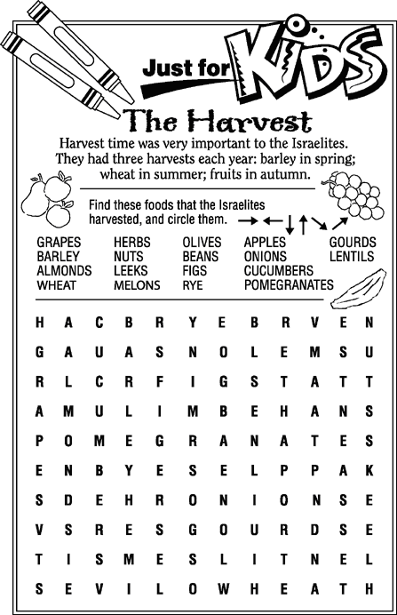

~~~~~~~~~~~~~~~~~~~~~~~~~~~~~~~~~~~~~~~~~
Giant Gift Cards available to purchase (before/after church)!

Church Attendance for last Sunday, Oct. 13, 2013 was 63.

