The Valleys Evangelical Covenant Church
The Rev. Kristine Heckard, Pastor
Choir Director, Ed Dobbin
Organist & Pianist, Mark & Joanne Enders
Acolyte, Cameron Crum
October 19, 2014
“Strong in the Word to Serve in the World”

(*Indicates all those who are able are invited to stand.)

Chimes
Greetings and Announcements
* Call To Worship Peggy Berra
L: Thanks be to God for all of you!
P: May the inspiration and renewal of this time of worship together come to us not only in word, but also in power and in the Holy Spirit, and with full conviction.
L: Come, let us worship God!

Prelude - “Where’re You Walk” by G. F. Handel
* Opening Hymn - Pg. 14
“Come, Let Us Worship and Bow Down”
* Prayer of Invocation
* Confession: (In Unison)
Almighty God, hear our struggle to know your will among our doubts. And when we leave here, send us out enriched by your presence among us. In Jesus’ name we pray. Amen.

* Kyrie: (To Be Sung responsively)
Leader/People: Lord, have mercy upon us.
Leader/People: Christ, have mercy upon us.
Leader/People: Lord, have mercy upon us.
* Assurance of Pardon
* Gloria Patri Pg. 623

* Profession of Faith - (In Unison)
We believe in God, Creator of all things. We believe in His Son Jesus Christ, who came to show us the way to the Father. We believe in the Holy Spirit of God - moving among us and inspiring the Love of God within us. We believe in the Church - the earthly extension of His Kingdom. We believe it is our calling to serve His Church with all our heart, our mind, our strength. Amen.
Children’s Sermon
Hymn of Preparation - “To Be Like Jesus” Pg. 384
Prayer cards will be collected during the 2nd hymn.
Our Morning Prayer
Choral Response - “Hear Our Prayer O Lord” Pg. 614

Scripture -
1 Thessalonians 1:1-10 (Found on Pg. 275 of NT Pew Bible)

Sermon - “You Are contagious When . . .”

Our Morning Offering
Offertory - “God Leads Us Along” by Ron Loree
* Offertory Response - “We Give Thee But Thine Own” Pg. 620
* Prayer of Dedication
* Closing Hymn - “I Want to be Like Jesus” Pg. 400
* Benediction/Threefold Amen/Extinguishing of the Candles

* Passing the Peace Greeting: All may greet those around them with an embrace or a handshake, accompanied by such words as:
Greeting: “The peace of God be with you.”
Response: “And also with you.”
* Postlude - “Breathe on Me, Breath of God” by Lani Smith

Welcome: Welcome to worship, one and all! We gather as brothers and sisters in Christ to hear his Word and grow in faith and discipleship. God bless you during this holy time. If you are a visitor, please take time to sign your name, address, and phone number in our guest book before you leave.

Our beautiful Altar Flowers are presented to the glory of God by Russ & Shirley Miller in honor of their 41st Wedding Anniversary on October 20th.

October….
Greeters: Sue Faust and Arletta Thomas.
Announcer: Peggy Berra. Acolyte: Cameron Crum.
Offering Team: Dan Yutronich, (Captain), Nancy Yutronich, Sharon Fetterhoff, Gary Fetterhoff. Please tell the Captain if you are unable to be there for a Sunday in your month. The Captain is responsible to get someone to help with the Offering Team if a member of the team cannot be there.

Lay Readers: Oct. 19 - To be announced; Oct. 26 - Theresa Miller; Nov. 2 - Rachael Bryson; Nov. 9 - Whitney Faust. If you cannot read on the date assigned, please call Pastor Kris at the church (896-3118) or her home (717-422-5788).

Nursery: Valleys provides nursery care for children ages 5 and under. Oct. 19 - Donna Motter; Oct. 26 - Brandi Crum; Nov. 2 - Donna Motter; Nov. 9 - Shirley Miller. If you wish to help in the Nursery or if you cannot be there on your assigned Sunday, please see Donna Novinger.

Church School Teachers (Adults): Oct. 19 - Ed Dobbin; Oct. 26 - Dave Novinger; Nov. 2 - Sharon Fetterhoff; Nov. 9 - Ed & Peggy Berra. If you cannot be there on your assigned Sunday, please inform Dave Novinger or Jessie Faust who will teach in your place.

Please turn off cell phones, pagers, etc. during our worship service. Thank you for your cooperation.

Giant Gift Cards available to purchase (before/after church)!
By purchasing Giant gift cards, you can help raise money for Valleys. Valleys receives $5 for every $100 Giant gift card purchased.

Church Attendance for last Sunday, Oct. 12th was 57.

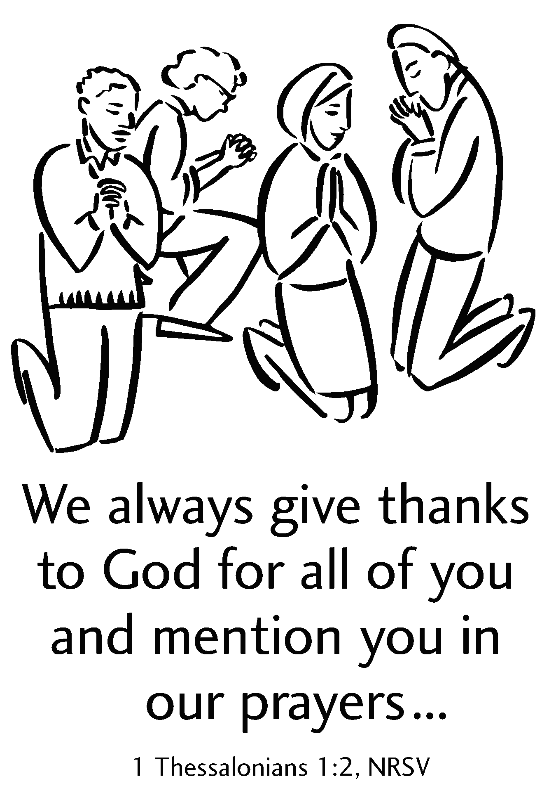

The Valleys
Evangelical Covenant Church
Halifax, PA

Church Office Hours: Mon. thru Fri. - 10AM to 3PM
Church Office(717-896-3118)
Web Site - ValleysEcc.Org Email - valleysecc@verizon.net

Pastor’s Hours: Mon., Tues., Thurs.; 10:00AM - 1:00PM
Office (896-3118), Cell (717-818-3041), home (717-422-5788)
Email - KOHeckard@aol.com

CHURCH CALENDAR
Oct. 19 - 9:00AM - Sunday School
10:15AM - Traditional Worship (Enders)
1:30PM - CROP WALK at Halifax Memorial Park
2:00PM - Zumba
6:30PM - Youth Group
Oct. 20 - 9:00AM-Noon - Halifax Senior Center open Mon.-Thurs.
10:00AM - Bible Study (Pastor Ron Reitz, Leaders)
7:30PM - Dartball - Valleys at St. Christopher (Lykens)
Oct. 21 - 6:00-8PM - Girl Scout Troop 10463
Oct. 22 - 5:00PM - Worship Committee
7:30PM - Choir
Oct. 23 - 6:10PM - Zumba Gold; 7:00-8PM - Zumba

Oct. 26 - 9:00AM - Sunday School
10:00-10:15AM - Learn Praise Hymns
10:15AM Blended Worship (Praise Team & Hymnal)
Mission Offering
1:00-5PM - Girl Scout Event

Oct. 26th -30th -Pastor Kris will be at Pilgrim Pines, NH at a Ashram-Pastors Retreat and Vitality Workshop.

Oct. 27 - 9:00AM-Noon - Halifax Senior Center open Mon.-Thurs.
10:00AM - Bible Study (Pastor Ron Reitz, Leaders)
6:00-8PM - Girl Scout Troop 774
7:30PM - Dartball - Messiah Lutheran at Valleys
Oct. 28 - 6:00-8PM - Girl Scout Troops 738 & 740
Oct. 29 - 6:00-8PM - Girl Scout Troop 10753
7:30PM - Choir

Nov. 2 - 9:00AM - Sunday School
10:15AM - Traditional Worship (Enders)
Covered Dish Fellowship Meal will follow Worship
2:00PM - Zumba
6:30PM - Youth Group

The following groups meet at Valleys - Monday - Victory Group (Weight Loss) - 5:30PM; Tuesdays - Weight Loss Challenge Group - 5:30-7:00PM
Praise Team Rehearsal: (Weeks 1, 3, 5 at Gary F; Weeks 2, 4 at church)

*PRAYER REQUESTS* *(indicates new)
Please remember all the people on our Prayer List with prayers, thoughts, cards: Members & Friends of The Valleys: Navigate Pathway;
Allen Goss, (Lifecare Rehab. Hosp,); Dean Etzweiler; John Shoop; Ken Breeman; Tom Hale; Elmer Feidt.
Missions: Covenant Missionaries: *Fred & Kelly Prudek; *Timothy & Helen Smith.
Our Shut Ins: Minnie Baker; Lydia Peiffer; Myra Hoffman; Anna Portzline, (The Manor).
Please inform Pastor Kris if you or a member of your family is in the hospital as the hospitals will not inform us unless you tell them to contact us. You may call the church office (896-3118) or Pastor Kris (818-3041).
______________________________________________________________________________
Upcoming Special Activities/Happenings:
“Friends In Faith” Sunday School Class: Class I invite you to come to the library each Sunday from 9:00 – 10:00 A.M. as we join together with friends in faith to explore how we can build a deeper relationship with Christ and with those around us. We are using Nichole Johnson’s book, “Fresh Brewed Life” as a guide for the Class. I hope that you will join me for a fresh brew of coffee and explore avenues to a fresh brewed life that awakens you to God, to yourselves, and to others. Pastor Kris

Halifax CROP Walk will be held today Sunday, October 19th. Participants meet at the Halifax Memorial Park Pavilion at 1:30PM. See Dave Novinger for a sponsor sheet if you wish to walk in the CROP Walk.

Women’s Bible Study night/time has changed to Thursday evenings at 6:15PM at Gloria Duttry’s home. Sharon Fetterhoff leads the Bible Study. We are studying Calm My Anxious Heart by Linda Dillow. Please contact Gloria (896-2507) if you would like to join us. Cost for book and Journal-($16) or $12 for book.

Gospel Bond, musical group of seven men based out of Selinsgrove, PA, will be at Valleys on Sunday, November 9th during 10:15AM Worship Service. A Free Will Offering will be taken for Gospel Bond. A covered dish meal will be shared following the program (meat will be provided by the church, please bring a casserole, or salad and a dessert).

Mr. Sticky will be at Valleys on Mon. Nov. 10th & Tues. Nov. 11th! Order forms are in the narthex - White forms are for Mon. Nov. 11th ) and Colored forms are for Tues. Nov. 12th. Cost is $3.00 per bun. Buns will be available for pick-up both days. A sign up sheet is in the narthex for helpers needed for both days.

Thanksgiving/Ingathering Sunday will be held on Sunday, November 23rd during Blended Worship. Please bring Non-perishable food items, which will be donated to the Upper Dauphin Human Services Food Bank.

Hanging of the Greens Service will be held on Sunday, November 30th during Traditional Service. This service which involves participation from the whole congregation is the beginning of our Advent season. At the end of the service there will be a festive celebration with tree decorating, coffee/hot cider and cookies. Please join us as we join together in anticipation as we learn about the traditions and celebrate the coming of our Lord.

Halifax Senior Center is open 9:00AM-Noon Monday thru Thursday at The Valleys E. C. C. Check the calendar on Bulletin board in narthex for list of activities. The Senior Center is collecting grocery coupons for U. S. military families stationed overseas (they are able to use the coupons on base for up to SIX MONTHS after the manufacturer’s expiration date). Manufacturer’s coupons only, no local or internet coupons accepted. Bring them in and place them in the box in the social hall.

GriefShare seminar: The Valleys EC Church is sponsoring a GriefShare seminar sometime after the new year starts. We are in need of table leaders who wish to help others work their way through grief.
If you are interested in helping, call Ritchie R. Moorhead or Donna Donahue-Moorhead at: Home – 717-896-8515 or Cell (Ritchie) – 570-517-6787. You can also contact us after church.
There will be 13 sessions with an introduction, a half hour video and about a half hour table discussion, Your help will be greatly appreciated. Thank you.

