The Valleys Evangelical Covenant Church
The Rev. Kristine Heckard, Pastor
Song Leaders: Marie Herb * Donna Novinger
Praise Band: Nicole Shoop, Gary Fetterhoff, Cameron Crum
Worship Technicians: Aren Faust & Aaron Herb
October 13, 2013 - Modified Worship

(*Indicates all those who are able are invited to stand.)

Pre-Service Music -
“Arms of Love“ Day One
“Great Are You Lord” The Goads
“The More I Seek You” The Goads

Greetings and Announcements Arletta Thomas

* Praise Hymn “Lord Reign In Me”
“Praise Adonai”
“Your Love Oh Lord”
“More Love, More Power”
(follow screen)

* Opening Prayer
* Confession (Follow Screen)
* Assurance
* Profession of Faith (Follow Screen)
How Goes Your Walk?

Prayer of Intercession
Prayer Music “Healing in This House” Day One

Scripture - 2 Kings 5:1-17 (follow screen)
Leon Shaffer, Lay Reader

Sermon - “Preparing For A Miracle”

Our Morning Offering
Offertory - “ Your Grace Still Amazes Me” The Goads
Prayer of Dedication
* Closing Hymn “In Christ Alone” (follow screen)

* Commissioning
* Passing the Peace Greeting:
All who are able may greet those around them with an embrace or a handshake, accompanied by such words as:
Greeting: “The peace of God be with you.”
Response: “And also with you.”

* Post-Service Music - “I Run to You” The Goads

Welcome: Welcome to our service! “Come, now is the time to worship. ... Come, just as you are before your God.” (Brian Doerksen) If you are a visitor, please take time to sign your name, address, and phone number in our guest book before you leave.

Today’s Music is complementary of The Goads and Day One.

October Greeters: Sue Faust and Charlie Shertzer. Announcer: Peggy Berra. Acolyte: Cameron Crum. October Offering Team: Dan Yutronich, Nancy Yutronich, Sharon Fetterhoff, Gary Fetterhoff

Lay Readers: Oct. 13 - Leon Shaffer; Oct. 20 - Norine Goss; Oct. 27 - Theresa Miller; Nov. 3 - Rachael Bryson. If you cannot read on the date assigned, please call Pastor Kris at the church (896-3118) or her home (717-422-5788).

Nursery: Valleys provides nursery care for children ages 5 and under. Oct. 13 - Neva Cichy; Oct. 20 - Carol Cooper; Oct. 27 - Shirley Miller; Nov. 3 - Donna Motter. We can still use more Nursery attendants! If you wish to help in the Nursery or if you cannot be there on your assigned Sunday, please see Donna Novinger.

Church School Teachers (Adults): Oct. 13 - Ann Cooper; Oct. 20 - Carol Reisch; Oct. 27 - Carol Reisch; Nov. 3 - Ed & Peggy Berra. If you would like to help in the Nursery or if you cannot be there on your assigned Sunday, please see Donna Novinger..

Children’s Church is on the 1st and 3rd Sundays of the month.

NO Choir practice this week (October 15th).

Confirmation Class will meet on Sunday, October 20 following Worship Service. Sue Faust will lead Confirmation class.

Strategic Planning Committee meets on Monday, October 21st at 6:30PM.

Pastor Kris will be on vacation Monday, October 14th thru Sunday, October 27th. Pastor Keith Dimpsey will be the Guest Speaker next Sunday, October 20th (Ed Dobbin, Liturgist) and Rev. Fred Walthour will be the Guest Speaker on Sunday, October 27th (Dave Novinger, Liturgist). Please call the church office (896-3118) for any pastoral needs during the time Pastor Kris is away.

Mr. Sticky will be at Valleys on Mon. Nov. 11th & Tues. Nov. 12! Order forms are in the narthex - White forms are for Mon. Nov. 11th ) and Colored forms are for Tues. Nov. 12th. Cost is $3.00 per bun. Buns will be available for pick-up both days.

New Members Class: Sunday, November 17th & 24th - A New Members Class will be offered for anyone interested in becoming a member of The Valleys ECC. If you are interested, please contact Pastor Kris.

“In It Together” will begin the Week of November 4th and continue indefinitely. We offer two opportunities to accommodate those busy schedules. Postings will appear on Facebook every Monday morning and you can read the post and respond at your convenience. Also, a group will meet at the church on Tuesday at 11:00 A.M. We are going to be reading through the Book of Luke and each week we will read a Chapter, pray, and share our thoughts. I hope you will join us.

Please turn off cell phones, pagers, etc. during our worship service. Thank you for your cooperation.

Newsletter: If wish to receive Valleys’ newsletter, please see Donna Novinger or put a note in the offering plate.

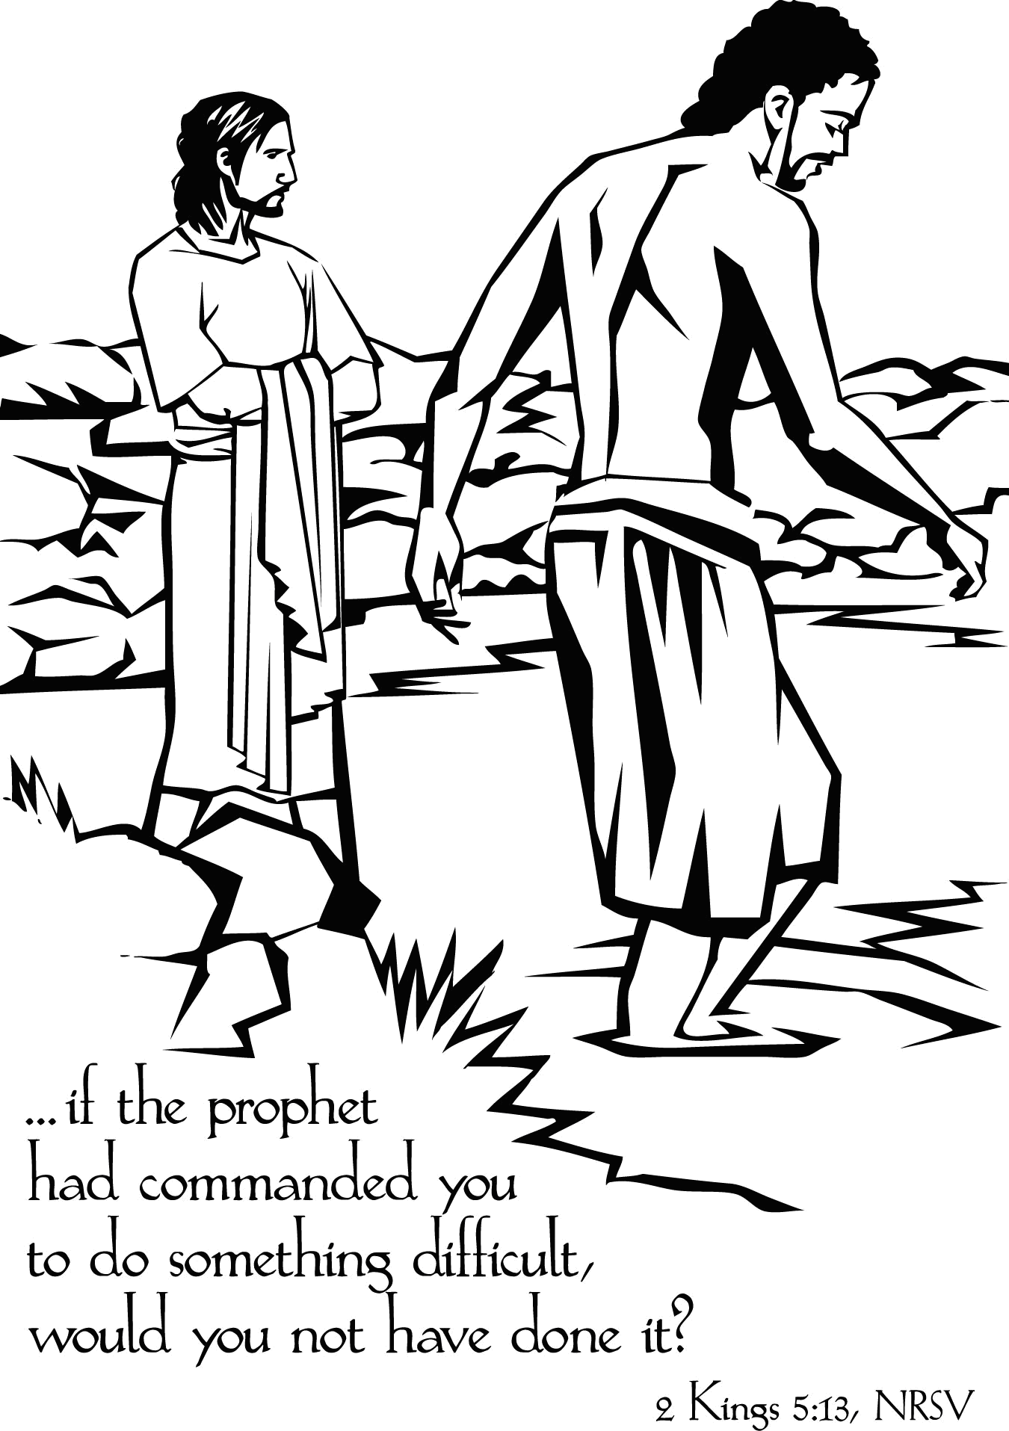

The Valleys
Evangelical Covenant Church
Halifax, PA

Church Office Hours: Mon. thru Fri. - 10AM to 3PM
Church Office(717-896-3118)
Web Site - http://valleysecc.org Email - valleysecc@verizon.net

Pastor’s Hours: Mon., Tues., Thurs.; 10:00AM - 1:00PM
Office (896-3118), Cell (717-818-3041), home (717-422-5788)
Email - KOHeckard@aol.com

CHURCH CALENDAR
Oct. 13 - 9:00AM - Sunday School
10:15AM -Modified Worship
2:00-3:00PM - Zumba; 3:15-4:00PM - Zumba Gold

Pastor Kris is on vacation Mon., Oct. 14 thru Sun., Oct. 27

Oct. 14 - 9:00AM-1:00PM - Halifax Senior Center open Mon-Fri
10:00AM - Bible Study (Leader Pastor Ron Reitz)
7:30PM - Dartball - Lykens U. Methodist at Valleys
Oct. 15 - 6:30-7:30PM - Girl Scout Troop 10463 (1st & 3rd Tues.)
No Choir practice this week
Oct. 16 - Noon-3:00PM - Pinochle Card Party
7:00PM - Council Meeting
Oct. 17 - 9:00PM - Comm. Circle of Prayer at Zion Stone U. M.
7:00-8:00PM - Zumba

Oct. 20 - 9:00AM - Sunday School
10:15AM -Traditional Worship - Keith Dimpsey, Guest Speaker (Ed Dobbin, Liturgist) Children’s Ch.
Confirmation Class meets following Worship
Noon-6:30PM - Girl S. Halloween Party/Fall Festival
2:00-3:00PM - Zumba; 3:15-4:00PM - Zumba Gold
4:00PM - CROP WALK begins at Halifax Memorial
Park (begins at the pavilion and ends at the Halifax Youth Center, approximately 3 miles in length) 6:30PM - Youth Group
Oct. 21 - 9:00AM-1:00PM - Halifax Senior Center open Mon-Fri
10:00AM - Bible Study (Leader Pastor Ron Reitz)
6:30PM - Strategic Planning Committee
7:30PM - Dartball - Lykens U. Methodist at Valleys
Oct. 22 - 6:00-8:00PM - Girl Scout Troop 10738
Oct. 23 - 6:00-7:30PM - Girl Scout Troop 10753
Oct. 24 - 7:00-8:00PM - Zumba

Oct. 27 - 9:00AM - Sunday School
10:15AM -Traditional Worship - Rev. Fred Walthour, Guest Speaker (Dave Novinger, Liturgist)
Mission Offering (Christmas Offering, Special Needs)

Keith Dimpsey will be Guest Speaker on Oct. 20 and
Rev. Fred Walthour will be Guest Speaker on Oct 27
*PRAYER REQUESTS*
Please remember all the people on our Prayer List with prayers, thought, and cards: *(indicates new)
Members & Friends of The Valleys: Navigate Pathway; *Ruth Maurer, (Ann & Tom Hale‘s neighbor); *Lori Graff, Sarah’s daughter); *Julie Enders, (home); *Marlin Erdman, (home); Colleen Gonder, (Diane & Leon Shaffer’s daughter); Betty Lebo & family; Allen Goss; Jane Baker; Dennis Leitzel; Diane Shaffer; Aaron Herb; Pauline Novinger; Melba Croutharmel; Pat Miller, (Friend of Diane Shaffer); John Hane; Bill Paulman; Dohn Fetterhoff, (Gary brother); Etta & Robert Miller; Gregg Gelnett; Carley Enders; Margie Zeigler.
Missions: Covenant Missionaries: Fred & Kelly Prudek; *Eugenio & Pia Restrepo; *Lisandro & Patricia Restrepo
Our Shut Ins: Minnie Baker; Anna Portzline; Lydia Peiffer
Military: Cameron Heddings, (grandson of Bonita Heddings is coming home).
Please inform Pastor Kris if you or a member of your family is in the hospital as the hospitals will not inform us unless you tell them to contact us. You may call the church office (896-3118) or Pastor Kris (818-3041).

Halifax Senior Center is open Monday thru Friday, 9:00AM to 1:00PM at The Valleys E. C. C.. See Ann Hale or Barbara Lauver if you wish to eat at the Senior Center (meals must be ordered in advance) and see the Senior Center calendar (on bulletin board in narthex) for list of activities.
Halifax Senior Center Activities:
Pinochle Card Party is held at the Halifax Senior Center on the third Wednesday of the month (Oct. 16) from Noon to 3:00PM.
Grocery Coupons for Overseas U. S. Military Families: Stop tossing those expired grocery coupons in the trash! The Senior Center is collecting grocery coupons for U. S. military families stationed overseas (they are able to use the on base for up to SIX MONTHS after the manufacturer’s expiration date). Only manufacturer’s coupons are accepted, no local or internet coupons accepted. Please place them in the box in the narthex.

Giant Gift Cards available to purchase (before/after church)!

CROP WALK

SUNDAY, OCTOBER 20
4:00PM
AT
The Halifax Memorial Park
(begins at the pavilion and ends at the Halifax Youth Center, approximately 3 miles in length)

The CROP Walk is a community-wide event by the Halifax Ministerium and Church World Service and is organized by local congregations, raising funds and awareness to combat hunger at home and around the world.

Ways you can help:
*Join the walk to help feed children, to find clean water, to help people sustain themselves at home and around the world! See Dave Novinger for a sponsor sheet if you wish to participate in the CROP Walk.

*Sponsor a walker (or more than one).

Together we can make a difference!

~~~~~~~~~~~~~~~~~~~~~~~~~~~~~~~~~~~~~~~~~

Church Attendance last Sunday, Oct. 6, 2013 was 84.

