The Valleys Evangelical Covenant Church
The Rev. Kristine Heckard, Pastor
Worship Technicians: Aren Faust & Cameron Crum
October 12, 2014 - Blended Worship, 10:15AM

“Strong in the Word to Serve in the World”

(*Indicates all those who are able are invited to stand.)

Sing a New Song -
“Trading My Sorrows” Darrell Evans “Hosanna” Paul Baloche
“Oceans (Where Feet May Fail” Hillsong United

Greetings and Announcements Peggy Berra

Praise Hymn (follow Screen)
* “Hosanna”

* Confession, Assurance

* Profession of Faith (follow Screen)

Morning Prayer & The Lord’s Prayer (Debts & Debtors)

Hymn - (Sing Twice) (follow Screen)
“Open Our Eyes, Lord” Page 383

Scripture - Psalm 106:7-25 (follow Screen)
Leon Shaffer, Lay Reader

Sermon - “Don‘t Forget to Remember”

Our Morning Offering
Offertory - “Greater” Mercy Me
Prayer of Dedication

* Closing Hymn (follow screen)
“O, How He Loves You and Me” Page 513

* Commissioning
* Passing the Peace Greeting:
All who are able may greet those around them with an embrace or a handshake, accompanied by such words as:
Greeting: “The peace of God be with you.”
Response: “And also with you.”
* Post-Service Music - “He’s Everything to Me”

Welcome: Welcome to worship as we come to join our voices to glorify God! May we all find encouragement, inspiration and direction for living during the worship service this morning. If you are a visitor, please take time to sign your name, address, and phone number in our guest book before you leave.

Our beautiful Altar Flowers are presented to the glory of God by June Wiest in loving memory of her son, Gary Wiest.

October….
Greeters: Sue Faust and Arletta Thomas.
Announcer: Peggy Berra. Acolyte: Cameron Crum.
Offering Team: Dan Yutronich, (Captain), Nancy Yutronich, Sharon Fetterhoff, Gary Fetterhoff. Please tell the Captain if you are unable to be there for a Sunday in your month. The Captain is responsible to get someone to help with the Offering Team if a member of the team cannot be there.

Lay Readers: Oct. 12 - Leon Shaffer; Oct. 19 - To be announced; Oct. 26 - Theresa Miller; Nov. 2 - Rachael Bryson. If you cannot read on the date assigned, please call Pastor Kris at the church (896-3118) or her home (717-422-5788).

Nursery: Valleys provides nursery care for children ages 5 and under. Oct. 12 - Neva Cichy; Oct. 19 - Donna Motter; Oct. 26 - Brandi Crum; Nov, 2 - Donna Motter. If you wish to help in the Nursery or if you cannot be there on your assigned Sunday, please see Donna Novinger.

Church School Teachers (Adults): Oct. 12 - Ken Bechtel II; Oct. 19 - Ed Dobbin; Oct. 26 - Dave Novinger; Nov. 2 - Sharon Fetterhoff. If you cannot be there on your assigned Sunday, please inform Dave Novinger or Jessie Faust who will teach in your place.
“Friends In Faith” Sunday School Class: Class (The class is designed for young adults.) Do you need hope for everyday living? Then I invite you to come to the library each Sunday from 9:00 – 10:00 A.M. We will join together with friends in faith to explore how we can build a deeper relationship with Christ and with those around us. We are using Nichole Johnson’s book, “Fresh Brewed Life” as a guide for the Class. I hope that you will join me for a fresh brew of coffee and explore avenues to a fresh brewed life that awakens you to God, to yourselves, and to others. Pastor Kris

Women’s Bible Study night/time has changed to Thursday evenings at 6:15PM at Gloria Duttry’s home. Sharon Fetterhoff leads the Bible Study. We are studying Calm My Anxious Heart by Linda Dillow. Please contact Gloria (896-2507) if you would like to join us. Cost for book and Journal-($16) or $12 for book.

“Free” Community Meal is on Tuesday, October 14th 5:30-7:00PM. Menu: Chicken & Waffles, Gravy, Coleslaw, Applesauce, Dessert. Drinks. See sign up sheet to donate items for meal or to help. (We may need more waffle makers.)

Council Meeting will be held on Wednesday, October 15th at 7:00PM.

Newsletter articles due Oct. 15th for Nov. newsletter!!

Choir: Choir will be on Thursday, October 16th at 7:30PM. We need more singers, please join us in praising God.

Halifax CROP Walk will be held on Sunday, October 19th. Participants will meet at the Halifax Memorial Park Pavilion at 1:30PM. See Dave Novinger for a sponsor sheet if you wish to walk in the CROP Walk.

Gospel Bond, musical group of seven men based out of Selinsgrove, PA, will be at Valleys on Sunday, November 9th during 10:15AM Worship Service. A Free Will Offering will be taken for Gospel Bond. A covered dish meal will be shared following the program (meat will be provided by the church, please bring a casserole, or salad and a dessert).

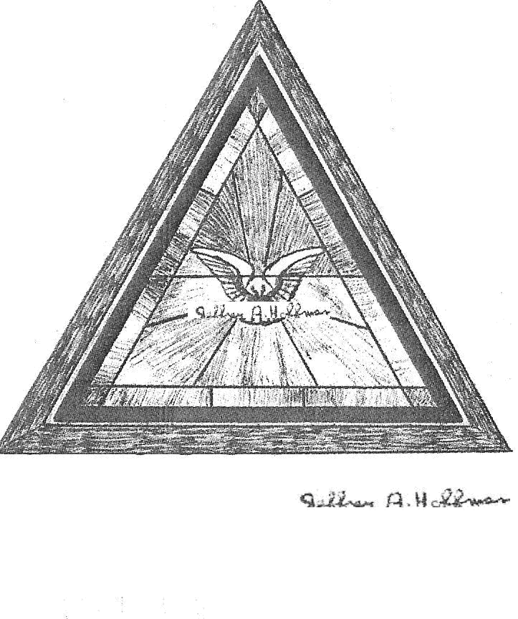

The Valleys
Evangelical Covenant Church
Halifax, PA

Church Office Hours: Mon. thru Fri. - 10AM to 3PM
Church Office(717-896-3118)
Web Site - ValleysEcc.Org Email - valleysecc@verizon.net

Pastor’s Hours: Mon., Tues., Thurs.; 10:00AM - 1:00PM
Office (896-3118), Cell (717-818-3041), home (717-422-5788)
Email - KOHeckard@aol.com

CHURCH CALENDAR
Oct. 12 - 9:00AM - Sunday School
10:00-10:15AM - Learn Praise Hymns
10:15AM Blended Worship (Praise Team & Hymnal)
1:00-5:30PM - Girl Scout Event (No Zumba at Valleys)
Oct. 13 - 9:00AM-Noon - Halifax Senior Center open Mon.-Thurs.
10:00AM - Bible Study (Pastor Ron Reitz, Leaders)
6:00-8PM - Girl Scout Trp. 774
7:30PM - Valleys at St. John’s Lutheran (Berrysburg)
Oct. 14 - 5:30-7:00PM - “Free” Community Meal
6:00-8PM - Girl Scout Trps. 738 & 740
Oct. 15 - Noon-3:00PM - Senior Center Pinochle Card Party
7:00PM - Council Meeting
Newsletter Articles are due today!
Oct. 16 - 6:10PM - Zumba Gold; 7:00-8PM - Zumba
6:15PM - Women’s Bible Study (at Gloria Duttry’s)
7:30PM - Choir
Oct. 19 - 9:00AM - Sunday School
10:15AM - Traditional Worship (Enders)
1:30PM - CROP WALK at Halifax Memorial Park
2:00PM - Zumba
6:30PM - Youth Group
Oct. 20 - 9:00AM-Noon - Halifax Senior Center open Mon.-Thurs.
10:00AM - Bible Study (Pastor Ron Reitz, Leaders)
7:30PM - Dartball - Valleys at St. Christopher (Lykens)
Oct. 21 - 6:00-8PM - Girl Scout Troop 10463
Oct. 22 - 5:00PM - Worship Committee
7:30PM - Choir
Oct. 23 - 6:10PM - Zumba Gold; 7:00-8PM - Zumba
Oct. 26 - 9:00AM - Sunday School
10:00-10:15AM - Learn Praise Hymns
10:15AM Blended Worship (Praise Team & Hymnal)
Mission Offering
1:00-5PM - Girl Scout Event

The following groups meet at Valleys: Mondays - Victory Group (Weight Loss) - 5:30PM; Tuesdays - Weight Loss Challenge Group - 5:30-7:00PM

Praise Team Rehearsal: (Weeks 1, 3, 5 at Gary F; Weeks 2, 4 at church)

Church Attendance last Sunday, Oct. 5, 2014 was 66.
*PRAYER REQUESTS*
Please remember all the people on our Prayer List with prayers, thought, and cards: *(indicates new)
Members & Friends of The Valleys: Navigate Pathway; *Tom Lauver, (Home); *Dennis & Barbara Croutharmel & Family; Brooke Croutharmel; Dean Etzweiler; Tom Hale; John Shoop; Ken Breeman; Allen Goss, (Lifecare Rehab. Hosp,); Elmer Feidt; Savannah Dobbin, (Ed’s granddaughter).
Missions: Covenant Missionaries: Fred & Kelly Prudek; *Joshua & Lori Shinar.
Our Shut Ins: Minnie Baker; Lydia Peiffer; Myra Hoffman; Anna Portzline, (The Manor).
Please inform Pastor Kris if you or a member of your family is in the hospital as the hospitals will not inform us unless you tell them to contact us. You may call the church office (896-3118) or Pastor Kris (818-3041).
~~~~~~~~~~~~~~~~~~~~~~~~~~~~~~~~~~~~~~~~~~~~~~~~~~~~~~~

Sympathy: We extend our Christian sympathy, love, thoughts and prayers to Dennis & Barbara Croutharmel and family as Dennis’s mother Melba Croutharmel went to be with the Lord on October 6th. May God wrap his loving arms around them and give them comfort.

Mr. Sticky will be at Valleys on Mon. Nov. 10th & Tues. Nov. 11th! Order forms are in the narthex - White forms are for Mon. Nov. 11th ) and Colored forms are for Tues. Nov. 12th. Cost is $3.00 per bun. Buns will be available for pick-up both days. A sign up sheet is in the narthex for helpers needed for both days.

Halifax Senior Center open 9:00AM-Noon Mon. thru Thurs. at The Valleys E. C. C. Check the calendar on Bulletin board in narthex for list of activities. October Monday morning Bible Study Leader is Pastor Ron Reitz. Senior Center Pinochle Card Party on Wednesday, Oct. 15th Noon to 3:00PM.

Giant Gift Cards available to purchase (before/after church)!
By purchasing Giant gift cards, you can help raise money for Valleys. Valleys receives $5 for every $100 Giant gift card purchased.

Please turn off cell phones, pagers, etc. during our worship service. Thank you for your cooperation.

