The Rev. Kristine Heckard, Pastor
Choir Director, Ed Dobbin
Organist & Pianist, Mark & Joanne Enders
Acolyte, Lydia Faust
January 20, 2013
Second Sunday After Epiphany

(*Indicates all those who are able are invited to stand.)

Chimes
* Passing the Peace Greeting:
All who are able may greet those around them with an embrace or a handshake, accompanied by such words as:
Greeting: “The peace of God be with you.”
Response: “And also with you.”

Greetings and Announcements
* Call To Worship Diane Shaffer
L: Let all who have known the mercy of the Lord come together!
P: Through God’s grace, the house of the Lord is open to each of us.
L: Yet we come as sinners, each fallen short of what God created us to be.
P: But in Christ, truly each of us is beloved in the eyes of God.
L: Then let our praise be heard for the mercy and grace of God.
All: Blessed be the name of the Lord!
L: Come, let us worship God!

Prelude - “God of All Nations” by Steve Scott
* Praise Hymn - “Love Divine, All Loves Excelling” Pg. 92
* Prayer of Invocation
* Call to Confession
* Confession: (In Unison )
Lord, so often we tend to come before You as if we deserve Your grace and mercy. So often we tend to act as if among all of Your people, we alone deserve Your favor. And too often we seem to either ignore our own sin or we focus too much on it, and we fail to see and receive the joy of life in Christ You intended for us to have. Forgive us, Lord, In Christ we pray. Amen.
* Kyrie: (To Be Sung)
Leader: Lord, have mercy upon us.
People: Lord, have mercy upon us.
Leader: Christ, have mercy upon us.
People: Christ, have mercy upon us.
Leader: Lord, have mercy upon us.
People: Lord, have mercy upon us.
* Assurance of Pardon
* Gloria Patri Pg. 623
* Profession of Faith - (In Unison)
We believe in one God, the eternal Father, manifest in Jesus Christ, our Lord, and abiding and working in the heart of God’s people as the Holy Spirit.
We believe in the redemption of our race by Jesus Christ, who is the Saviour of all who believe in him unto obedience.
We believe that we are called to live a life of Love, Joy, Peace, Patience, Kindness, Forgiveness, Faithfulness, Humility and Sacrifice.
We believe in the kingdom of God, established by Jesus Christ, which shall prevail over all the earth in righteousness, love, and peace.
Children’s Sermon
Hymn of Preparation - “He Touched Me” Pg. 504
Prayer cards will be collected during the 2nd hymn.
Morning Prayer & The Lord’s Prayer (Debts & Debtors)
Choral Response - “Hear Our Prayer O Lord” Pg. 614

Anthem
Scripture - John 2:1-11 Renny Witmer, Lay Reader
(Found on Pg. 125 of NT Pew Bible)

Sermon - “Filled to the Brim”

Our Morning Offering
Offertory - “Canticle of Joy” by James Denton
* Offertory Response - “We Give Thee But Thine Own” Pg. 620
* Prayer of Dedication
* Closing Hymn - Pg. 97
“All Hail the Power of Jesus’ Name”
* Benediction
* Threefold Amen
* Extinguishing of the Candles
* Postlude - “Aria” by George Handel

Welcome: We heartily greet all worshipers in the name of Christ our Lord. It’s our goal to live as members of God’s family. Please extend your hand to greet one another warmly and sincerely. If you are a visitor, please take time to sign your name, address, and phone number in our guest book before you leave.

January Greeters: Arletta Thomas and Ann Hale. Announcer: Diane Shaffer. Acolyte: Lydia Faust. January Offering Team: Bob Endy, Body Dimpsey, Dennis Croutharmel, Ed Berra.

Lay Readers: Jan. 20 - Renny Witmer; Jan. 27 - Sue Faust; Feb. 3 - Brandi Crum; Feb. 10 - Donna Novinger. If you can not read on the date assigned, please call Pastor Kris at the church (896-3118) or her home (717-422-5788).

Church School Teachers (Adults): Jan. 20 - Boyd Dimpsey; Jan. 27 - Ed Dobbin; Feb. 3 - Bob Endy; Feb. 10 - Ken Bechtel II. If you cannot teach on your assigned Sunday, please inform Dave Novinger or Jessie Faust who will teach in your place.

Please turn off cell phones, pagers, etc. during our worship service. Thank you for your cooperation.

Giant Gift Cards available to purchase (before/after church)!

SERVICE CANCELLATION POLICY
*****************************************************************
If a service or activity has to be cancelled due to adverse weather conditions during the winter, please check the following TV stations - WHTM Channel 27 and WHP Channel 21 to see if Valleys appears on their cancellation display.
*****************************************************************
~~~~~~~~~~~~~~~~~~~~~~~~~~~~~~~~~~~~~~~~~~~~~~~~~~
Church Attendance for Sun., Jan. 13, 2013 was 79.

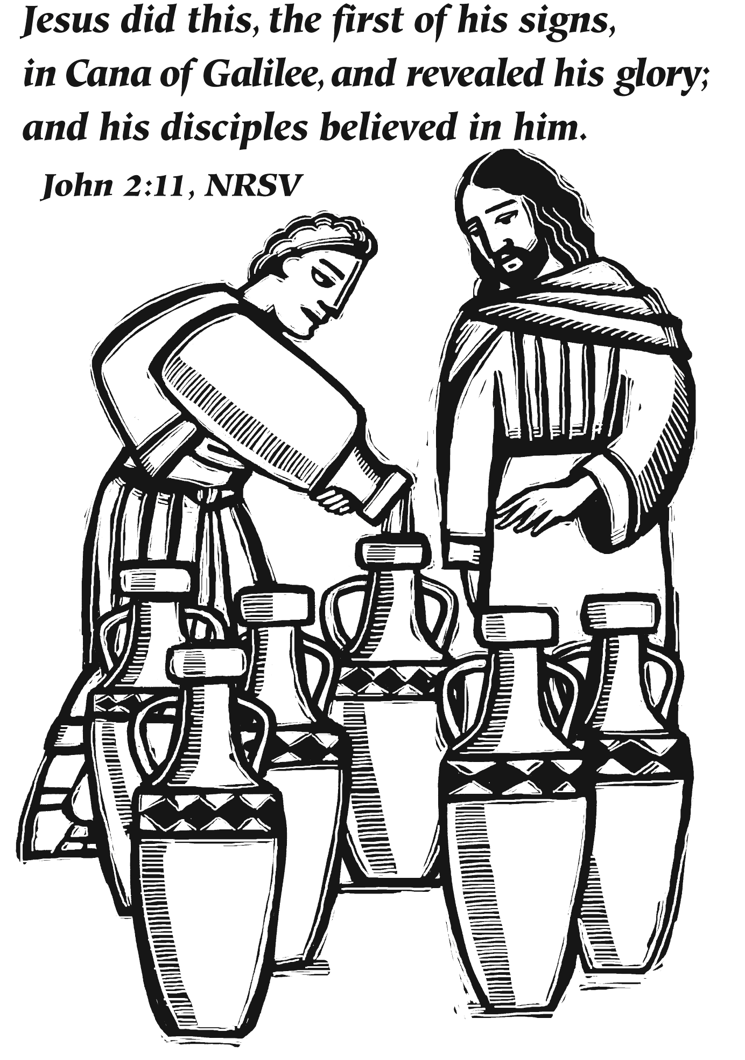

The Valleys
Evangelical Covenant Church
Halifax, PA

Church Office Hours: Mon. thru Fri. - 10AM to 3PM
Church Office(717-896-3118)
Web Site & Email - http://valleysecc.org valleysecc@verizon.net

Pastor’s Hours: Mon., Tues., Thurs.; 10:00AM - 1:00PM
Office (896-3118), Cell (717-818-3041), home (717-422-5788)
Email - KOHeckard@aol.com

CHURCH CALENDAR
Jan. 20 - 9:00AM - Sunday School
10:15AM - Church Annual Congregation Meeting and Meal will follow church. No Confirmation Class
2:00-3PM - Zumba, Kids Zumba 3:15-4PM -Zumba Gold
6:30PM - Youth Group
Jan. 21 - 10:00AM - Bible Study
7:30PM -Lykens U. Methodist at Valleys
Jan. 22 - 7:30PM - Choir
Jan. 23 - 6:00-7:00PM - Daisy Girl Scout Troop meeting
7:00PM - Council Reorganization Meeting
Jan. 27 - 9:00AM - Sunday School
10:15AM - Church - Mission Sunday (Focus on Hope Sunday for Congo Kids) Mission Offering
2-3PM - Zumba, Kid’s Zumba 3:15-4PM - Zumba Gold
Jan. 28 - 10:00AM - Bible Study
6:30-7:30PM - Girl Scout Troop 10774
Jan. 30 - 6:00-8:00PM - Girl Scout Troop 10728
7:30PM - Choir
Feb. 2 - 9:00AM - 12:00Noon - Media Coaching
Feb. 3 - 9:00AM - Sunday School
10:15AM - Church - Installment of Elders & Deacons (Children’s Church)
Fellowship Covered Dish Meal following church
Confirmation Class following meal
2-3PM - Zumba, Kid’s Zumba 3:15-4PM - Zumba Gold
Feb. 4 - 10:00AM - Bible Study
5:30PM - Prayer Team
6:00-9:00PM - Girl Scout Leaders
7:30PM - Dartball - Valleys at St. Christopher L. (Lykens)
Feb. 5 - 6:30-7:00PM - Girl Scout Troop 10463
7:00PM - Deacons
Feb. 6 - 6:00-8:00PM - Girl Scout Troop 10728
7:30PM - Choir
Feb. 7 - 10:00PM - Dauphin Co. Extension of Garden Club Meet.
No February Senior Citizens Meeting
Feb. 10 - 9:00AM - Sunday School
10:15AM - Church (Children’s Church)
2-3PM - Zumba, Kid’s Zumba 3:15-4PM - Zumba Gold

*PRAYER REQUESTS* *(indicates new)
Please remember all the people on our Prayer List with prayers, thought, and cards: Members & Friends of The Valleys: Navigate Pathway;
*Marie Herb; *Ed Berra; *Dean Saylor Sr. & Dean Saylor Jr., (friends of Diane Shaffer); Allen Goss; Elvin Lebo; Pauline Novinger; Melba Croutharmel; Minnie Baker; Glen Jones, (Jim Jones’ brother); David Minns, (Friend of Sue Maichle & Jim Jones); Gregg Gelnett; Carley & Paul Enders; Nevin Maurer; Charles “Cappy” Reisch; Margie Zeigler, (Frey Village).
Missions: Covenant Missionaries: Fred & Kelly Prudek; *Randy & Cheryl Bevis.
Our Shut Ins: Anna Portzline; Lydia Peiffer;
Military: James Lesh, (grandson of Ed & Pat Dobbin), stationed in Afghanistan. Wesley Eshleman, (grandson of Betty Eshleman), stationed in Kuwait.
Please inform Pastor Kris if you or a member of your family is in the hospital as the hospitals will not inform us unless you tell them to contact us. You may call the church office (896-3118) or Pastor Kris (818-3041).

Nursery: Valleys provides nursery care for children ages 5 and under. Nursery Attendants: Jan. 20 -Tracey Cooper; Jan. 27 - Brandi Crum; Feb. 3 - Neva Cichy; Feb. 10 - Carol Cooper. More Nursery attendants are needed! To help in the Nursery or if you cannot be there on your assigned Sunday, please see Donna Novinger.

Installation of Elders & Deacons: Service of Installation of Elders and Deacons will be held on Sunday, February 3rd during Worship Service followed by a Fellowship Covered dish meal. (Please bring a meat dish or a casserole and a dessert to share.)

Media Coaching: Anyone interested in learning how to operate easy worship, the hymnal, or learn steps to make a video from home photos & videos, come and join us on Sat. Feb. 2nd and Sat. Feb 16th. To sign up, call Pastor Kris

Newsletter Articles: Please give all newsletter articles for the February/March newsletter to the church secretary by today, Jan. 20th.
Dartball: Faith won 1 game 7-6; Valleys won 1 game 3-2. Home- runs: Faith: Deb Scott; Valleys: Pete Bryson (2), Renny Witmer.

